APRIL 07, 2019

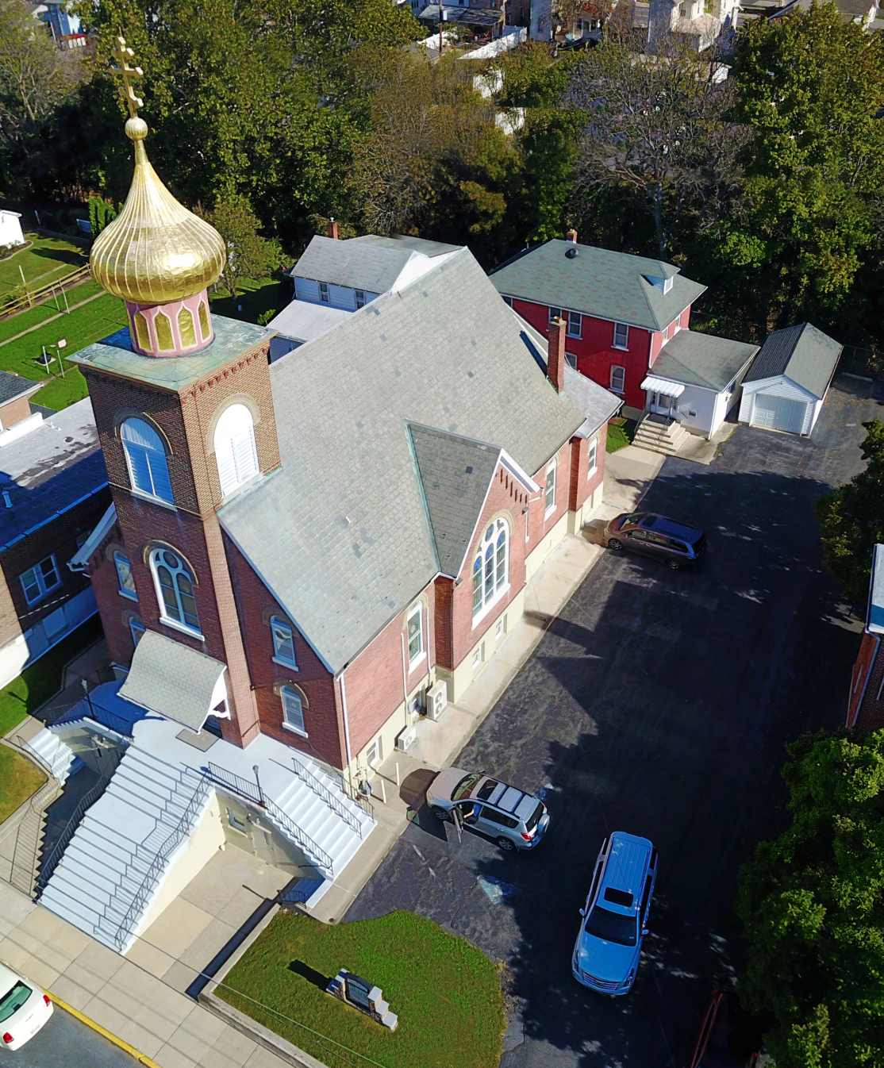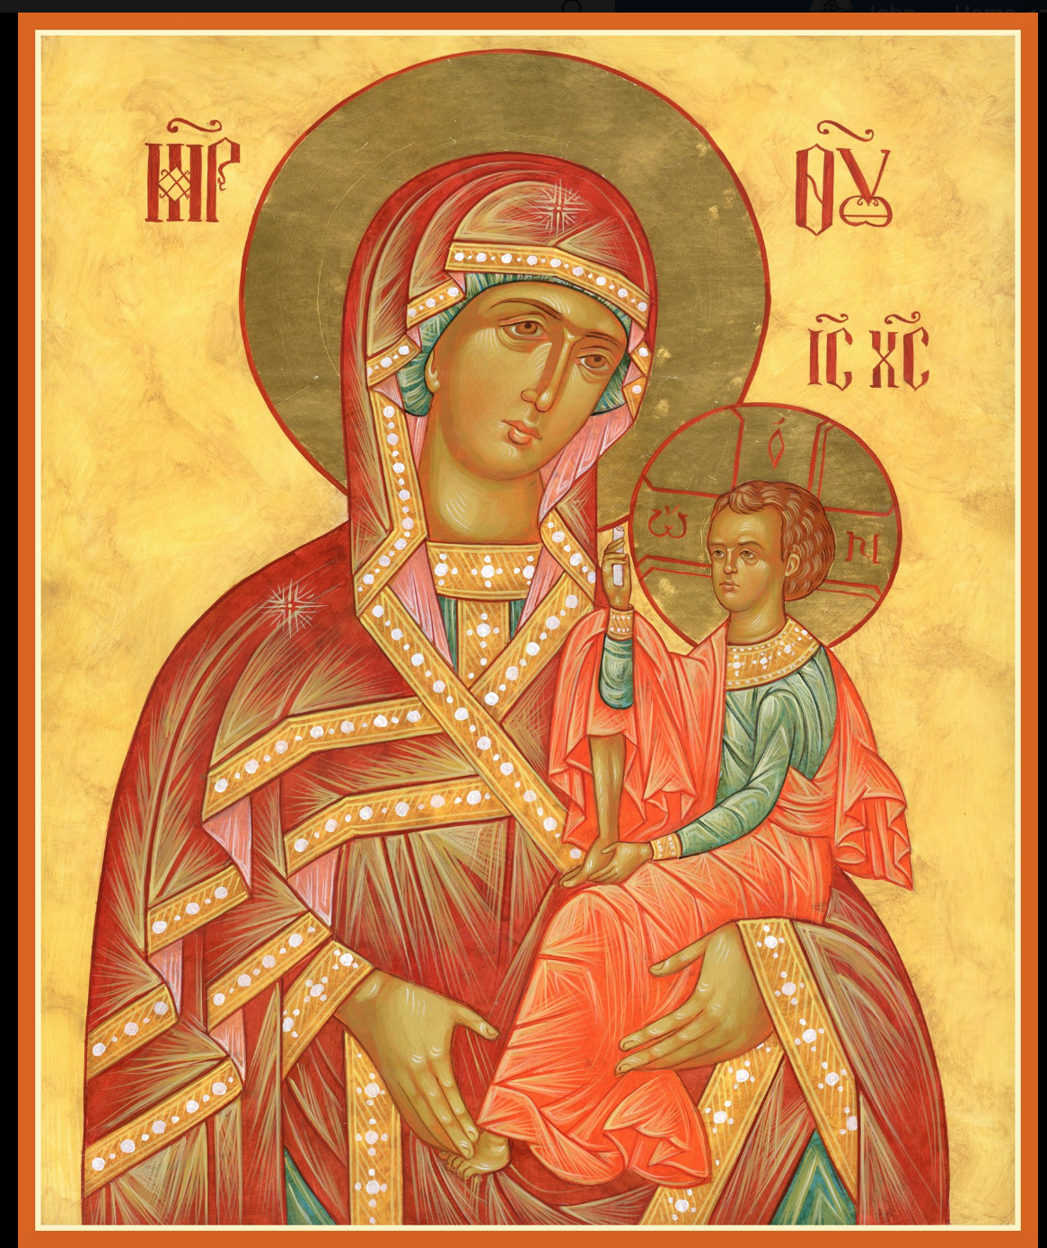

ASSUMPTION OF THE VIRGIN MARY
UKRAINIAN ORTHODOX CHURCH
ECUMENICAL PATRIARCHATE OF CONSTANTINOPLE AND NEW ROME
1301 Newport Avenue
Northampton, Pennsylvania 18067
Mitered Archpriest Myron Oryhon
Protodeacon Mychail Sawarynski, Attached

Telephones: Church Office… (610) 262-2882
Church Fax/Kitchen/Hall… (610) 262-0552
Fr. Myron Oryhon – (607) 752-1999
Protodeacon Mychail’s Residence… (610) 262-3876
Websites: holyassumption.org
ukrainianorthodoxchurchusa.org
lvorthodox.wordpress.com
E-mail: Parish… avmuoc@gmail.com
Protodeacon Mychail…pravoslavni@rcn.com
Webmaster, John Hnatow… john.hnatow@gmail.com
==============================================================
07th April, (25th Mar.) 2019
FOURTH SUNDAY OF GREAT LENT. ANNUNCIATION OF THE VIRGIN MARY. Tone 4.
Hebrews 6:13-20 Mark 9:17-31 Hebrews 2:11-18 Luke 1:24-38

PROPERS FOR LITURGY OF ST. BASIL THE GREAT
Tropar of the Resurrection, Tone 4
When the women disciples of the Lord learned from the angel the joyous message of Your Resurrection, they cast away the ancestral curse and with gladness told the apostles: death is overthrown. Christ God is risen, granting the world great mercy.
Tropar of the Annunciation , Tone 4
Today is the beginning of our salvation, the revelation of the Eternal Mystery. The Son of God becomes the Son of the Virgin, as Gabriel announces the coming of Grace. Together with him, let us cry out to the Birth-Giver of God: Rejoice, Lady Full of Grace, the Lord is with you.
Glory to the Father and to the Son and to the Holy Spirit now and ever and unto ages of ages. Amen.
Kondak of the Annunciation, Tone 8

To you, unconquerable Lady, Birth-Giver of God, we, your triumphant servants, having been delivered from dangers, offer hymns of thanksgiving. Lady of invincible might, free us from all dangers, that we may cry to you: “Rejoice, Unwedded Bride.”

Prokimen in Tone 4
How marvelous are Your works, O Lord. In wisdom You have made them all.

Verse: Bless the Lord, my soul. O Lord my God, You are very great.

Prokimen of the Annunciation in Tone 4
Announce from day to day the glad tidings of the salvation of our God.

Verse: Chant to the Lord a new song. Chant to the Lord, all the earth.

Alleluia Verses, Tone 4
Bend your bow and proceed prosperously, and reign because of truth, meekness and righteousness.

You have loved righteousness and hated iniquity.

He shall come down as rain upon a fleece. And as dew which falls upon the earth.

His Name shall be blessed forever; His Name shall continue longer than the sun.

In place of “All of creation rejoices…”
Announce glad tidings of great joy, all the earth. You heavens praise the glory of God.
Irmos Tone 4
Let no profane hand touch the living Ark of God, but let the lips of the faithful cry aloud in great joy to the Birth-Giver of God: “Rejoice, Lady Full of Grace; the Lord is with You.”

Communion Hymn:
Praise the Lord from the heavens, praise Him in the highest.
The Lord has elected Zion. He has chosen her as a habitation for Himself. Alleluia (3X)

LITURGICAL MENEION & SCRIPTURE READINGS
FIFTH WEEK OF GREAT LENT

Sun. 07 April. Fourth Sunday of the Great Fast.
4:00 PM VESPERS at St. Mary’s Church, Allentown

Mon. 08 Apr. Apodosis of the Annunciation. Synaxis of the
Strict Fast ARCHANGEL GABRIEL. Hieromartyr
IRENAEUS, Bishop of Srem, Serbia (304).
Genesis 13:12-18 Proverbs 14:27-15:4

Tue. 09 Apr. St. MATRONA of Thessalonica (4th C.). Martyrs
Strict Fast MANUEL & THEODOSIUS (304).
Genesis 15:1-15 Proverbs 15:7-19

Wed. 10 Apr. HILARION the New, Abbot of Pelecete (754).
Strict Fast STEPHEN the Wonderworker, Abbot of Tryglia.
Genesis 17:1-9 Proverbs 15:20-16:9
4:00 PM PRESANCTIFIED LITURGY St. Mary’s Allentown

Thur. 11 Apr. Martyr MARK, Bishop of Arethusa. Venerable
Fast: JOHN, Anchorite of Egypt. EUSTATHIUS, the
Wine & Oil Confessor, Bishop of Kios in Bithynia (9th C.). Genesis 18:20-33 Proverbs 16:17-17:17
7:00 PM CANON OF ANDREW OF CRETE St. Mary’s

Fri. 12 Apr. Venerable JOHN CLIMACUS of Sinai, Author of
Fast: the Ladder (649). Prophet JOAD (10th C. B.C.).
Wine & Oil Genesis 22:1-18 Proverbs 17:17-18:5
5:30 PM CONFESSIONS; 9th HOUR & TYPICA
6:00 PM LITURGY OF THE PRESANCTIFIED GIFTS
(Fasting from 12:00 Noon, if able)
Soup and Bread will follow in church hall.

Sat. 13 Apr. GLORIFICATION OF THE MOTHER OF GOD.
Fast Day: AKAFIST SATURDAY. HYPATIUS the Wonder-
Wine & Oil worker, Bishop of Gangra. Ven. APOLLONIUS.
Hebrews 9:24-28 Mark 8:27-31
9:00- Visitation of the sick and homebound with Holy
12:00 AM Communion (call Father for a time)
8:30 AM RETREAT at St. Francis Center for Renewal
5:00 PM GREAT VESPERS followed by CONFESSIONS

SUN. 14 Apr. 5th SUNDAY OF GREAT LENT. TONE 5.
Fast Day: St. MARY OF EGYPT. GERONCIUS &
Wine & Oil BASILIDES (3rd C.) Righteous ACHAZ.
8:30 AM THIRD & SIXTH HOUR; Mystery of Penance
9:00 AM DIVINE LITURGY OF BASIL the GREAT
4:00 PM LENTEN VESPERS at St. Nicholas Cathedral

NECROLOGY:
07 April… Gregory Zgoba ’32, Katherine Wentz ‘78
09 April… Volodymyr Bursky (infant) ’35, Karolina
Yaremchuk ’85, Nicholas Chuyko ’88,
Michael Kuchinos ‘03
11 April… Katherine Bochnok ’70, Wasyl Sawka ‘93
12 April… John Roman ’33
13 April… Theodosia Gontar ’83, Olexander Reminniy ‘12

VICHNAYA PAMYAT! MEMORY ETERNAL

BIRTHDAYS:
07 April… Walter Dworakivsky, Karen Osmun
08 April… Tessie Kuchinos, Patricia Kuchinos, Michael Kuchinos, Jared Kroboth
10 April… Lara Smallen, Jerome Kroboth
12 April… Janelle Kroboth, Lesya Semonovych

MNOHAYA LITA! MANY YEARS!

WE PRAY FOR THE HEALTH AND WELL BEING of the ill afflicted: William Savitz, Catherine Kochenash, Fr. Vasyl Dovgan, Vladimir & Emma Krasnopera, Tessie Kuchinos, Brendan Phillips, Jessie Hnatow, Jessica Meashock, Wasyl Hewko, Adam Hewko, Betty Hendrickson, Andrew Thaxton, Michelle Pierzga, Susan Ferretti, Carole Zarayko, William Fischer, Ekaterina Seremula, Reader Evhen (Roger) Seremula, Marianna Goshow, child born to Ariel Weiller, Judy Albright, Nancy Stellato

NORTHAMPTON FOODBANK is still in need of foodstuffs, especially tuna and canned potatoes.

OCMC “AGAPE CANISTER” DONATIONS were $47.00 Thank you for your support of our Missions around the globe.

RELIGIOUS INSTRUCTION CLASS FOR PARISH CHILDREN:
Mrs. Mary Ost – Sundays 9:00-9:30
Mrs. Linda Winters-Apr. 7- 11 AM; Apr. 14- 9 AM; Apr. 21 – 11 AM.
Ms. Bettyann Woyewoda – Sundays at 8:40-9:15; April 7, 14, 21; May 5, 12, 19. 26

NEXT PIEROHI SALE WILL BE APRIL 18th. Order by Apr. 13th. Call Helen 610-261-4575 or 484-239-5731. Additional dates are:
May 9, 16, 23.

JR UOL PASKA SALE: Pick-up on Sunday, April 14th.

Continue to collect receipts from “Redner’s Save a Tape Program.

Sunday School students are collecting funds for “HEIFER INTERNATIONAL”, a global nonprofit charity working to end poverty and hunger through sustainable, values-based holistic community development. It distributes animals and agricultural and values-based training to families in need around the world as a means of providing self-sufficiency. Collection jar is located in the hall on the Coffee Hour table. Please be generous during this Great Lent.

LENTEN RETREAT on APRIL 13th at St. Francis Center for Renewal in Bethlehem. The theme will be “SPIRITUAL JOURNEY”.
Guest speakers are Metropolitan Gregory and Fr. Anthony Perkins.
Fee: $45 for adults. Contact Natalie (nsufler@aol.com) reservations.

SR UOL MEETING MAY 5th following the Coffee Hour.

CHEESECAKE & NUTROLL PICKUP, SATURDAY, APRIL 13th between 9 and 12 AM in the church hall.

“ORTHODOX AFRICA”
St. Barnabas Orthodox Orphanage and School has 180 children that it cares for; feeding them two meals a day, taking care of their medical needs, educating them and teaching them the Orthodox Faith.
Fr. Methodius Kariuki, rector, plans to build a dormitory to house the children at a cost of $45,000. If you would like to become a “FOUNDER” of the dormitory by sponsoring a child for $250 or if you can give any amount to become a “DONOR”, you and your family (living and dead) will be commemorated at every Liturgy in Kinangop, Kenya in perpetuity. Checks can be made out and sent to St. Nicholas Orthodox Church, P.O. Box 37, McKinney, TX 75070.
Designate “St. Barnabas Orphanage.” If you would prefer to make a cash donation, see Deacon Mikhail and he will send the funds. May this be a part of your joyous Lenten journey.

