APRIL 28, 2019

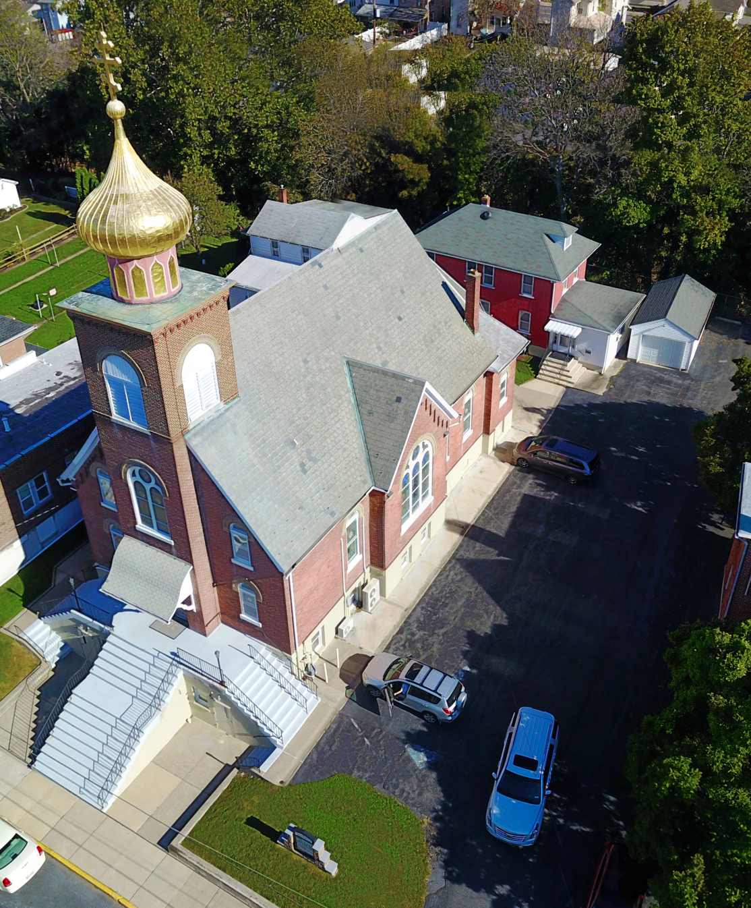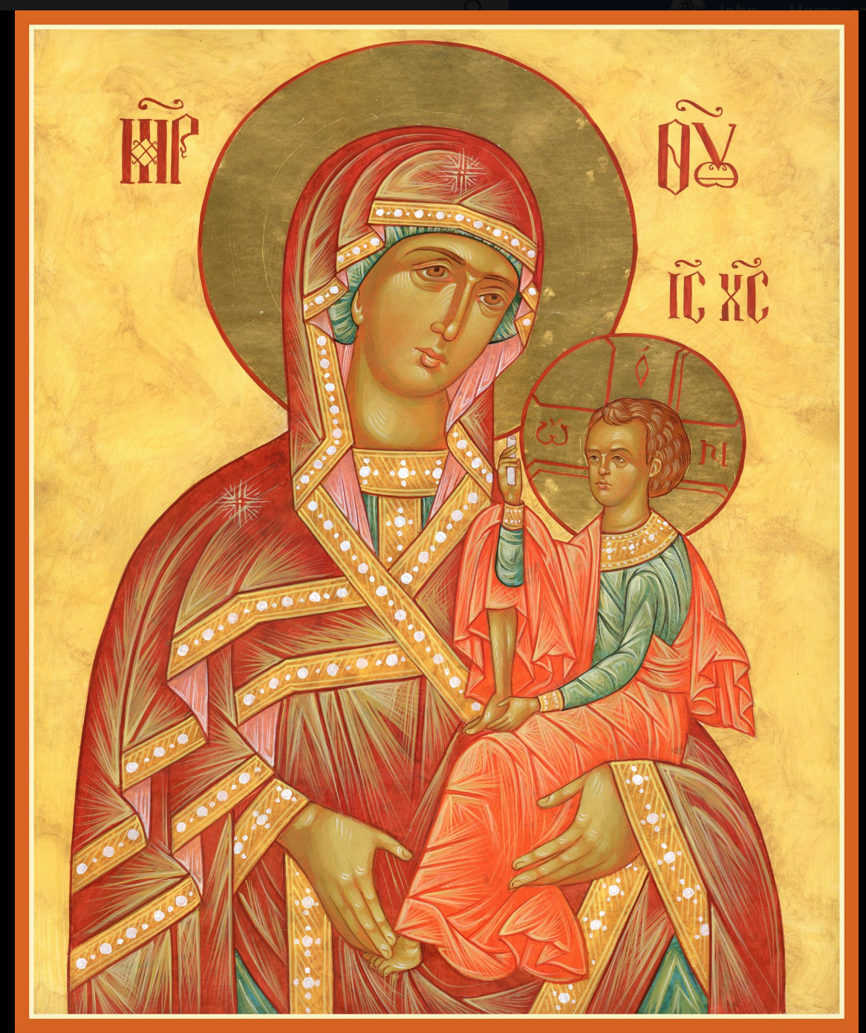

ASSUMPTION OF THE VIRGIN MARY
UKRAINIAN ORTHODOX CHURCH
ECUMENICAL PATRIARCHATE OF CONSTANTINOPLE AND NEW ROME
1301 Newport Avenue
Northampton, Pennsylvania 18067
Mitered Archpriest Myron Oryhon
Protodeacon Mychail Sawarynski, Attached

Telephones: Church Office… (610) 262-2882
Church Fax/Kitchen/Hall… (610) 262-0552
Fr. Myron Oryhon – (607) 752-1999
Protodeacon Mychail’s Residence… (610) 262-3876
Websites: holyassumption.org
ukrainianorthodoxchurchusa.org
lvorthodox.wordpress.com
E-mail: Parish… avmuoc@gmail.com
Protodeacon Mychail…pravoslavni@rcn.com
Webmaster, John Hnatow… john.hnatow@gmail.com
==============================================================
28th April (15th April) 2019
THE BRIGHT RESURRECTION OF CHRIST. THE PASCHA OF THE LORD.
Acts 1:1-8 John 1: 1-17
CHRIST IS RISEN! TRULY, HE IS RISEN!
KRISTOS VOSKRES! BO ISTINYU VOSKREC!

LITURGICAL MENEION & SCRIPTURE READINGS
FOR BRIGHT WEEK
(NO FASTING THIS WEEK)
(NO KNEELING UNTIL PENTECOST)

Mon. 29 Apr. BRIGHT MONDAY. Virgin-martyrs AGAPE, IRENE, & CHIONIA in Illyria (304).
Acts 1: 12-17, 21-26 John 1: 18-28

10:00 AM Divine Liturgy at St. Mary’s, Allentown

Tue. 30 Apr. BRIGHT TUESDAY. Martyr ADRIAN of Corinth
(251). Hieromartyr SIMEON, Bishop in Persia.
Acts 2: 14-21 Luke 24: 12-35

Wed. 01 May BRIGHT WEDNESDAY. Ven. JOHN, disciple of
St. GREGORY of Decapolis (820). Martyrs VICTOR, ZOTICUS, ZENO, ACINDYNUS &
SEVERIAN of Nicomedia (303).
Acts 2: 22-36 John 1: 35-51

PARISH COUNCIL MEETING, WEDNESDAY EVENING 7 PM

Thur. 02 May BRIGHT THURSDAY. St. JOHN of the Ancient
Caves in Palestine (8th C.) Martyrs CHRISTOPHER
THEONAS, & ANTONINUS in Nicomedia (303).
Acts 2: 38-43 John 3: 1-15

Fri. 03 May BRIGHT FRIDAY. THEODORE TRICHINAS, hermit near Constantinople (400). GREGORY &
ANASTASIUS, Patriarchs of Antioch. Child-martyr
GABRIEL of Bilostok (1690).
Acts 3: 1-8 John 2: 12-33

Sat. 04 May BRIGHT SATURDAY. Hieromartyr JANUARIUS
& his companions: FESTUS, PROCLUS & SOSIUS,
Deacons; DESIDERIUS, reader; EUTYCHIUS &
ACUTIUS (305).

5:00 PM GREAT VESPERS OF ANTIPASCHA.

Sun. 05 May 2nd SUNDAY OF PASCHA; ST. THOMAS.
8:30 AM THIRD & SIXTH HOURS
9:00 AM LITURGY OF ST. JOHN CHRYSOSTOM
11:30 AM PANIKHIDA & BLESSING OF THE GRAVES
AT PARISH CEMETERY

NECROLOGY:
28 April… Tekla Fedorovych ‘26
29 April… Philip Kereb ’25, Nelcy Azar ‘15
30 April… Julian Didenko ’39, Mary Kulp ’91.
Natalia Lutyi ‘18
02 May… Nicholas Kymniakevych ’29, Caroline Kuliansky ‘72
03 May… Agnes Chuyko ‘64
04 May… Semen Chychota ’30, Russell Gontar ’85,
Helen MacKenzie ‘99

VICHNAYA PAMYAT! MEMORY ETERNAL

ANNIVERSARY:
02 May… John & Linda Vitushinsky

MNOHAYA LITA! MANY YEARS!

WE PRAY FOR THE HEALTH AND WELL-BEING of the ill afflicted: William Savitz, Catherine Kochenash, Fr. Vasyl Dovgan, Vladimir & Emma Krasnopera, Tessie Kuchinos, Brendan Phillips, Jessie Hnatow, Jessica Meashock, Wasyl Hewko, Adam Hewko, Betty Hendrickson, Andrew Thaxton, Michelle Pierzga, Susan Ferretti, Carole Zarayko, William Fischer, Ekaterina Seremula, Marianna Goshow, child born to Ariel Weiller, Judy Albright,
CONGRATULATIONS to JOHN IGOR SAWARYNSKI, who received his first HOLY CONFESSION on Great and Holy Saturday. God grant him many years!

We welcome DEACON OLEH KRAVCHENKO & his PANI, OL’HA, to our parish for Holy Week and Pascha.

OCMC “AGAPE CANISTER” DONATIONS were $31.00 Thank you for your support of our Missions around the globe.

MANY THANKS to NADDA & WALTER for their donation of Palms and Pussy Willows on Palm Sunday and to RICHARD STECH for baking the ARTOS for Pascha. Many, blessed years!

RELIGIOUS INSTRUCTION CLASS FOR PARISH CHILDREN:
Mrs. Mary Ost – Sundays 9:00-9:30
Mrs. Linda Winters- May 5 – 11 AM; May 12 – 9 AM; May 19 – no class; May 26 – no class; June 2 – 11 AM; June 9 – 9 AM
Ms. Bettyann Woyewoda – Sundays at 8:40-9:15; May 5, 12, 19. 26

NEXT PIEROHI SALE WILL BE MAY 9th . Order by May 5th.
Call Helen 610-261-4575 or 484-239-5731. Additional dates are:
May 16 & 23.

SR UOL MEETING May 5th, following the Coffee Hour.

NORTHAMPTON FOODBANK is still in need of foodstuffs, especially tuna, canned potatoes and baby food.

Continue to collect receipts from “REDNER’S SAVE A TAPE PROGRAM”. Deposit them in the box in the Vestibule. This quarter brought in a total of $158.84. Thanks for supporting this project.
And our thanks to Helen Crayosky for chairing this fundraiser.

A BLESSED PASCHA to all members of the parish council, to the altar servers, the choir, its director Linda, to the readers, to Alex & Lesya Semenovych, & all workers who made Pascha awe inspiring.

