May 3, 2020
ASSUMPTION OF THE VIRGIN MARY
UKRAINIAN ORTHODOX CHURCH
ECUMENICAL PATRIARCHATE OF CONSTANTINOPLE AND NEW ROME
1301 Newport Avenue
Northampton, Pennsylvania 18067
Rev. Fr. Oleg Kravchenko, Rector
Protodeacon Mikhail Sawarynski, Attached
Websites: holyassumption.org and ukrainianorthodoxchurchusa.org
Facebook: Assumption of the Virgin Mary Ukrainian Orthodox Church
YouTube: AVM UOC church
Contacts: Fr. Oleg Kravchenko - (732) 507-2274
Email: olegkravchenko2212@gmail.com
Protodeacon Mikhail – (H) (610) 262-3876)
Email: pravoslavni@rcn.com
Office – (610) 262-2882
Email: avmuoc@gmail.com
Webmaster, John Hnatow
Email: john.hnatow@gmail.com

Sun. 03 May (Apr. 20th) 2020. THIRD SUNDAY OF PASCHA. MYRRH-BEARING WOMEN, Righteous Joseph of Arimathea and Nicodemus. Tone 2. THEODORE Trichinas (400), Patriarchs GREGORY & ANASTASIUS of Antioch. Child-martyr GABRIEL of Bilostok.
Acts 6:1-7 Mark 15:43-16:8

CHRIST IS RISEN! ХРИСТОС ВОСКРЕС!
TRULY, HE IS RISEN! ВОІСТИНУ ВОСКРЕС!
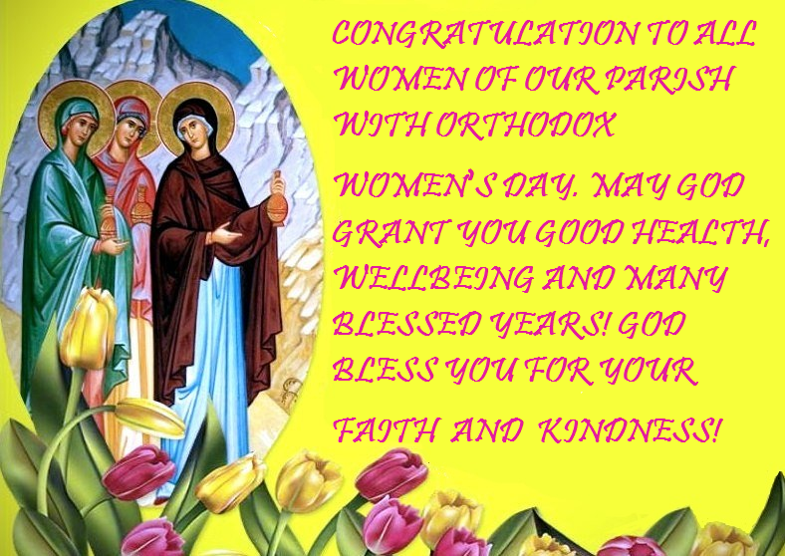
In the history of the church, the role of women has been very great. There are many women saints and martyrs who gave up their lives rather than give up their faith in the Resurrected Christ. Even more than this, there are numerous unnamed women saints in the church who lived their whole life for Christ, totally dedicated to Him by bearing witness to His Gospel and His Resurrection. These many women, who throughout the ages, have given their quiet strength to the church, because they have taken the experience of the empty tomb and extended it throughout the centuries in order to give credence

to the Risen Christ. These women have been teachers, singers, readers, martyrs, nuns, mothers and single women working in the world. They live out the message of those first myrrh-bearing women that Christ is Risen and have kept that message alive throughout all these centuries. The entire church owes much to the untiring efforts of these women and their unselfish service to the church because their faith and devotion has allowed the church to continue even under the most dire circumstances of poverty, persecution and deprivation. We can look to the Soviet Union today as an illustration of this. We see the witness of Christian mothers who have quietly and secretly taken their infants to the church, in spite of the threat of the authorities, to have them baptized. It was the women who sang to their infants the holy songs from the Liturgy and the various offices of the church. They have quietly taught their children how to pray and exemplified the teachings of the faith in their homes by sharing with them a very living faith. These women disciples, these heirs to the myrrh-bearers throughout the centuries, are worthy of tribute. They have brought their personal faith and dedication into the midst of the church. (by Fr. Kenneth M. Bachofsky).

Liturgical Meneion & Scripture Readings For The Third Week After Pascha

Mon. 04 May Hieromartyr Januarius, and his companions: Festus, Proclus, and Sosius, deacons; Desiderius, reader; and Eutychius and Acutius (305).
Acts 6:8–7:5; 7:47-60 Jn. 4:46-54
Tue. 05 May St. Theodore the Sykeote, bishop of Anastasiopolis (613). Apostles Nathaniel, Luke, and Clement.
Acts 8:5-17 Jn. 6:27-33
Wed. 06 May Holy Glorious Great-martyr, Victory-bearer and Wonderworker George (303). Martyr Alexandra the Empress. Martyrs Anatolius and Protoleon (303).
Acts 8:18-25 Jn. 6:35-39
Thu. 07 May Martyr Sabbas Stratelates (“the General”) of Rome, and 70 soldiers (272). Ven. Elizabeth the Wonderworker of Constantinople (540). Venn. Sabbas and Alexius the Hermit of the Kyiv Caves (13th c.).
Acts 8:26-39 Jn. 6:40-44
Fri. 08 May Holy Apostle and Evangelist Mark (63). St. Macedonius, patriarch of Constantinople (516).
Acts 8:40–9:19 Jn. 6:48-54
1 Pet. 5:6-14 Mk. 6:7-13
Sat. 09 May Hieromartyr Basil, bishop of Amasea (322). Righteous Virgin Glaphyra of Nicomedia (322).
Acts 9:20-31 Jn. 15:17 - 16:2
Sun. 10 May Fourth Sunday of Pascha, of the Paralyzed Man. Ven. Stephen, abbot of the Kyiv Caves and bishop of Volodymyr in Volyna (1094).
Acts 9:32-42 Jn. 5:1-15
9:00 AM Divine Liturgy (Online)
PROPERS FOR LITURGY OF ST. JOHN CHRYSOSTOM
Christ is risen from the dead, trampling down Death by death; and upon those in the tombs, bestowing Life. (3X)

Tropar of the Resurrection, Tone 2
When You descended to death, Life Immortal, You slayed Hell with the splendor of Your Divinity. And when from the depths You raised the dead, all the Powers of Heaven cried out: Giver of Life, Christ our God, glory to You.

Tropar to St. Joseph of Arimathea, Tone 2
The Noble Joseph took Your Most Pure Body down from the Tree. Wrapping It in fine linen and anointing It with spices, he placed It in a new tomb. Your Third Day Resurrection, Lord, granted the world great mercy.

Tropar of the Myrrh-Bearers, Tone 2
The angel came to the Myrrh-bearing women at the tomb and said: “Myrrh is appropriate for the dead, but Christ has revealed Himself to be a stranger to corruption. So proclaim: the Lord is risen, granting the world great mercy.”

Glory to the Father and to the Son and to the Holy Spirit.

Kondak of the Myrrh-Bearers, Tone 2
Christ, You commanded the Myrrh-bearers to rejoice. By Your Resurrection, God, You stopped the lamentation of Eve. You commanded the Apostles to preach: the Savior is risen.

Now and ever and unto ages of ages. Amen.

Kondak of Holy Pascha, Tone 8
You descended into the tomb Immortal One and destroyed the power of Death. In victory You rose, Christ God, proclaiming “Rejoice!” to the Myrrh-bearing women. You granted peace to Your Apostles and bestowed resurrection on the fallen.

Prokimen, Tone6
Lord save Your people and bless Your inheritance.

Verse:To You Lord will I call. My God be not silent to me.

Epistle Reading: Acts 6:1-7

Alleluia Verses in Tone8

Lord, You have favored Your Land; You have restored the well-being of Jacob.

Kindness and Truth shall meet; Justice and Peace shall kiss.

Gospel from St. Mark:15:43-16:8

Instead of “It is right in truth…”
The angel cried to the Lady Full of Grace: Rejoice, Pure Virgin. Again I say: Rejoice. Your Son is risen from His three days in the tomb. With Himself He has raised up all the dead; Rejoice, all
peoples.
Irmos: Shine, Shine, O New Jerusalem for the Glory of the Lord has shone on you. Exalt, now and be glad, O Zion and rejoice, Pure Birth-Giver of God, in the Resurrection of Your Son.

In place of “We have seen the True Light…”
Tropar: Christ is risen from the dead…

Communion Hymn:
Receive the Body of Christ, taste of the fountain of immortality.
Praise the Lord from the heavens. Praise Him in the highest. Alleluia (3X)

Dismissal:”Instead of Glory to You, O Christ our God…”
Christ is risen from the dead…(3X)

BIRTHDAYS:
06 May…Stephen Unger
09 May…Taras Pypiuk, Matthew Vitushinsky
MNOHAYA LITA! MANY YEARS!

NECROLOGY:
03 May…Agnes Chuyko ‘64
04 May…Semen Chychota ’30, Russell Gontar ’85, Helen MacKenzie ‘99
05 May…Theodore Micio 57, Xenia Klodnycky ’83, Leroy Drobick ’86, Stella Antolick ‘15
06 May…Taras-Luka Yaremchuk (infant) ‘43
08 May…Anastasia Schur ‘68
09 May…Anastasia Machibroda ‘35
VICHNAYA PAMYAT! MEMORY ETERNAL!

During the Great Lent Giveaway 2020, organized by the youth of our parish, we collected $1000 for the needs of UOC of the USA! We thank to all, who donated to this fundraising!

2020 ESSAY CONTEST. Let's participate! https://uolofusa.org/essaycontest. Deadline – May 23, 2020.
WE PRAY FOR THE HEALTH AND WELL-BEING of the ill-afflicted: Allan, Lubov Slonova, Chet Bohanek, William Savitz, Catherine Kochenash, Vladimir & Emma Krasnopera, Brendan Phillips, Jessie Hnatow, Jessica Meashock, Adam Hewko, Betty Hendrickson, Andrew Thaxton, Michelle Pierzga, Susan Ferretti, Carole Zarayko, Mariana Goshow, Judy Albright, Rob Hewko, Daniel Kochenash, Christopher Mack, Norman Betrous.
Directives from our hierarchy:
NONE OF THE FAITHFUL FROM YOUR PARISH OR FROM ANYWHERE ELSE MAY BE PRESENT IN CHURCH FOR THE LITURGY.
Regarding to the situation, Sunday School, Pierogi making, Church Studies, ARE CANCELLED. All services are online on our Facebook page.

GOD BLESS YOU. HOPE TO SEE YOU SOON IN THE CHURCH!

EXPLANATIONS OF THE HOLY FATHERS. Jesus was placed in a tomb made for someone else to demonstrate that death did not belong to this one (AUGUSTINE). The three days are counted in this way: He died on the first day, was in the grave the whole of the second day and arose on the morning of the third day (IGNATIUS, AUGUSTINE). We can be sure that Jesus died because his death was validated to Pilate by a centurion's inspection (AUGUSTINE). The incarnate Word was not the body as such but was the Word embodied. The Word was not changed into bones and flesh but took upon itself flesh. Jesus descended into the nether world while his body remained in the tomb (ATHANASIUS). Joseph of Arimathea's concealed discipleship became revealed in his courageous act of devotion (CHRYSOSTOM).
WHO ARE THEY? Mary Magdalene is the most famous of the seven Myrrh-Bearing women. She was healed by Jesus of the illness described by the Holy Scripture as “being possessed by seven demons.” After the Ascension of Christ, she journeyed to Rome to convince Emperor Tiberius how wrong Pontius Pilate had been. Salome, the Mother of James and John who brought spices to anoint Christ, remained devoted to Mary the Mother of God the remainder of her life. Mary, the Mother of James and Joses devoted many years to the service of our Lord. Joanna, the wife of Chuza, assisted the Apostles during their first years as leaders of the new Faith. She had great courage. Susanna, who was a close friend of Mary Magdalene, shared in the work of spreading the message of salvation. She sewed “Communion Suppers” and administered to the sick and the aged. Mary and Martha, the sisters of Lazarus, dedicated their lives to spreading the New Faith.
ILLUSTRATION. A great-grandson of some woman asked her why she had so many wrinkles on her hands. “I’m old,” she told him. “Do you know what happens when you get old,” he asked. “You die and they bury you in the ground.” Before she could say anything he added, “But that’s ok; God comes and unburies you.” He’s just told the Paschal story. We get buried by the circumstances of life. Over and over God comes to the tombs of our lives and unburies us. That’s Pascha. That is the power and love of God. It is as true as it is simple.
Recall the stones that have blocked your way.
Christ is risen and they are removed.
Name your loved ones who have died.
Christ is risen and they are unburied.
Count your sins.
Christ is risen and you are forgiven.
Stand before God.
Christ is risen and you are loved.

