MAY 05, 2019

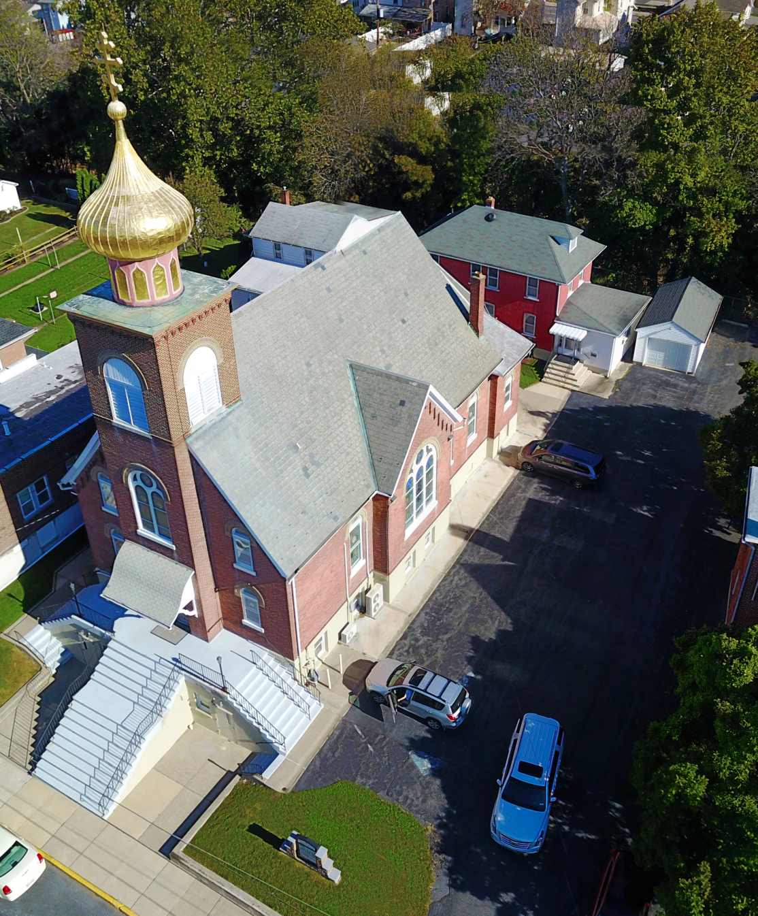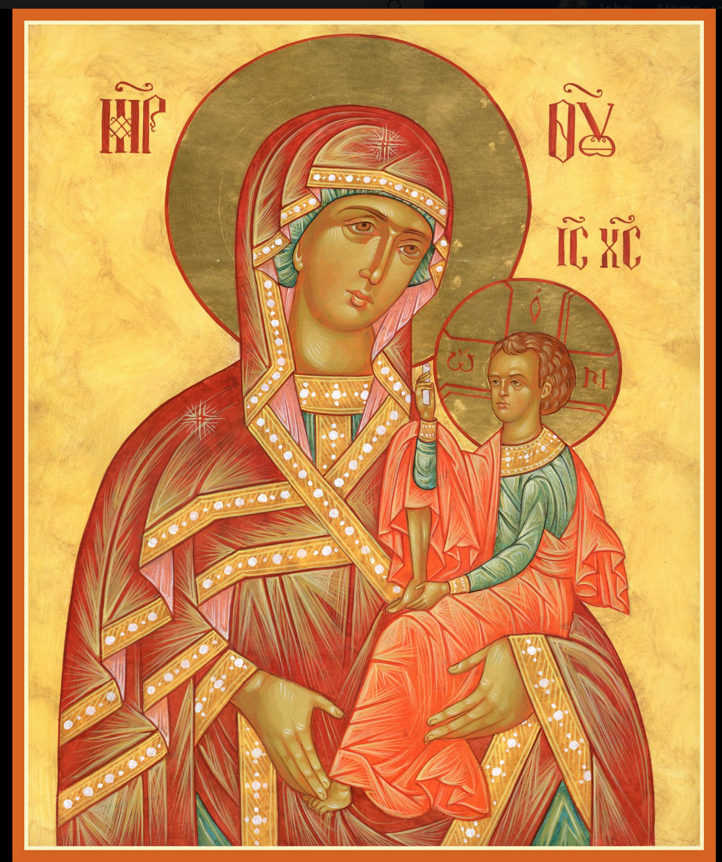

ASSUMPTION OF THE VIRGIN MARY
UKRAINIAN ORTHODOX CHURCH
ECUMENICAL PATRIARCHATE OF CONSTANTINOPLE AND NEW ROME
1301 Newport Avenue
Northampton, Pennsylvania 18067
Mitered Archpriest Myron Oryhon
Protodeacon Mychail Sawarynski, Attached

Telephones: Church Office… (610) 262-2882
Church Fax/Kitchen/Hall… (610) 262-0552
Fr. Myron Oryhon – (607) 752-1999
Protodeacon Mychail’s Residence… (610) 262-3876
Websites: holyassumption.org
ukrainianorthodoxchurchusa.org
lvorthodox.wordpress.com
E-mail: Parish… avmuoc@gmail.com
Protodeacon Mychail…pravoslavni@rcn.com
Webmaster, John Hnatow… john.hnatow@gmail.com
==============================================================
05th May (22nd April) 2019
ANTIPASCHA. 2ND SUNDAY OF PASCHA of ST. THOMAS. THEODORE the Skyeote, Bishop of Anastasiopolis (613). Apostles NATHANIEL, LUKE and CLEMENT. St. VITALIS of Abba Serid Monastery at Gaza (620).
Acts 5: 12-20 John 20: 19-31
Today’s Bulletin, sponsored in loving memory of Brother, + CHARLES SIVAK, is offered by Juanita (Sivak) Vitushinsky
PROPERS FOR LITURGY OF ST. JOHN CHRYSOSTOM

Tropar, Tone 7: Christ our Life, You rose from the tomb after it had been sealed. While the doors remained closed, You stood among Your disciples renewing a righteous spirit in them. Our God, the Resurrection of all, You are most merciful.

Glory to the Father and to the Son and to the Holy Spirit, now and ever and to the ages of ages. Amen.

Kondak, Tone 8: Christ God, Thomas explored Your Life-Giving side with an inquisitive hand. Since You had entered the room while the doors were locked, he cried out with the other Apostles: “You are my Lord and my God.”

Prokimen in Tone 3,
Great is our God and great is His Power. His understanding is beyond measure.

Verse: Praise the Lord, for a Psalm is good; Let our praise to God be sweet.

Alleluia Verses, Tone 8,
Come let us rejoice in the Lord, Let us make a joyful noise to God our Savior.

For the Lord is a great God and a great King over all the earth.

In place of “It is right in truth…”
The angel cried to the Lady, Full of Grace; Rejoice, Pure Virgin. Again I say: Rejoice, Your Son is risen from His three days in the tomb. With Himself He has raised up all the dead: Rejoice, all peoples.
Irmos: Shine, Shine, O New Jerusalem, for the Glory of the Lord has shone on you. Exult now and be glad, O Zion, and rejoice: Pure Birth-Giver of God in the Resurrection of Your Son.

Communion Hymn:
Praise the Lord, Jerusalem, praise your God, Zion. Alleluia (3X)

In place of “We have seen the true light…”
Christ is risen from the dead, trampling down death by death, and upon those in the tombs bestowing life. (slowly 1X)

At the end of Liturgy the priest intones “Glory to You, O Christ…”
Paschal Tropar: Christ is risen… (3X) and Paschal Dismissal.

LITURGICAL MENEION & SCRIPTURE READINGS
FOR SECOND WEEK OF PASCHA

Sun. 05 May GENERAL PANIKHIDA at Parish Cemetery and
BLESSING OF GRAVES at 11:30 AM TODAY.

Mon. 06 May Glorious Great-martyr and Wonderworker GEORGE (303).
Acts 3: 19-26 John 2: 1-11

Tue. 07 May Martyr SABBAS STRATELATES (“The General” of Rome and 70 soldiers with him (272).
Acts 4: 1-10 John 3: 16-21

Wed. 08 May Holy Apostle and Evangelist MARK (63).
Fast Day: Acts 4: 13-22 John 5: 17-24
Fish

Thur. 09 May Hieromartyr BASIL, Bishop of Amasea (322). Righteous Virgin GLAPHYRA of Nicomedia (322).
Acts 4: 23-31 John 5: 24-30

Fri. 10 May Holy Apostle & Hieromartyr SYMEON, the
Fast Day: Kinsman of the Lord (107) EULOGIUS the
Fish Hospitable.
Ven STEPHEN, Bishop of Volodymyr in Volyna.
Acts 5: 1-11 John 5:30-6:2

Sat. 11 May Apostles JASON & SOSIPATER of the 70 & their
Companions. CYRIL, Bishop of Turiv (1183).
Acts 5: 21-33 John 6: 14-27

5:00 PM GREAT VESPERS OF MYRRH-BEARERS

Sun. 12 May 3rd SUNDAY OF PASCHA; MYRRH-BEARING
WOMEN, Righteous JOSEPH of Arimathea and
NICODEMUS. MOTHER’S DAY in the USA

8:30 AM THIRD & SIXTH HOURS
9:00 AM LITURGY OF ST. JOHN CHRYSOSTOM

NECROLOGY:
05 May… Frank Micio ’57, Xenia Klodnycky ’83, Leroy Drobick ’86, Stella Antolick ‘15
06 May… Taras Luka Yaremchuk (infant) ‘43
08 May… Anastasia Schur ‘68
09 May… Anastasia Machibroda ’35,
10 May… Michael Meashock ‘78
11 May… John Siglecki (6 yrs. old) ’22, Helen Gontar ‘87

VICHNAYA PAMYAT! MEMORY ETERNAL
BIRTHDAYS:
06 May… Stephen Unger
09 May… Taras Pypiuk, Matthew Vitushinsky

MNOHAYA LITA! MANY YEARS!

WE PRAY FOR THE HEALTH AND WELL-BEING of the ill afflicted: William Savitz, Catherine Kochenash, Fr. Vasyl Dovgan, Vladimir & Emma Krasnopera, Tessie Kuchinos, Brendan Phillips, Jessie Hnatow, Jessica Meashock, Wasyl Hewko, Adam Hewko, Betty Hendrickson, Andrew Thaxton, Michelle Pierzga, Susan Ferretti, Carole Zarayko, William Fischer, Ekaterina Seremula, Marianna Goshow, child born to Ariel Weiller, Judy Albright,

OCMC “AGAPE CANISTER” DONATIONS were $82.00. What a great effort. Thank you for your support of our Missions around the globe.

RELIGIOUS INSTRUCTION CLASS FOR PARISH CHILDREN:
Mrs. Mary Ost – Sundays 9:00-9:30
Mrs. Linda Winters- May 5 – 11 AM; May 12 – 9 AM; May 19 – no class; May 26 – no class; June 2 – 11 AM; June 9 – 9 AM
Ms. Bettyann Woyewoda – Sundays at 8:40-9:15; May 5, 12, 19. 26

NEXT PIEROHI SALE WILL BE MAY 9th . Order by May 5th.
Call Helen 610-261-4575 or 484-239-5731. Additional dates are:
May 16 & 23.

SR UOL MEETING TODAY following the Coffee Hour.

NORTHAMPTON FOODBANK is still in need of foodstuffs, especially tuna, canned potatoes and baby food.

Continue to collect receipts from “REDNER’S SAVE A TAPE PROGRAM”. Deposit them in the box in the Vestibule. This quarter brought in a total of $158.84. Thanks for supporting this project.
And our thanks to Helen Crayosky for chairing this fund-raiser.

We continue to greet fellow Christians for the next 30 days with the Paschal Greeting “CHRIST IS RISEN!”, “Truly, He is Risen!”; “CHRISTOS VOSKRES!”; “Voistinu Voskrese!”; “KRISTOS ANESTI!”; “Alithos Anesti!”; “EL MESSIEH KAHM!”; “Hakken kahm”; “HRISTOS A INVIAT”; “Adevarat a inviat!”. Until the eve of Ascension, June 6th. Pentecost is June 16th.

ANTIPASCHA: ST. THOMAS SUNDAY
The icon for today is called “The Touching of Thomas” or “The Belief of Thomas.” After he touched the Life-Giving side of the Lord, he no longer had any doubts. This day is also known as “Antipascha” or in place of Pascha. Beginning today, the 8th day of Paschal celebration the Church dedicates every Sunday of the year to the Lord’s Resurrection. On this day in the early Church, newly-baptized Christians removed their robes and entered into the life of the world again. We have not seen Christ physically, nor touched His risen body, yet in the Holy Spirit, we have seen ad touched and tasted the Word of Life. “Blessed are those who have not seen and yet believe”. (John 20).

NEWS FROM THE ORTHODOX WORLD
The Orthodox communities of Colombia have been thirsting for a deeper understanding of the Orthodox Faith. OCMC has been invited by a local priest, Fr. Rafael Padillo to visit 3 parishes in the cities of Ceret , Cartegena de Indias and Manaura in July. Mission team members will offer catechism classes to people of all ages. Metropolitan Athenagoras of Mexico established the first mission in 2006 which has grown to 15,000 Orthodox Christians.

