JUNE 02, 2019

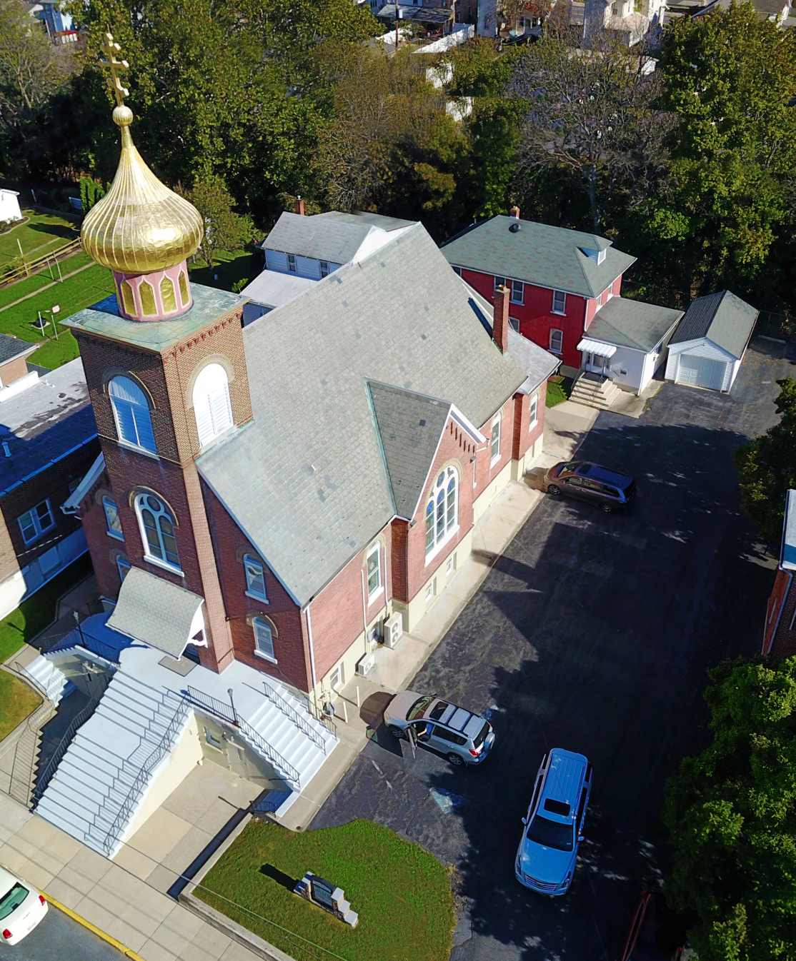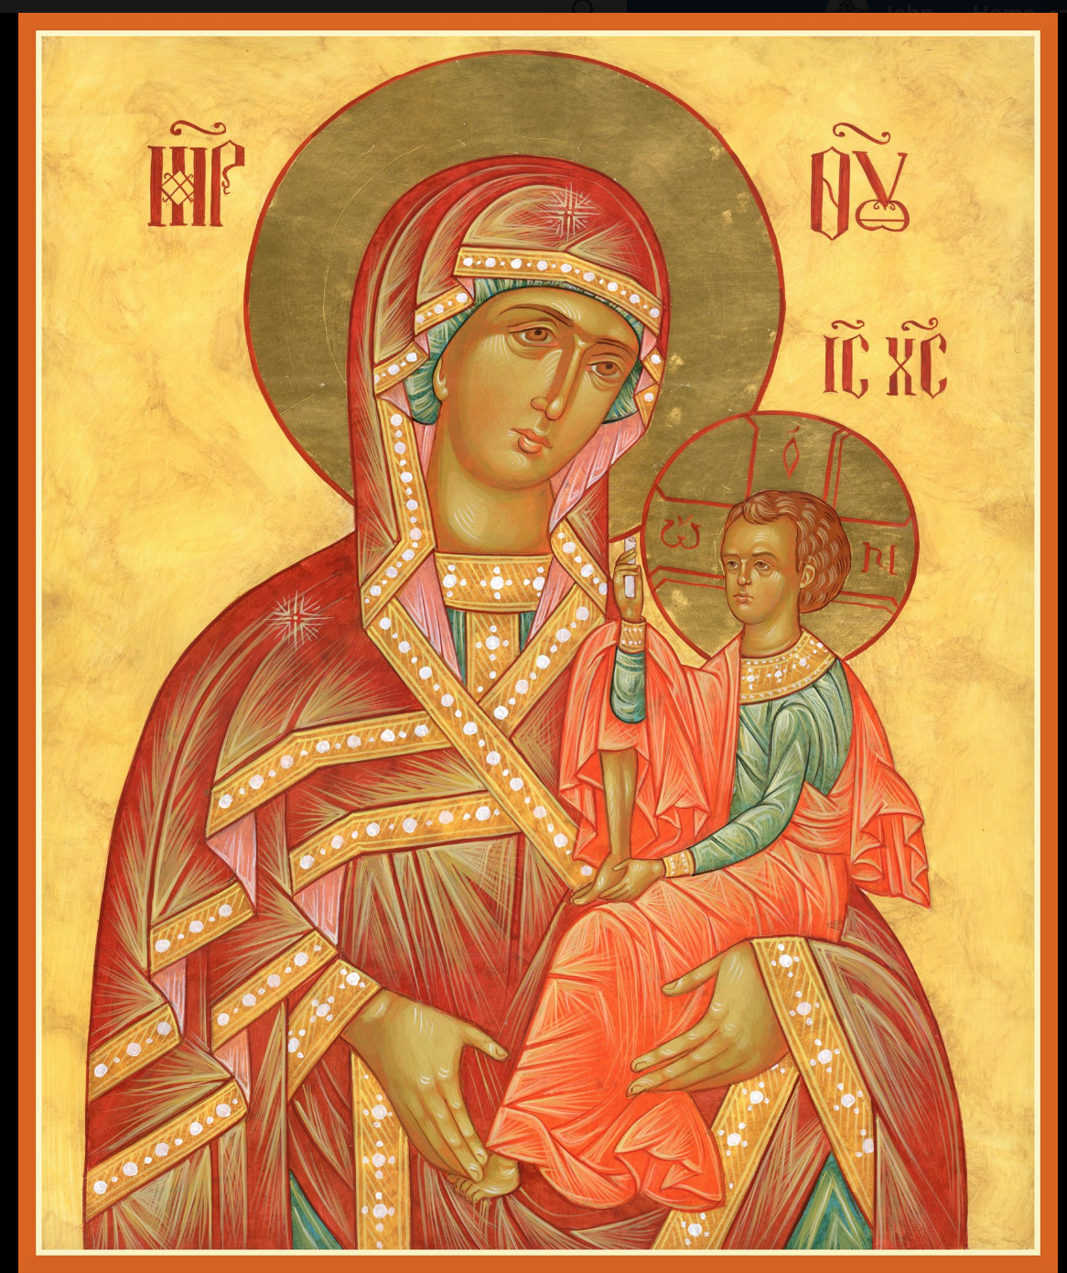

ASSUMPTION OF THE VIRGIN MARY
UKRAINIAN ORTHODOX CHURCH
ECUMENICAL PATRIARCHATE OF CONSTANTINOPLE AND NEW ROME
1301 Newport Avenue
Northampton, Pennsylvania 18067
Mitered Archpriest Myron Oryhon
Protodeacon Mychail Sawarynski, Attached
Deacon Oleh Kravchenko, Attached
Telephones: Church Office… (610) 262-2882
Church Fax/Kitchen/Hall… (610) 262-0552
Fr. Myron Oryhon – (607) 752-1999
Protodeacon Mychail’s Residence… (610) 262-3876
Websites: holyassumption.org
ukrainianorthodoxchurchusa.org
lvorthodox.wordpress.com
E-mail: Parish… avmuoc@gmail.com
Protodeacon Mychail…pravoslavni@rcn.com
Webmaster, John Hnatow… john.hnatow@gmail.com
==============================================================
02nd June (20th May) 2019

6th SUNDAY OF PASCHA of the BLIND MAN. Tone 5. Martyr
THALELAEUS & companions. Martyrs ALEXANDER &
ASTERIUS (284). Martyr ASCLAS of Egypt (287)
Acts 16: 16-34 John 9: 1-38

PROPERS FOR LITURGY OF ST. JOHN CHRYSOSTOM

Tropar, Tone 5
Let us, the faithful, praise and worship the Word, without beginning like the Father and the Spirit, born for our salvation of the Virgin. He willed to be lifted p on the Cross in the flesh to endure death and to raise the dead, by His glorious Resurrection.

Glory to the Father and to the Son and to the Holy Spirit.

Kondak of the Blind Man, Tone 4
I came to You, my Christ, blind from birth in my spiritual eyes and call to You in repentance; You are the most radiant light for those in darkness.

Now and ever and unto ages of ages. Amen.

Paschal Kondak, Tone 8
You descended into the tomb, Immortal One and destroyed the power of Death. In victory you arose, Christ God. Proclaiming “Rejoice!” to the Myrrh-bearing women, you granted peace to Your apostles and bestowed resurrection on the fallen.

Prokimen in Tone 8,
Pray and make your vows before the Lord our God.

Verse: In Judah God is known. His Name is great in Israel.

Alleluia Verses, Tone 8,
Look upon me and have mercy on me.

Lead my steps according to Your word.

In place of “It is right in truth…”
The angel cried to the Lady, Full of Grace; Rejoice, Pure Virgin. Again I say: Rejoice, Your Son is risen from His three days in the tomb. With Himself He has raised up all the dead: Rejoice, all peoples.
Irmos: Shine, Shine, O New Jerusalem, for the Glory of the Lord has shone on you. Exult now and be glad, O Zion, and rejoice: Pure Birth-Giver of God in the Resurrection of Your Son.

Communion Hymn:
Receive the Body of Christ, taste the Fountain of Immortality.

Praise the Lord from the heavens, praise Him in the highest. (Alleluia 3X)

In place of “We have seen the true light…”
Christ is risen from the dead, trampling down death by death, and upon those in the tombs bestowing life. (slowly 1X)

At the end of Liturgy: Christ is risen… (3X) and Paschal Dismissal.

LITURGICAL MENEION & SCRIPTURE READINGS
FOR THE SIXTH WEEK OF PASCHA

Mon. 03 June Ss. CONSTANTINE & HELEN(4th C.) CASSIAN
the Greek monk (1504).
Acts 17: 1-15 John 11: 47-57

Tue. 04 June Hieromartyr BASILISCUS, Bishop of Comana
(308) Second Ecumenical Council (381)
Acts 17:19-28 John 12: 19-36

Wed. 05 June LEAVE TAKING OF THE PASCHAL SEASON.
Fast Day: Ven. MICHAEL the Confessor, Bishop of Synnada
Fish (821) Ven. EUPHROSYNE, Princess of Polotsk.
Acts 28: 22-28 John 12: 36-47

Thur. 06 June ASCENSION OF OUR LORD. Ven. SYMEON
STYLITES of the Wonderful Mountain (596)
Acts 1: 1-12 Luke 24: 36-53
9:00 AM DIVINE LITURGY in our church

Fri. 07 June Third Finding of the Head of JOHN THE BAPTIST
Fast Day: (850) Hieromartyr THERAPON, Bishop of Cyprus.
Fish Acts 19: 1-8 John 14: 1-11

Sat. 08 June Apostles CARPUS of the 70 and ALPHAEUS (1st C.)
Martyrs ABERCIUS & HELEN (1st C.)
Acts 20: 7-12 John 14: 10-21

5:00 PM GREAT VESPERS OF THE HOLY FATHERS

Sun. 09 June 7th SUNDAY OF PASCHA; HOLY FATHERS of the 1st ECUMENICAL COUNCIL IN NICEA. Tone 6.
8:30 AM THIRD & SIXTH HOURS
9:00 AM LITURGY OF ST. JOHN CHRYSOSTOM

NECROLOGY:
04 June… Peter Kochenash ‘90
05 June… Stephen Kudrick ‘30
06 June… Julia Oleksa ’31, Pauline Bluder ‘81
07 June… Michael Yurechko ‘97
08 June… Anna Bodnyk ’70, Russell Krasnopera ‘83

VICHNAYA PAMYAT! MEMORY ETERNAL

BIRTHDAYS:
04 June… Anthony Mauser
05 June… Linda Tilson
06 June… Anne Carlantone
08 June… Nicholas Vitushinsky

ANNIVERSARIES:
04 June… John & Michelle Pozzetta
06 June… Nicholas & Danielle Vitushinsky

MNOHAYA LITA! MANY YEARS!

The Parish is deeply indebted to Walter, Melanie, Steve, Helen, Reader Maximos, Paul and to all the PYROHONA workers who selflessly give their time and labor for the well being of this parish.
GOD GRANT YOU ALL MANY, BLESSED YEARS!

WE PRAY FOR THE HEALTH AND WELL-BEING of the ill afflicted: William Savitz, Catherine Kochenash, Fr. Vasyl Dovgan, Vladimir & Emma Krasnopera, Tessie Kuchinos, Brendan Phillips, Jessie Hnatow, Jessica Meashock, Wasyl Hewko, Adam Hewko, Betty Hendrickson, Andrew Thaxton, Michelle Pierzga, Susan Ferretti, Carole Zarayko, William Fischer, Ekaterina Seremula, Marianna Goshow, Judy Albright,

SISTERHOOD MEETING TODAY, JUNE 2 AFTER COFFEE HR.

Melanie Unger will be accepting donations for the patron page of the UOL Convention Book. Patrons are $3.00. Please see Melanie.

OCMC “AGAPE CANISTER” DONATIONS were $.00.
Thank you for your support of our Missions around the globe.

RELIGIOUS INSTRUCTION CLASS FOR PARISH CHILDREN:
Mrs. Mary Ost – Sundays 9:00-9:30
Mrs. Linda Winters- June 2-11 AM; June 9-9 AM
Ms. Bettyann Woyewoda – Sundays at 8:40-9:15; June 2, 9

NORTHAMPTON FOODBANK is still in need of foodstuffs, especially tuna, canned potatoes and baby food.

VOLUNTEERS for SUMMER COFFEE HOUR are needed Sign-up sheet in Hall. Coffee will be prepared. You supply the baked goods.

Please continue to save your REDNER’S TAPES using the “Reward’s Card.”

