r JUNE 16, 2019

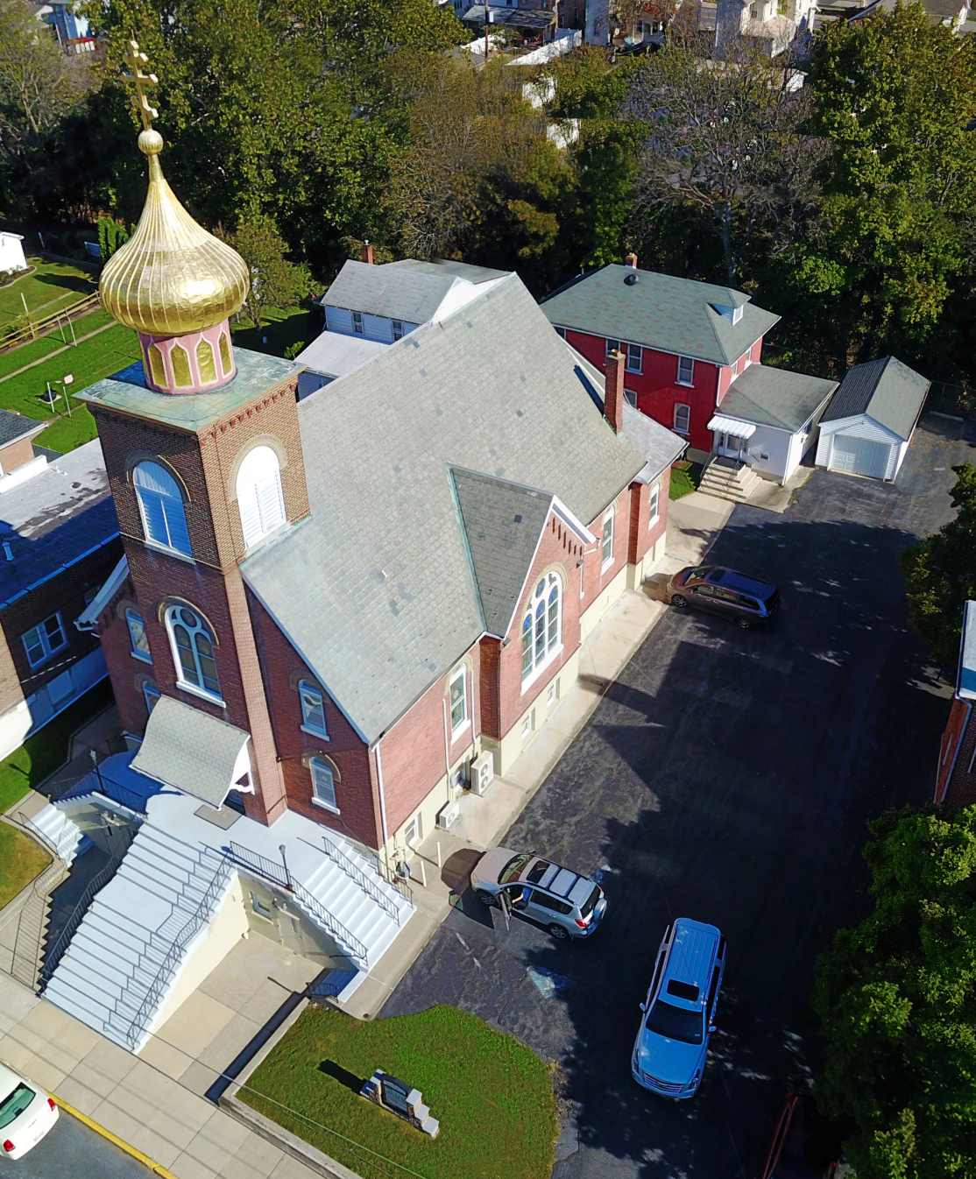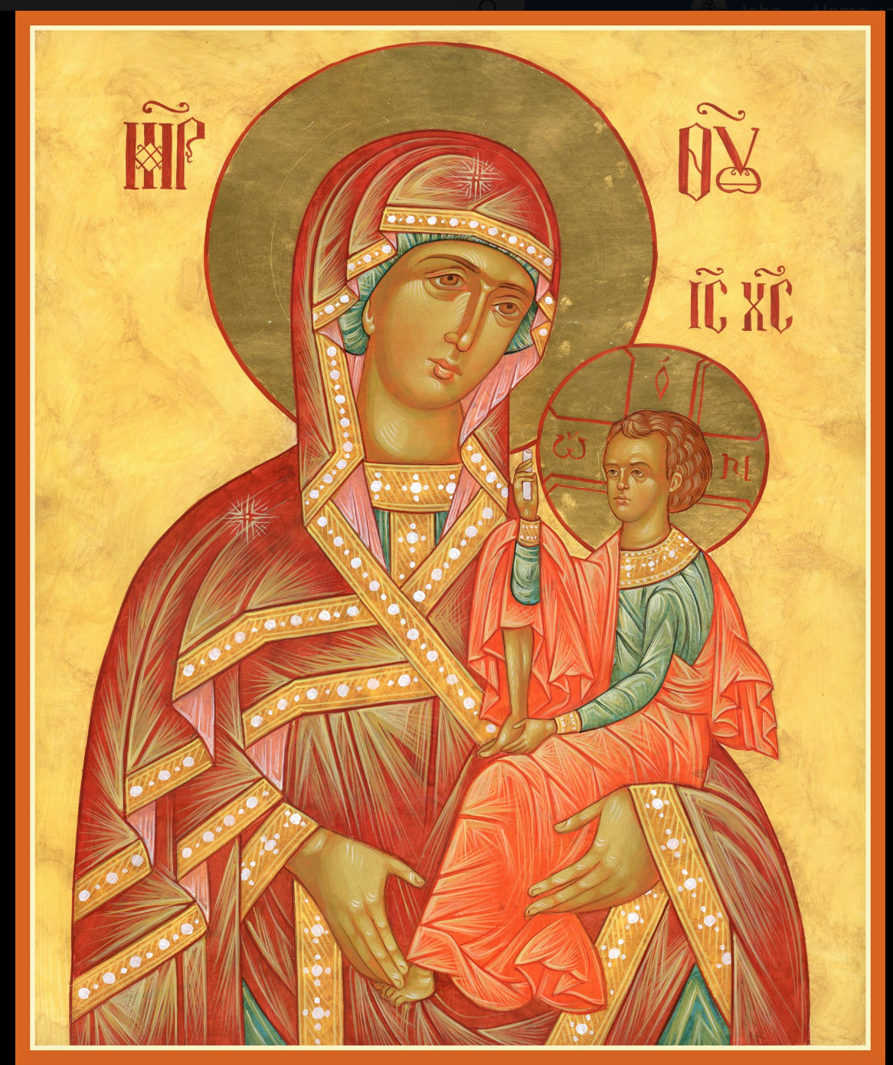

ASSUMPTION OF THE VIRGIN MARY
UKRAINIAN ORTHODOX CHURCH
ECUMENICAL PATRIARCHATE OF CONSTANTINOPLE AND NEW ROME
1301 Newport Avenue
Northampton, Pennsylvania 18067
Mitered Archpriest Myron Oryhon
Protodeacon Mychail Sawarynski, Attached
Deacon Oleh Kravchenko, Attached
Telephones: Church Office… (610) 262-2882
Church Fax/Kitchen/Hall… (610) 262-0552
Fr. Myron Oryhon – (607) 752-1999
Protodeacon Mychail’s Residence… (610) 262-3876
Websites: holyassumption.org
ukrainianorthodoxchurchusa.org
lvorthodox.wordpress.com
E-mail: Parish… avmuoc@gmail.com
Protodeacon Mychail…pravoslavni@rcn.com
Webmaster, John Hnatow… john.hnatow@gmail.com
==============================================================
16th June (3rd June) 2019

HOLY PENTECOST – TRINITY SUNDAY. Martyrs LUCILLIAN, CLAUDIUS, HYPATIUS, PAUL & DIONYSIUS. Virgin PAULA.
Acts 2: 1-11 John 7: 37-52, 8:12
Today’s Bulletin, sponsored in loving memory of +PROTOPRESBYTER STEPHEN HANKAVICH (1997) is being offered by Reader Maximos Meashock. MEMORY ETERNAL!
CHRIST IS AMONG US! HE IS AND ALWAYS SHALL BE!
PROPERS FOR HOLY PENTECOST
Entrance Hymn
Lord, be exalted in Your strength; we will sing and praise Your power.

Tropar of Holy Pentecost, Tone 8
Blessed are You, Christ God, Who has revealed the fishermen to be most wise by sending upon them the Holy Spirit and thereby catching the universe in Your net. Christ God, Who loves mankind, glory to You.

Glory to the Father and to the Son and to the Holy Spirit now and ever and unto ages of ages. Amen.

Kondak of Holy Pentecost, Tone 8
When the Most High descended and confused tongues, he scattered the nations. But when He distributed the tongues of fire, He called all to unity. Therefore, with one accord, we glorify the All Holy Spirit.

“In place of the Thrice Holy Hymn”
As many as have been baptized into Christ, have put on Christ. Alleluia.

Prokimen of Holy Pentecost, Tone 4
Their voice has gone out into all the earth and their words to the very ends of the world.

Verse: The heavens declare the glory of God and creation proclaims the work of His Hands.

Alleluia Verses, Tone 4
By the word of the Lord were the heavens established and all their hosts by the Spirit of His mouth.

The Lord looked down from Heaven. He beheld all human children.

In place of “It is right in truth…”
Magnify, my soul, the Holy Spirit, who proceeds from the Father.

Irmos, Tone 5: Rejoice, Queen, glory of motherhood and maiden-hood. Every mouth, however eloquent and sweet of speech, is incapable of worthily chanting praise and every mind is amazed when it tries to understand Your birth-giving of Christ. For this reason, with one accord, we magnify you.

LITURGICAL MENEION & SCRIPTURE READINGS
FOR THE FIRST WEEK AFTER PENTECOST

FAST FREE WEEK

Mon. 17 June DAY OF THE HOLY SPIRIT. METROPHANES,
First Patriarch of Constantinople (325).
Ephesians 5: 8-19 Matthew 18:10-20

Tue. 18 June Hieromartyr DOROTHEOS, Bishop of Tyre (362).
Translation of the relics of the Blessed Prince IHOR,
Of Chernihiv & Kyiv. CONSTANTINE of Kyiv.
Romans 1:1-7, 13-17 Matthew 4:25-5-13

Wed. 19 June Ven. BESSARION the Wonderworker of Egypt.
Ven. HILARION, abbot of the Damatian Monastery.
Romans 1:18-27 Matthew 5:20-26

Thur. 20 June Martyr THEODOTUS of Ancyra (303). Martyrs
CYRIACA, CALERIA, & MARY of Caesarea (305).
Hieromartyr MARCELLINUS, Pope of Rome (304).
Romans 1:28-2:9 Matthew 5:27-32

Fri. 21 June Great Martyr THEODORE STRATELATES (319).
EPHRAIM, Patriarch of Antioch (545). ZOSIMUS
the Monk of Phoenicia. THEODORE, Bishop of
Suzdal (1023). Finding the relics of Ss. BASIL & CONSTANTINE Princes of Yaroslavl (1249).
Romans 2:14-29 Matthew 5:33-41

Sat. 22 June Leave-taking of Pentecost. CYRIL, Archbishop of
Alexandria. Five nuns beheaded in Persia: TEKLA, MARIAMNE, MARTHA, MARY, & ENMATHA (346).
Romans 1:7-12 Matthew 5:42-48

5:00 PM GREAT VESPERS of ALL SAINTS.

Sun. 23 June 1st Sunday after Pentecost. ALL SAINTS. Tone 8

8:30 AM THIRD & SIXTH HOURS
9:00 AM DIVINE LITURGY of JOHN CHRYSOSTOM

NECROLOGY:
19 June… Stanley Takarzk ‘81
20 June… Anna Krasnopera ’84, Protopresbyter
Stephen Ninkovich ‘97
21 June… John Bodnyk ‘80
22 June… Maria Rud ‘83

VICHNAYA PAMYAT! MEMORY ETERNAL

BIRTHDAYS:
18 June… Christina Truss, Michelle Pozzetta
19 June… Nicholas Truss
20 June… Bettyann Woyewoda
22 June… David Misko

ANNIVERSARIES:
17 June… Nicholas & Irene Alexander
21 June… Deacon Michael & Pani Martha Sawarynski

MNOHAYA LITA! MANY YEARS!

TODAY, WE PRAY FOR ALL THE FATHER’S OF THE PARISH; MNOHAYA LITA! AND MEMORY ETERNAL TO ALL OF OUR FATHERS WHO HAVE DEPARTED THIS LIFE AND GONE ON TO THEIR FINAL REWARD IN THE HOPE OF THE RESURRECTION AND LIFE EVER-LASTING.

WE PRAY FOR THE HEALTH AND WELL-BEING of the ill afflicted: Pani Ol’ha Kravchenko and the child she is bearing, William Savitz, Catherine Kochenash, Fr. Vasyl Dovgan, Vladimir & Emma Krasnopera, Tessie Kuchinos, Brendan Phillips, Jessie Hnatow, Jessica Meashock, Wasyl Hewko, Adam Hewko, Betty Hendrickson, Andrew Thaxton, Michelle Pierzga, Susan Ferretti, Carole Zarayko, William Fischer, Ekaterina Seremula, Marianna Goshow, Judy Albright.

SAVE THE DATE: ANNUAL CHURCH PICNIC will held at Canal St. Park with a “PIG ROAST” catered by Fr. James Cairns on SATURDAY, SEPTEMBER 28th from 12 noon to 7 PM. Outdoor Vespers will be served beginning at 5 PM at the park.

OCMC “AGAPE CANISTER” DONATIONS were $13.00.
Thank you for your support of our Missions around the globe.

NORTHAMPTON FOODBANK is still in need of foodstuffs, especially tuna, canned potatoes and baby food.

VOLUNTEERS for SUMMER COFFEE HOUR are needed Sign-up sheet in Hall. Coffee will be prepared. You supply the baked goods.

Please continue to save Redner’s tapes; use your Reward’s Card.”

MANY THANKS to the SR UOL and its workers who prepared last Sunday’s delicious brunch. $200 was raised and will be sent to the METROPOLITAN JOHN SCHOLARSHIP FUND.

OCMC NEWS

The Board of Directors of the Orthodox Mission Center in St. Augustine, Florida met at the Mission Center for its spring meeting, May 20-22 on the Feast of Ss. Constantine and Helena and the 10th anniversary of the dedication of the Missionary Training and Administration Building. Executive Director Fr. Martin Ritsi presented the current special projects underway. These included:
Building missionary housing in Guatemala.
Building churches in Uganda and Indonesia.
Assisting orphanages in Albania, Kenya, Guatemala, India,
Madagascar and Mexico.
Assisting with education in Ghana and Kenya.
Supporting the dioceses of Albania, Ghana, Hong Kong,
Jerusalem, Kenya, South Korea, Madagascar & Sweden.
Supporting seminaries in Alaska & Kenya.
Drilling wells in Kenya & Uganda.
Sponsoring a memorial fund for Bishop Athanasius of Kenya.

Fr. Martin also noted future efforts being considered in conjunction with long-term missionaries and short-term teams. Missionary Director James Nicholas briefed the board on long-term missionary training. Thomas and Elizabeth Manuel, two OCMC missionaries, currently studying Spanish in Mexico are preparing to serve in Guatemala. They shared their experiences in the life of field service.

