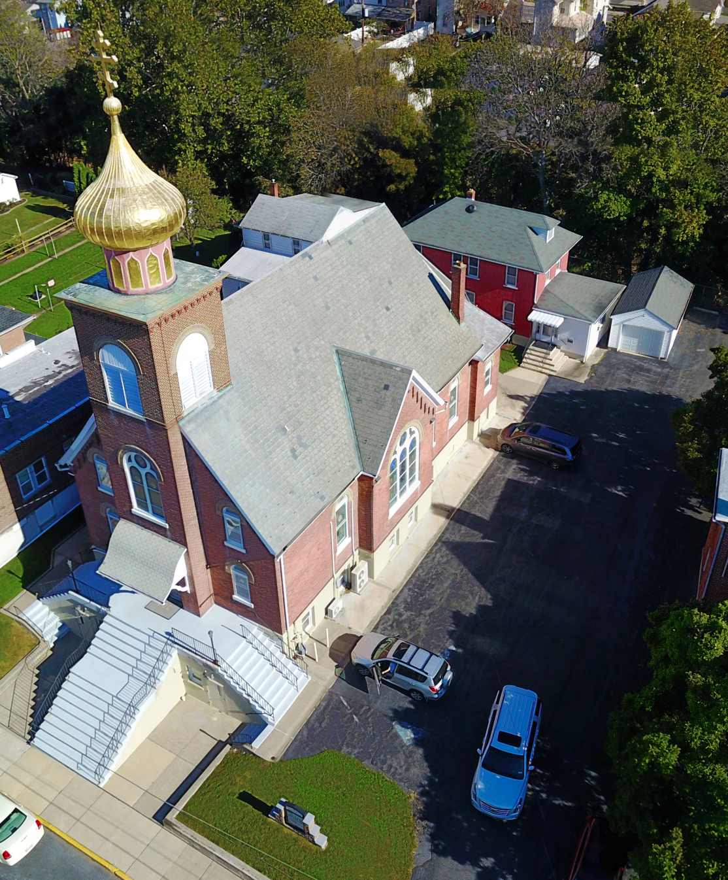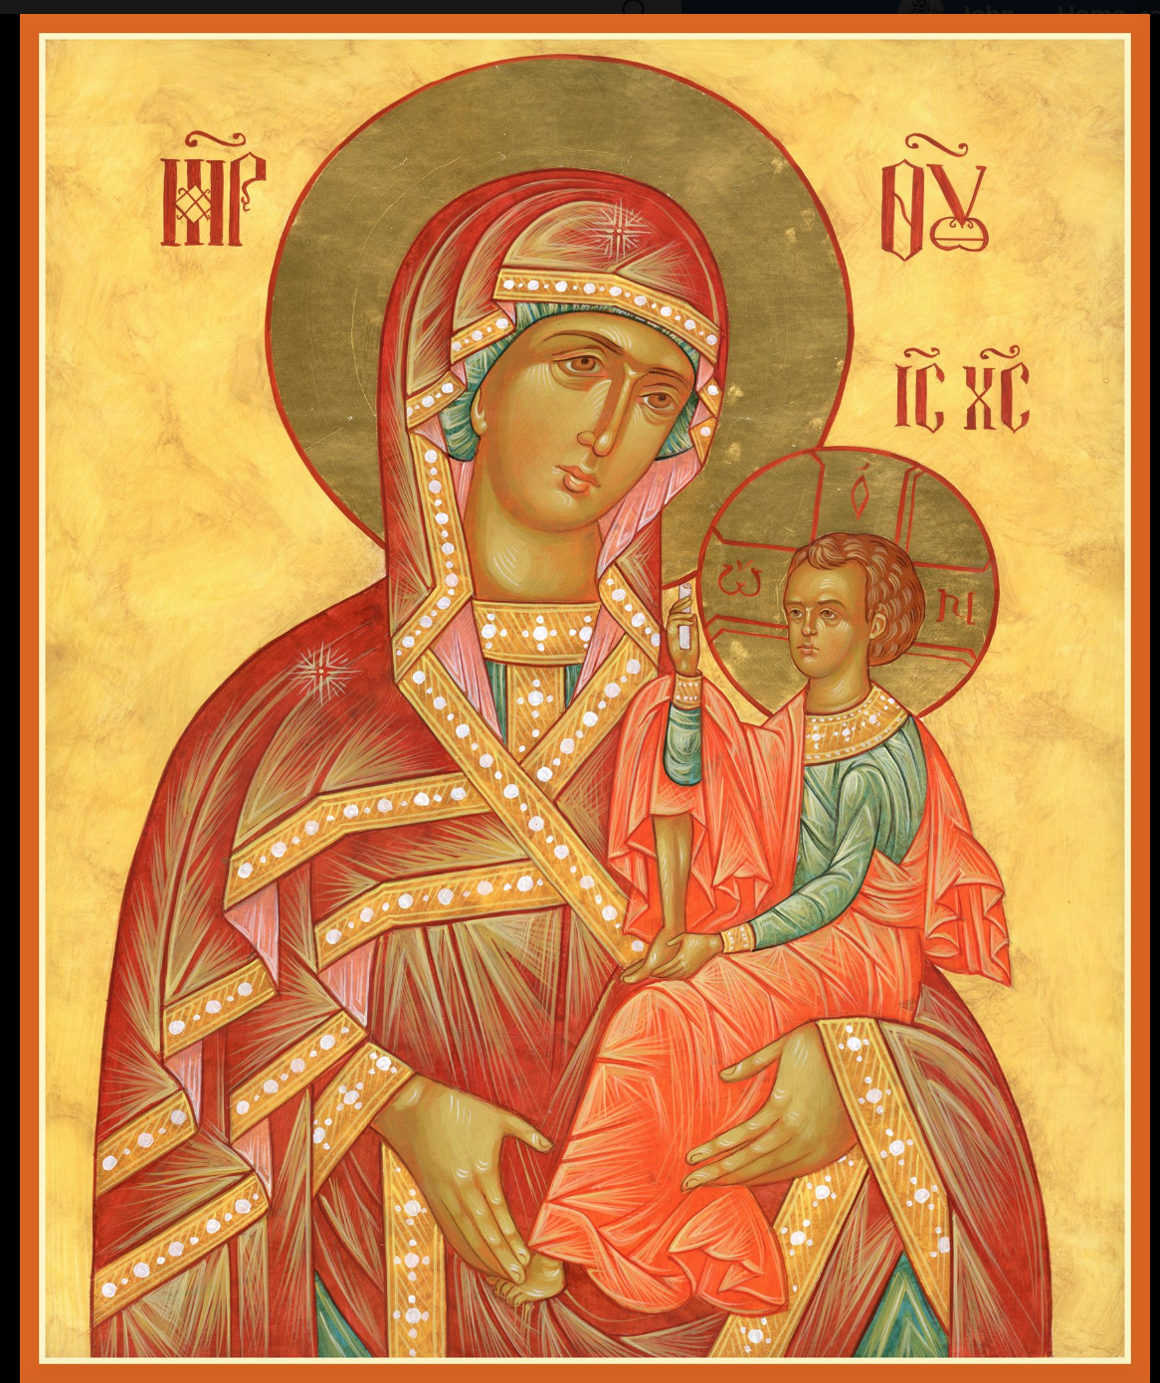

ASSUMPTION OF THE VIRGIN MARY
UKRAINIAN ORTHODOX CHURCH
ECUMENICAL PATRIARCHATE OF CONSTANTINOPLE AND NEW ROME
1301 Newport Avenue
Northampton, Pennsylvania 18067
Mitered Archpriest Myron Oryhon
Protodeacon Mychail Sawarynski, Attached
Deacon Oleh Kravchenko, Attached
Telephones: Church Office… (610) 262-2882
Church Fax/Kitchen/Hall… (610) 262-0552
Fr. Myron Oryhon – (607) 752-1999
Protodeacon Mychail’s Residence… (610) 262-3876
Websites: holyassumption.org
ukrainianorthodoxchurchusa.org
lvorthodox.wordpress.com
E-mail: Parish… avmuoc@gmail.com
Protodeacon Mychail…pravoslavni@rcn.com
Webmaster, John Hnatow… john.hnatow@gmail.com
==============================================================
23rd June (10th June) 2019

1st Sunday after Pentecost. Tone 8. ALL SAINTS. Hieromartyr TIMOTHY, Bishop of Prusa (362). Martyr ALEXANDER & Virgin Martyr ANTONINA of Constantinople (313). Monk THEOPHANES of Antioch (369). BASSIAN, Bishop of Lodi, Lombardy (409).
Hebrews 11:33-12:2 Matthew 10:32-33, 37-38-19:27-30

CHRIST IS AMONG US! HE IS AND ALWAYS SHALL BE!
PROPERS FOR LITURGY OF ST. JOHN CHRYSOSTOM

Tropar of the Resurrection, Tone 8
You descended from on high, Merciful One. You accepted the three-day burial to deliver us from our passions. Lord, Our Life and Resurrection: Glory to You.

Tropar for All Saints, Tone 4
As with fine cloth and royal purple, Your Church has been adorned with the blood of the martyrs shed throughout the world. Christ God, She cries out to You: Send Your Goodness to Your people; grant peace to Your world and great mercy to our souls.

Glory to the Father and to the Son and to the Holy Spirit.

Kondak of the Resurrection, Tone 8
By rising from the tomb, You raised up the dead. Adam is risen and Eve exults in Your Resurrection. The entire world celebrates Your rising from the dead, Greatly Merciful One.

Now and ever and unto ages of ages. Amen.

Kondak for All Saints, Tone 8
Lord and Creator, the universe offers You the God-bearing martyrs as the First Fruits of all Creation. By their prayers, Most Merciful One through the Birth-Giver of God establish Your Church in deep peace.

Prokimen of the Resurrection, Tone 8
Pray and make your vows before the Lord our God.

Verse: In Judah God is known; His Name is great in Israel.

Prokimen for All Saints, Tone 4
God is wonderful in His saints, the God of Israel.

Alleluia Verses in Tone 4
The righteous cried and the Lord heard them and delivered them out of their afflictions.

Many are the afflictions of the righteous, but out of them the Lord will deliver them.

Communion Hymn:
Praise the Lord from the heavens, praise Him in the Highest.

Rejoice in the Lord, you righteous, praise befits the upright.
Alleluia (3X)

LITURGICAL MENEION & SCRIPTURE READINGS
FOR THE SECOND WEEK AFTER PENTECOST

BEGINNING OF THE APOSTOLIC FAST

Mon. 24 June HOLY APOSTLES BARTHOLOMEW &
FAST DAY: BARNABAS (1st C.)
FISH Romans 2:28-3:18 Matthew 6:31-34-7:9-11

Tue. 25 June Ven. ONUPHRIUS the Great (400). Ven. PETER
FAST DAY: of Mt. Athos (734)
OIL Romans 4:4-12 Matthew 7:15-21

Wed. 26 June Martyr AQUILINA of Byblos (293) Bishop
FAST DAY: TRIPHYLLIUS of Leucosia, Cyprus (370)
NO OIL Romans 4:13-25 Matthew 7:21-21

Thur. 27 June PROPHET ELISHA (10th C. BC) METHODIUS,
FAST DAY: Patriarch of Constantinople (847).
OIL Romans 5:10-16 Matthew 8:23-27

Fri. 28 June PROPHET AMOS (8th C. BC) Martyrs VITUS,
FAST DAY: MODESTUS & LUCANIA. MICHAEL of Kyiv.
OIL Romans 5:17-6:2 Matthew 9:14-17

Sat. 29 June TYCHON, Bishop of Amathus, Cyprus (425)
FAST DAY: Martyrs TIGRIUS & EUTROPIUS (404)
FISH Romans 3:19-26 Matthew 7:1-8

5:00 PM GREAT VESPERS of ALL SAINTS OF UKRAINE.

Sun. 30 June 2nd Sunday after Pentecost. ALL SAINTS OF UKRAINE. Tone 1

8:30 AM THIRD & SIXTH HOURS
9:00 AM DIVINE LITURGY of JOHN CHRYSOSTOM

NECROLOGY:
23 June… Mary Strychar ‘29
24 June… Philip Krasnopera ’63, Michael Onuschak ‘80
25 June… Katherine Kotoris ’70, Joseph Antolick ‘02
29 June… Peter Plaska ‘57

VICHNAYA PAMYAT! MEMORY ETERNAL

BIRTHDAYS:
23 June… Andrew Grason, James Osmun
24 June… Patty Parchomenko
26 June… Subdeacon Matthew Winters
29 June… Matthew Grason

ANNIVERSARIES:
23 June… Brian & Mary Ost
25 June… Stephen & Melanie Unger

MNOHAYA LITA! MANY YEARS!

WE PRAY FOR THE HEALTH AND WELL-BEING of the ill afflicted: Pani Olha Kravchenko and the child she is bearing, William Savitz, Catherine Kochenash, Fr. Vasyl Dovgan, Vladimir & Emma Krasnopera, Tessie Kuchinos, Brendan Phillips, Jessie Hnatow, Jessica Meashock, Wasyl Hewko, Adam Hewko, Betty Hendrickson, Andrew Thaxton, Michelle Pierzga, Susan Ferretti, Carole Zarayko, William Fischer, Ekaterina Seremula, Marianna Goshow, Judy Albright.

SAVE THE DATE: ANNUAL CHURCH PICNIC will be held at Canal St. Park with a “PIG ROAST” catered by Fr. James Cairns on SATURDAY, SEPTEMBER 28th from 12 noon to 7 PM. Outdoor Vespers will be served beginning at 5 PM at the park.

OCMC “AGAPE CANISTER” DONATIONS were $16.00.
Thank you for your support of our Missions around the globe.

NORTHAMPTON FOODBANK is still in need of foodstuffs, especially tuna, canned potatoes and baby food.

VOLUNTEERS for SUMMER COFFEE HOUR are needed Sign-up sheet in Hall. Coffee will be prepared. You supply the baked goods.

Please continue to save Redner’s tapes; use your Reward’s Card.”

PARISH COUNCIL MEETING: WEDNESDAY, JULY 10th 7 PM.

MANY THANKS to the SR UOL and its workers who prepared last Sunday’s delicious brunch. $200 was raised and will be sent to the METROPOLITAN JOHN SCHOLARSHIP FUND.

ANTHONY SAWARYNSKI would like to thank the Parish Council and the JR UOL for their graduation gifts, an Icon of Christ the Savior and an Orthodox Study Bible as he begins his next journey in life. He also extends his gratitude to the parishioners for their support and encouragement during his formative years in the parish.

