ASSUMPTION OF THE VIRGIN MARY UKRAINIAN ORTHODOX CHURCH
ECUMENICAL PATRIARCHATE OF CONSTANTINOPLE AND NEW ROME
1301 Newport Avenue, Northampton, Pennsylvania 18067
Rev. Fr. Oleg Kravchenko, Rector
Protodeacon Mikhail Sawarynski, Attached
Websites: holyassumption.org and ukrainianorthodoxchurchusa.org
Facebook: Assumption of the Virgin Mary Ukrainian Orthodox Church
YouTube: AVM UOC Church
Contacts:
Fr. Oleg Kravchenko - (484) 834-7261; olegkravchenko2212@gmail.com
Protodeacon Mikhail – (H) (610) 262-3876); pravoslavni@rcn.com
Office – (610) 262-2882; avmuoc@gmail.com
Webmaster, John Hnatow – john.hnatow@gmail.com

Click HERE for Prayer in Time of Corona Virus
Tune in to our news, announcements, and online Facebook Livestream Liturgies HERE!

LET’S PRAY FOR THE PEACE IN UKRAINE!

Sun. 10 July 4th Sunday after Pentecost. Tone 3. Ven. Sampson the Hospitable (530). St. Joanna the Myrrh-bearer (1st c.). Ven. Severus, presbyter of Interocrea in Italy (6th c.).
Rom. 6:18-23 Mt. 8:5-13

Christ is among us! He is and always shall be!
Христос посеред нас! Є і Буде!

Liturgical Meneion & Scripture Readings
Mon. 11 July Ven. Paul the Physician of Corinth (7th c.).
Rom. 12:4-5, 15-21 Mt. 12:9-13
Tue. 12 July The Holy, Glorious Leaders of the Apostles, Peter and Paul.
2 Cor. 11:21–12:9 Mt. 16:13-19
9:00 AM DIVINE LITURGY AT HOLY PROTECTION, ALLENTOWN
6:30 PM Moleben for Ukraine (St. Josaphat UCC, Bethlehem).
Wed. 13 July Synaxis of the Holy, Glorious and All-praised Twelve Apostles
Rom. 15:7-16 Mt. 12:38-45
Thu. 14 July Wonderworking Unmercenaries Cosmas and Damian, martyrs at Rome.
Rom. 15:17-29 Mt. 12:46–13:3
Fri. 15 July The Placing of the Honorable Robe of the Theotokos at Blachernae (5th c.).
Rom. 16:1-16 Mt. 13:3-9
Sat. 16 July Ven. Anatolius (another) recluse of the Far Caves in Kyiv (13th c.).
Gal. 5:22–6:2 Lk. 6:17-23
Sun. 17 July 9:00 AM DIVINE LITURGY
- We are grateful to Father Vasyl for coming and serving today!

Communion is provided to Orthodox Christians who receive It ONLY in Orthodox Churches.

For the pastoral visitation at home or hospital please contact Fr. Oleg.

PROPERS FOR THE LITURGY OF ST. JOHN CHYRSOSTOM
Tropar of the Resurrection, Tone 3. Let the heavens rejoice. Let the earth be glad. For the Lord has shown strength with His Arm. He has trampled down death by death. He has become the First-born of the Dead. He has delivered us from the depths of Hell and has granted the world great mercy.
Tropar of the Dormition, Tone 1. In giving birth, you preserved your virginity, In falling asleep you did not forsake the world, Birth-Giver of God. You were translated to Life, Mother of Life and through your prayers you deliver our souls from death.
Tropar to Venerable Sampson, Tone 8. Through your patience, your unceasing prayer, your love for the poor and the help you gave to them, you became worthy of your reward, O Holy Sampson. Intercede with Christ God that He may save our souls.
Kondak of the Resurrection, Tone 3. On this day You rose from the tomb, Merciful One, leading us from the gates of death. On this day Adam exults as Eve rejoices. With the prophets and patriarchs they unceasingly praise the divine majesty of Your Power.
Glory… Kondak to Sampson, Tone 8. We honor your relics, for you are an excellent physician and powerful intercessor; as we gather to praise you with psalms and hymns, divinely wise and Venerable Sampson, we glorify Christ, Who granted you the grace of healing.
Now and Ever… Kondak of the Dormition, Tone 2. Neither the tomb nor death had power over the Birth-Giver of God, she is ever watchful in her prayers, and in her intercession lies unfailing hope, for as the Mother of Life, she has been translated to Life, by the One Who dwelt within her ever-virginal womb.
Prokimen of the Resurrection, Tone 3. Sing praises to our God, sing praises. Sing praises to our King, sing praises.
Clap your hands, all you people. Shout to God with a joyful voice.
AlleluiaT.3. Lord, inn You have I hoped; let me never be put to shame.
Verses, Be a God of protection for me; a house of refuge, to save me.
Communion Hymn: Praise the Lord from the heavens, praise Him in the Highest. The Righteous shall be in everlasting remembrance; they shall not fear any evil report. Alleluia (3X)
The Centurion’s Servant. The themes of Jesus’ authority and power are carried on in the healing of the centurion’s servant. But here special attention is given to a non-Jew’s act of faith in Jesus’ power. The centurion was a Gentile soldier (probably a Syrian) who was stationed at the military garrison in Capernaum. Whereas Luke’s account portrays him as communicating with Jesus through intermediaries (the elders of the Jews and friends), Matthew pictures him in a dialogue of faith directly with Jesus. His request in verse 6 is prefaced with the title “Lord,” and his response to Jesus’ willingness to cure his paralyzed servant highlights the power of Jesus’ word (v. 8). As a military man, he knows the force of a verbal command in a well-run army, and so he believes that the word of Jesus is powerful enough to cure his servant (vv. 8-9). The Gentile centurion’s faith is praised as surpassing anything that Jesus has encountered among God’s chosen people (v. 10). It is seen as anticipating the situation after Jesus’ death and resurrection when the Gentiles will find a place among God’s people at the heavenly banquet (and in the church) and many Jews by birth will be excluded for their unbelief in Jesus (vv. 11-12). As a response to the Centurion’s display of faith, Jesus carries out the act of healing (v. 13).
- Fr. Oleg will be away with his family in Europe. In case of a pastoral emergency please call Fr. Richard (St. Mary Protection, Allentown) on his mobile phone 201-240-5888.
- Next Saturday Great Vespers – July 23.
- Please sign up for the Coffee Hours. Thank you.
- Our Senior Chapter of the UOL will be sponsoring a YARD/GARAGE SALE in August! Start searching for items that you are willing to donate. All proceeds will benefit our UOL Chapter. Any unsold items will be returned to the donor. Our UOL Chapter assists our Parish by sponsoring activities and events as well as contributing financial assistance. Stay tuned for further details!
- Pan-Orthodox Virtual Bible Study via Zoom. Wednesdays at 12 PM. Meeting ID: 576 301 6482. Passcode: 238492. For questions, text: johnharbilas@gmail.com. It’s possible to gather in church hall and make it on the big screen. If interested-tell Fr. Oleg.

- Lehigh Valley POPS Orchestra – Benefit Concert for Aid to Ukraine sponsored by the Ukrainian Clergy Brotherhood of Lehigh Valley. July 24, 3 PM. Saint John the Baptist Ukrainian Catholic Church Hall, Northampton. Entrance free (donations).
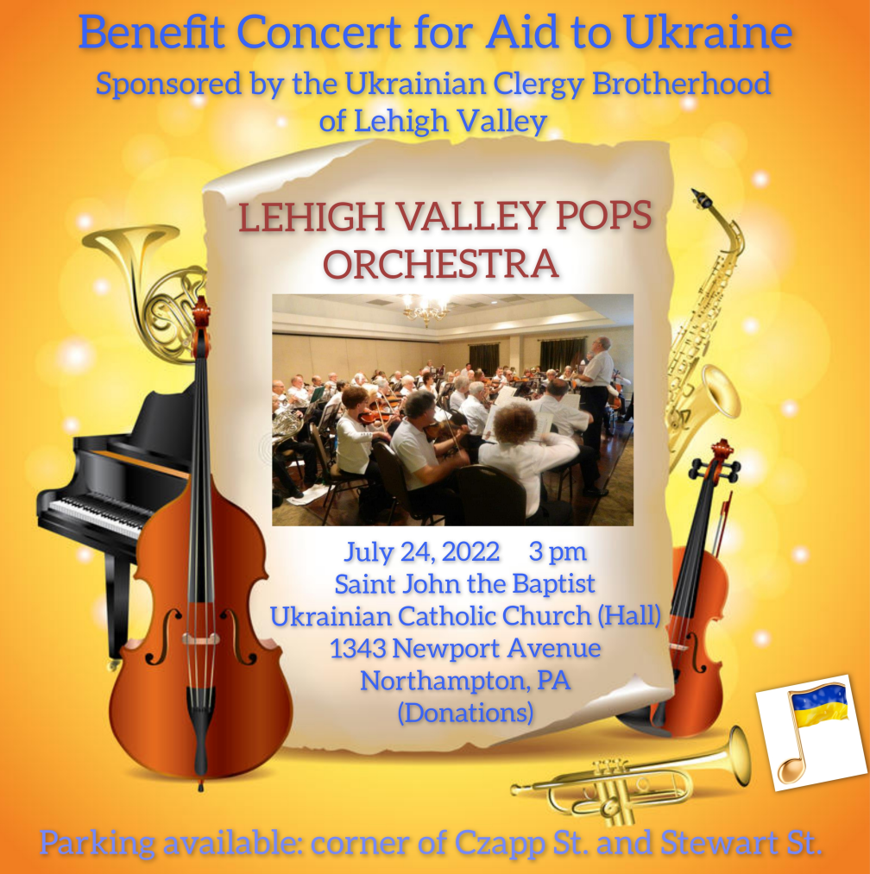
- Donations for Ukraine: medical supplies, diapers, baby food, new or gently used shoes and clothing.
- Donations for the food bank: baby foods; cans of potatoes, tuna fish, canned meats, pasta, spaghetti sauce, mac & cheese.
- SAVE THE DATE! Join us as we celebrate the 101st Anniversary of the founding of our Holy Temple. Saturday, September 24, 2022. Hierarchal Divine Liturgy (10:00 AM) and Banquet in Northampton Event and Banquet Center.
BIRTHDAYS:
10 July…Kathleen Crayosky, Julia Kroboth
12 July…Nicholas Alexander
13 July…Dennis Schmall
MANY YEARS! MNOHAYA LITA!
NECROLOGY: All Ukrainian civilians and soldiers killed in the Russian invasion.
12 July…Vladimir Schur ’59, Michael Metchoe ‘09
13 July…Mary Miga ’01
14 July…Katherine Smallen ’88
15 July…Mary Lee Leszczuk ’17
16 July…Anna Molnar ’92, Olen Ferbey ’14
VICHNAYA PAMYAT! MEMORY ETERNAL!

PRAYER FOR THE HEALTH & SALVATION OF THE AFFLICTED: Ukrainian soldiers and civilians wounded during the Russian aggression, Metropolitan Antony, Helen Crayosky, Ivan, William Leszczuk, child Charlie, Angela Knoblach, James Osmun, priest Vasyl Dovgan, Rosemarie Pypiuk, Kirk Swauger, Stephanie Donnelly, Nicholas Alexander, Danny Berro, child Alexandria, Elizabeth Pastushenko, Philippe Chasseuil, Joan Molnar, Brandon and Stacy Snyder, Aaliyah Osmun, Ihor Broda, William Savitz, Vladimir Krasnopera, Brendan Phillips, Jessie Hnatow, Jessica Meashock, Adam Hewko, Andrew Thaxton, Susan Ferretti, Judy Albright, Rob Hewko, Daniel Kochenash, Christopher Mack, Norman Betrous, Tom Petro Jr., Linda Schantz, Michael Lado, Robert Zarayko Jr., Viktoriya Yanchuk.

