ASSUMPTION OF THE VIRGIN MARY UKRAINIAN ORTHODOX CHURCH
ECUMENICAL PATRIARCHATE OF CONSTANTINOPLE AND NEW ROME
1301 Newport Avenue, Northampton, Pennsylvania 18067
Rev. Fr. Oleg Kravchenko, Rector
Protodeacon Mikhail Sawarynski, Attached
Websites: holyassumption.org and ukrainianorthodoxchurchusa.org
Facebook: Assumption of the Virgin Mary Ukrainian Orthodox Church
YouTube: AVM UOC Church
Contacts:
Fr. Oleg Kravchenko - (484) 834-7261; olegkravchenko2212@gmail.com
Protodeacon Mikhail – (H) (610) 262-3876); pravoslavni@rcn.com
Office – (610) 262-2882; avmuoc@gmail.com
Webmaster, John Hnatow – john.hnatow@gmail.com

Let’s pray for peace in Ukraine Молімось за мир в Україні
Tune in to our news, announcements, and online Facebook Livestream Liturgies HERE!
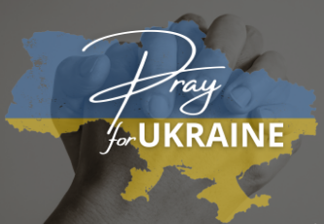

Sun. 16 July. (03 July) 6th SUNDAY after PENTECOST. TONE 5. Martyr HYACINTH. Martyrs DIOMEDES, EULAMPIUS, ASCIEPIODOTUS, GOLINDUC of Caesarea (106), Martyrs MOCIUS & MARK (4th C.) Ven. ALEXANDER, founder of the Monastery of the Unsleeping Ones (430) ANATOLIUS, Patriarch of Constantinople. Ven. ANATOLIY of the Near Caves & Ven. ANATOLIY the recluse of the Far Caves in Kyiv (12th-13th Centuries)
Reading: Romans 12: 6-14 Gospel : Matthew 9: 1-8

The Bulletin is sponsored by Stephen and Melanie Unger
in loving memory of Melanie’s father, Michael Smallen

Liturgical Meneion & Scripture Readings
Mon. 17 July St. Andrew, Archbishop of Crete (712-726). Ven. Martha, mother of St. Symeon Stylites the Younger (551).
1 Cor. 5:9–6:11 Mt. 13:54-58

Tue. 18 July Ven. Athanasius of Mt. Athos (1000). Martyr Anna at Rome (304).
1 Cor. 6:20 – 7:12 Mt. 14:1-13
06:30 PM MOLEBEN FOR UKRAINE (Holly Protection, Allentown)

Wed. 19 July Ven. Sisoes the Great of Egypt (429). Uncovering of the relics of Holy Princess Juliana Vilshanska (1540).
1 Cor. 7:12-24 Mt. 14:35 – 15:11

Thu. 20 July Ven. Thomas of Mt. Maleon (10 c.). Martyr Evangelus. Martyr Cyriaca (IV).
1 Cor. 7:24-35 Mt. 15:12-21

Fri. 21 July Holy Great-martyr Procopius of Caesarea in Palestine (303).
1 Cor. 7:35–8:7 Mt. 15:29-31

Sat. 22 July Hieromartyr Pancratius, bishop in Sicily (1st c).
Rom. 12:1-3 Mt. 10:37–11:1
06:00 PM Great Vespers.

Sun. 23 July 09:00 AM DIVINE LITURGY.

PROPERS FOR THE LITURGY OF ST. JOHN CHRYSOSTOM

Tropar of the Resurrection, Tone 5: Let us, the faithful, praise and worship the Word, co-eternal with the Father and the Spirit, born for our salvation of the Virgin. In His Good Will He was lifted up on the Cross in the flesh, to suffer death, and to raise the dead, by His glorious Resurrection.
Tropar of the Dormition, Tone 1: In giving birth, you preserved your virginity. In falling asleep you did not forsake the world, Birth-Giver of God. You were translated to Life, Mother of Life, and through your prayers you deliver our souls from death.
Tropar to the Martyr Hyacinth, Tone 4: Like a fragrant hyacinth of the Church of Christ, O all-blessed Hyacinth, you radiate grace to the ends of the world. By brilliance of your confession of faith, you were illustrious in contest in emulation of God the Word, and you ever illumine those who acclaim you.
Kondak of the Resurrection, Tone 5: You descended into Hell, my Savior, destroying the gates as Almighty, resurrecting the dead as Creator and destroying the sting of death. You have delivered Adam from the curse, Lover of all Mankind. Therefore, we all cry out to You: Lord, save us.
Glory… Kondak Martyr Hyacinth, Tone 2: Come, you faithful, plait a crown of unfading hyacinths today for the Martyr Hyacinth, and let us cry to him: “Rejoice, glory of martyrs.”
Now and ever… Kondak of the Dormition, Tone 2: Neither the tomb nor death had power over the Birth-Giver of God, she is ever watchful in her prayers, and in her intercession lies unfailing hope, for as the Mother of Life, she has been translated to Life, by the One Who dwelt within her ever-virginal womb.
Prokimen of the Resurrection, Tone 5: You, O Lord, shall protect us and preserve us from this generation forever.
Verse: O Lord, save me, for there is no longer any righteous man.
Reading: St. Paul to the Romans: 12:6-14
Alleluia Verses, Tone 5: Of Your mercies O Lord, I will sing forever; unto generation and generation I will proclaim Your truth with my mouth.
You said: Mercy will be established forever and My truth will be prepared in the heavens.
Gospel: Matthew 9:1-8
Communion Hymn: Praise the Lord from the heavens. Praise Him in the Highest. Alleluia (3X)

- Travel season: ask priest Oleg for a prayer before traveling.
- Parish picnic Wayne Grube Park for Saturday, Sept. 30, 2023.
- Pan-Orthodox Virtual Bible Study via Zoom every Wednesday at 12 PM. Meeting ID: 576 301 6482. Passcode: 238492.
- Bible Study via Zoom every Wednesday at 7 PM with a professor of Saint Sophia Seminary Fr. Demetrios. Ask Fr. Oleg for the link.
- For Food Bank: baby foods, canned potatoes, and meats, tuna, pasta, sauces, mac. & cheese.

ANNIVERSARIES:
18 July…Matthew & Andrea Sawarynski

BIRTHDAYS:
17 July…Mary Ann Dworakivsky
18 July…Brendan Phillips
19 July…Elizabeth Kravchenko
20 July… Anthony Sawarynski, William Hantz,
МНОГАЯ ЛІТА! MANY YEARS!

NECROLOGY: Ukrainian civilians and soldiers, killed in the Russian invasion.
16 July…Anna Molnar ’92, Olena Ferbey ’14
17 July…Justine Czepelak ’50
18 July…Rosalia Chudyk ’67, Mykola Martyniuk ‘02
19 July…Mary Nieves ’94
20 July…Michael Karypenko ’57, Mary Hurtyn ’92, Ann Haas ’14
22 July…Michael Smallen Sr. ’95
21 July…Bohdan Kowalyshyn (infant) ’38
ВІЧНА ПАМ’ЯТЬ! MEMORY ETERNAL!

PRAYER FOR THE HEALTH & SALVATION OF THE AFFLICTED: Ukrainian soldiers and civilians, wounded during the Russian aggression, Barbara Grason, Paul Kochenash, Rosemarie Pypiuk, Helen Crayosky, Matthew Vitushinsky, Nadine Savitz, William Savitz, Nicholas Alexander, James Osmun, Vladimir Krasnopera, Tom Petro Jr., Elena Iaroshenko, Volodymyr Hranat(wounded soldier), Ihor Broda, William Leszczuk, Jessica Meashock, Ruslana Reznik, Kateryna Seremula, Lubov Slonova, priest Vasyl Dovgan, priest Gerald Ozlanski, Raisa Melnychuk, Olha Beizyn, Vasyl Beizyn, Mary Berger, Debi Hutnick, Eric Hewko, Pamela Williams, Phil O’Brien, child Charlie, Juliana, Shirl Merolli, Kirk Swauger, Stephanie Donnelly, Danny Berro, child Alexandria, Elizabeth Pastushenko, Philippe Chasseuil, Aaliyah Osmun, Brendan Phillips, Adam Hewko, Andrew Thaxton, Susan Ferretti, Judy Albright, Daniel Kochenash, Christopher Mack, Joann Hoodmaker, Norman Betrous, Robert Zarayko Jr.

Patristic commentary on the Gospel. Jesus' own city was Nazareth (JEROME), yet even though he was Lord and Savior of the world, the people he was helping preferred that he go away (CHROMATIUS). The healing of the body points beyond itself to the healing of the soul (CHRYSOSTOM). It was the faith of the paralytic's friends, not the paralytic, that Jesus recognized (JEROME). The physician does not waste time probing into the senseless wishes of one who is irrationally delirious; rather the physician urgently listens to the patient's friends (PETER CHRYSOLOGUS). Jesus first granted remission of sins and then showed his ability to restore health; with the taking up of the pallet, he made it clear that bodies would be free from infirmity and suffering. Finally, with the paralytic's return to his home, Jesus showed that believers must be given back the way to paradise (HILARY). Whether the sins of the paralytic were forgiven, only he who could forgive them would know for sure (JEROME). With the same majesty and power by which Jesus perceived the thoughts of the scribes, he is able to forgive people their sins (JEROME). Christ thereby shows here that he is truly God and equal to the One by whom he is begotten (CHRYSOSTOM, HILARY). The sins of Adam are forgiven in Christ (HILARY).

Celebrity Quotes About Jesus Christ and Bible
Theodore Roosevelt : “(My) great joy and glory that, in occupying an exalted position in the nation, I am enabled, to preach the practical moralities of The Bible to my fellow-countrymen and to hold up Christ as the hope and Savior of the world.”
Elvis Presley: “I’m not the King. Jesus Christ is the King. I’m just an entertainer”
Bono : “When you align yourself with God’s purpose as described in the Scriptures, something special happens to your life.”
Sylvester Stallone : “You need to have the guidance someone else. You can not train yourself. I feel the same way about Christianity and what the Church is : The Church is the gym of the soul
Mark Wahlberg : “The first thing I do when I start my day is, I get down on my hands and knees and give thanks to God. Whenever I go outside of my house, the first thing I do is stop at the church.”
Johnny Cash: “When God forgave me, I figured I’d better do it too.”
Denzel Washington: “Inside every one of us we have something tugging at us, telling us to believe in something…(the Bible) is the answer to that”
Justin Bieber : “Do you feel you have exhausted all options? Do you feel helpless? Do you feel like you are never good enough? What if I told you that there’s a God that’s willing to meet you WHEREVER you’re at! What if I told you he could take away your pain, shame, guilt, and fears. #JESUS”

ORTHODOXY AROUND THE WORLD
Kyriakos Mitsotakis was sworn in as P.M. of Greece by Archbishop Ieronymous of Athens in the presence of President Sakellaropolou.
Ecumenical Patriarch visited the Agathon Monastery where he was welcomed by the Abbot, Archimandrite Germanos with the veneration of the Holy Skull of St. John the Faster.
Sunday of All Saints of the British Isles was celebrated at the Church of St. Colman, 7th C. monk of the Monastery of Iona, in Stradbally, Ireland by Bishop Irenei of London.
The Ukrainian Union of Afghanistan Veterans held a charity event at Resurrection Church in Kyiv providing wheelchairs to those in need.
Orthodox Christians have been making their pilgrimage to Fort Ross, California, designated a Historic State Park, for over 100 years. The Chapel of the Holy Trinity located here was built in the 1820’s.
More than 15,000 pilgrims came to the Monastery of the 12 Apostles in Barsana for the 30th anniversary of the revival of monastic life. Founded in 1326 it was closed by the communist regime. Bishop Justin led services and awarded Abbess Filoftein church honors.
President Volodymyr Zelensky & Polish President Andrej Duda met in Ss Peter & Paul Cathedral in Lutsk on July 9th. They plan to commemorate the Volyn massacre in 1943

Additions in Ukrainian

Недільне Євангеліє. Матфея 9:1-8 Тоді Він, увійшовши в човен, переплив назад і прибув до Свого міста. 2 І ось принесли до Нього розслабленого, що лежав на постелі. І, побачивши віру їхню, Ісус сказав розслабленому: дерзай, чадо! Прощаються тобі гріхи твої! 3 При цьому деякі з книжників говорили собі: Він богохульствує. 4 Ісус же, бачачи помисли їхні, промовив: навіщо ви думаєте лукаве в серцях своїх? 5 Бо що легше — сказати: прощаються тобі гріхи, чи сказати: встань і ходи? 6 Та щоб знали ви, що Син Людський має владу на землі прощати гріхи. Тоді говорить розслабленому: встань, візьми постіль твою та йди у дім твій. 7 І той устав, узяв постіль свою і пішов у дім свій. 8 Народ же, побачивши це, здивувався і прославив Бога, Який дав таку владу людям.
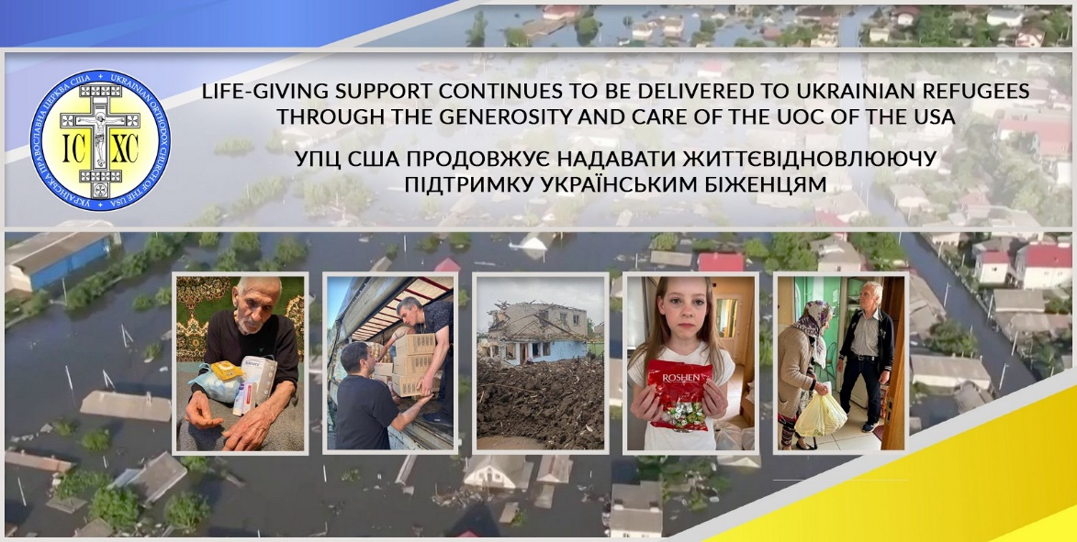
That’s what we do for people in Ukraine

