JULY 21, 2019

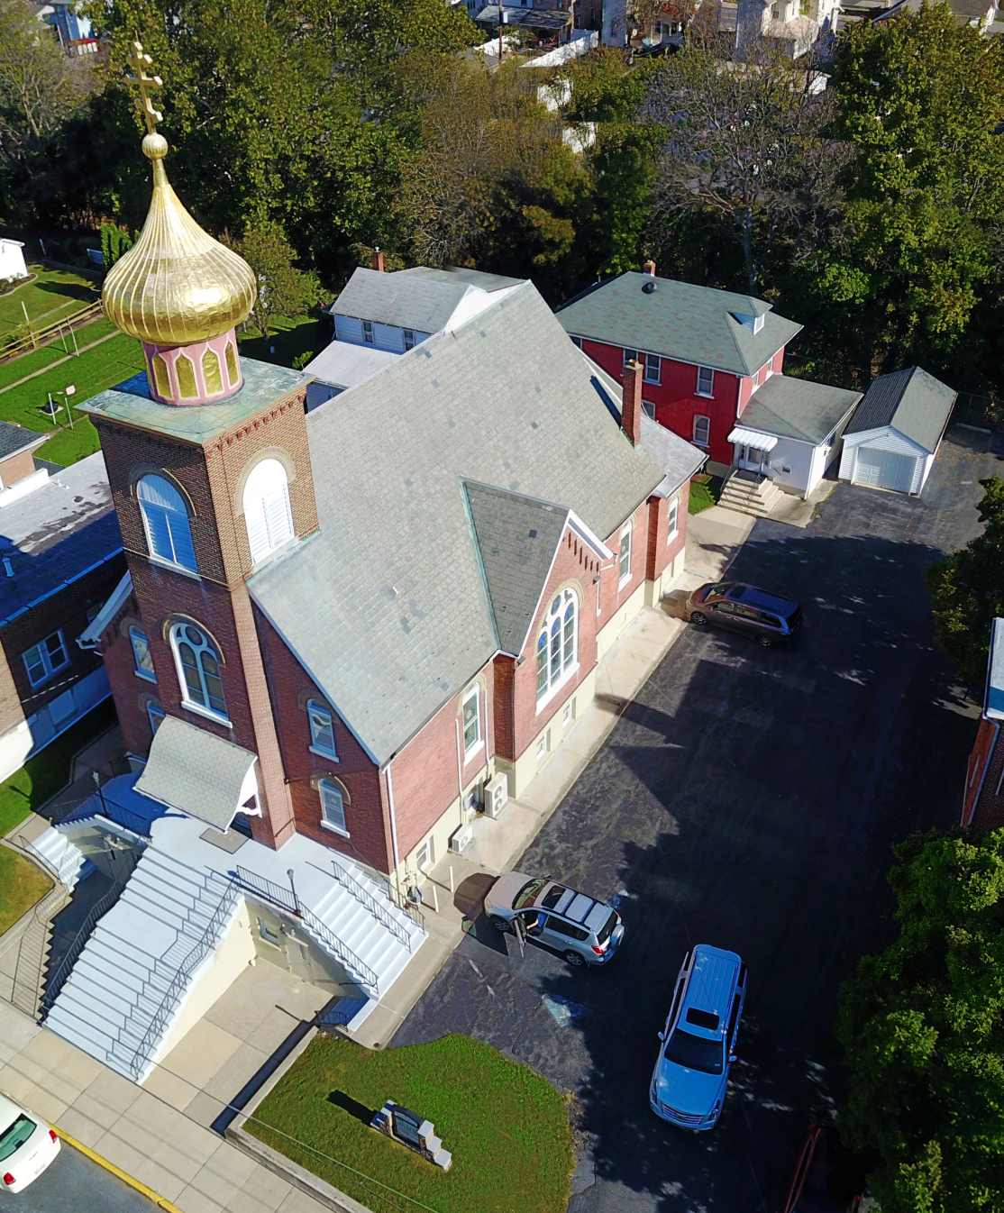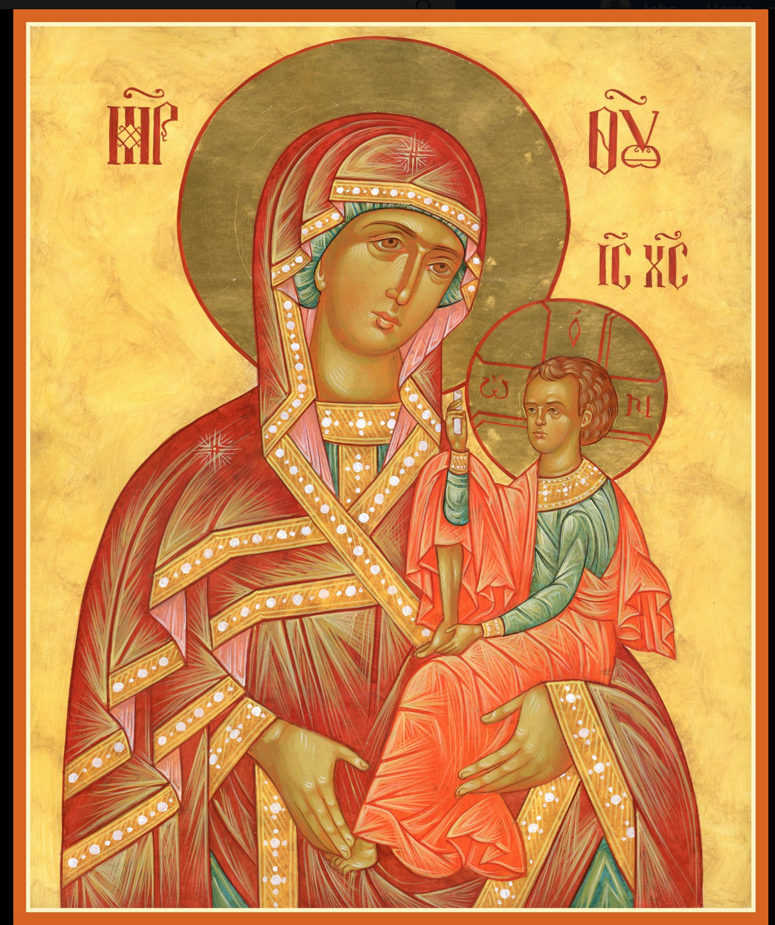

ASSUMPTION OF THE VIRGIN MARY
UKRAINIAN ORTHODOX CHURCH
ECUMENICAL PATRIARCHATE OF CONSTANTINOPLE AND NEW ROME
1301 Newport Avenue
Northampton, Pennsylvania 18067
Mitered Archpriest Myron Oryhon
Rev. Fr. Oleh Kravchenko, Attached
Protodeacon Mychail Sawarynski, Attached

Telephones: Church Office… (610) 262-2882
Church Fax/Kitchen/Hall… (610) 262-0552
Fr. Myron Oryhon – (607) 752-1999
Protodeacon Mychail’s Residence… (610) 262-3876
Websites: holyassumption.org
ukrainianorthodoxchurchusa.org
lvorthodox.wordpress.com
E-mail: Parish… avmuoc@gmail.com
Protodeacon Mychail…pravoslavni@rcn.com
Webmaster, John Hnatow… john.hnatow@gmail.com
==============================================================
21st July (8th July) 2019

Fifth Sunday after Pentecost. Tone 4. Holy Great Martyr PROCOPIUS of Caesarea in Palestine (303). Ven. THEOPHILUS of Pantocrator Monastery, Mt. Athos (1548). New Martyr ANASTA-SIUS of Constantinople (1743). Martyr MIRDAT of Georgia.

Romans 8: 14-21 Matthew 9: 9-13

PROPERS FOR LITURGY OF ST. JOHN CHRYSOSTOM

Tropar of the Resurrection, Tone 4
When the women disciples of the Lord learned from the angel the joyous message of Your Resurrection, they cast away the ancestral curse and with gladness told the apostles: death is overthrown. Christ God is risen, granting the world great mercy.

Tropar of the Dormition, Tone 1
In giving birth, you preserved your virginity. In falling asleep you did not forsake the world, Birth-Giver of God. You were translated to Life, Mother of Life, and through your prayers you deliver our souls from death.

Tropar to Great Martyr Procopius, Tone 4
Your holy martyr Procopius, O Lord, through his suffering has received an incorruptible crown from You, our God. For having Your strength, he laid low his adversaries and shattered the power-less boldness of demons. Through his intercessions save our souls.

Kondak of the Resurrection, Tone 4
My Savior and Redeemer, as God, arose from the tomb and deliv-ered the earthborn from bondage. He has shattered the gates of Hell and, as Master, He has risen on the third day.

Glory to the Father and to the Son and to the Holy Spirit.

Kondak to Great Martyr Procopius, Tone 2
Set ablaze by divine zeal for Christ and protected by the might of the Cross, you cast down the insolence and boldness of the enemy, Procopius. You exalted the honorable Church, excelling in faith and giving light to us all.

Now and ever and unto ages of ages. Amen.

Kondak of the Dormition, Tone 2
Neither the tomb nor death had power over the Birth-Giver of God; she is ever watchful in her prayers and in her intercession lies un-failing hope. For as the Mother of Life, she has been translated to life by the One Who dwelt within her ever-virginal womb.

Prokimen of the Resurrection, Tone 4
How marvelous are Your works, O Lord. In wisdom You have made them all.

Verse: Bless the Lord, my soul. O Lord my God, You are very great.

Alleluia Verses in Tone 4
Bend Your bow and proceed prosperously, and reign because of truth, meekness and righteousness.

You have loved righteousness and hated iniquity.

Communion Hymn:
Praise the Lord from the heavens, praise Him in the Highest.
Alleluia (3X)

LITURGICAL MENEION & SCRIPTURE READINGS
FOR THE FIFTH WEEK AFTER PENTECOST

Mon. 22 July Hieromartyr PANCRATIUS, Bishop of Taormina.
Hieromartyr CYRIL, Bishop of Gortyna (250).
Romans 16:17-24 Matthew 13:10-23

Tue. 23 July 45 Martyrs at Nicopolis, Armenia (319). Martyr
APOLLONIUS of Sardis. Ven. ANTHONY of the
Kyiv Caves (1073) SILOUAN of the Far Caves.
1 Corinthians 1:1-9 Matthew 13:24-30

Wed. 24 July Commemoration of the Miracle of Great Martyr
FAST DAY Euphemia. Blessed Equal to the Apostles OLHA,
Oil Princess of Kyiv, Helen in Baptism (969).
1 Corinthians 2:9-3:8 Matthew 13:31-36

Thur. 25 July Martyrs PROCLUS & HILARY of Ancyra. Ven.
MICHAEL of Maleinus (962) Martyr GOLINDUC Martyrs THEODORE & son JOHN of Kyiv (983)
1 Corinthians 3:18-23 Matthew 13:36-43

Fri. 26 July Synaxis of Holy ARCHANGEL GABRIEL. St.
FAST DAY STEPHEN of St. Sabba Monastery (794).
Oil 1 Corinthians 4:5-8 Matthew 13:44-54

Sat. 27 July Apostle AQUILA of the 70. PRISCILLA. Martyr
JUSTUS of Rome. Ven. ELLIUS of Egypt (4th C.)
Romans 9:1-5 Matthew 9:18-26

5:00 PM GREAT VESPERS

Sun. 28 July 6th Sunday after Pentecost. FATHERS of the First
SIX ECUMENICAL COUNCILS. Holy Great Prince VOLODYMYR, Enlightener of Kyiv. Tone 5.

8:30 AM THIRD & SIXTH HOURS
9:00 AM DIVINE LITURGY of JOHN CHRYSOSTOM

NECROLOGY:
21 July… Bohdan Kowalyshyn (infant) ‘38
22 July… Michael Smallen Sr. ‘95
23 July… Stephen Hewko ’84, Katherine Bodnyk ‘95
24 July… Paul Nazar ‘88
25 July… John Arndt ‘88
27 July… Andrew Krayowsky ‘64

VICHNAYA PAMYAT! MEMORY ETERNAL

BIRTHDAYS:
24 July… Anne Dworakivsky
25 July… Beth Seremula
26 July… Sean Nemeh
27 July… Caroline Hallman

MNOHAYA LITA! MANY YEARS!

WE PRAY FOR THE HEALTH AND WELL-BEING of the ill afflicted: Pani Ol’ha Kravchenko and the child she is bearing, William Savitz, Catherine Kochenash, Fr. Vasyl Dovgan, Vladimir & Emma Krasnopera, Tessie Kuchinos, Brendan Phillips, Jessie Hnatow, Jessica Meashock, Wasyl Hewko, Adam Hewko, Betty Hendrickson, Andrew Thaxton, Michelle Pierzga, Susan Ferretti, Carole Zarayko, William Fischer, Ekaterina Seremula, Marianna Goshow, Judy Albright, Jerome Yankowy.

SAVE THE DATE: ANNUAL CHURCH PICNIC will held at Canal St. Park with a “PIG ROAST” catered by Fr. James Cairns on SATURDAY, SEPTEMBER 28th from 12 noon to 7 PM. Outdoor Vespers will be served beginning at 5 PM at the park.

OCMC “AGAPE CANISTER” DONATIONS were $67.00; thank
you for your generous support of our Missions around the globe.

NORTHAMPTON FOODBANK is still in need of foodstuffs, especially tuna, canned potatoes and baby food.

VOLUNTEERS for SUMMER COFFEE HOUR are needed Sign-up sheet in Hall. Coffee will be prepared. You supply the baked goods.

Please continue to save Redner’s tapes; use your Reward’s Card.”

GREAT MARTYR PROCOPIUS OF CAESAREA

A native of Jerusalem, Procopius lived and suffered during the reign of Emperor Diocletian. His father, an eminent Roman, named Christopher was a Christian. His birth name was Neanius and he received an excellent secular education and advanced in government service. He was sent to Egypt in 303 to perse-cute the Christian Church. On his way he had a vision of Jesus Christ asking him “why do you persecute Me?’ A radiant Cross appeared in the sky and he felt a spiritual happiness, becoming favorably disposed
towards Christians. He was arrested and held in chains and sent to Caesarea in Palestine. In prison Christ Himself baptized the suffering servant giving him the name Procopius. Inspired by his example many of his former guards and soldiers went to martyrdom. His mother, Theodosia, a pagan, became repentant and was executed. Finally, he was beheaded by the sword in 303 at Caesarea, the first martyrdom in that city.

NEWS FROM THE ORTHODOX WORLD
Basil and Elizabeth Wingard of Sweden converted to Orthodoxy several years ago from Lutheranism. They are members of St. Dimitri Church in Kristianstad. Sweden has 5 Orthodox dioceses with about 140,000 believers. Elizabeth had been a deaconess in the Lutheran Church for 25 years and attributes the lack of holiness in Lutheranism today for her conversion, “when I became Orthodox, I could feel the fullness of faith.”

Archbishop Jakub of Bialystok and Bishop Andrzej of Suprasl con-secrated the new Church of St. Luke of Crimea, known as the “Blessed Surgeon” in the Knyszyn Forest of Poland in memory of the 55 people killed by the Nazis in Laznie in 1943.

