AUGUST 04, 2019

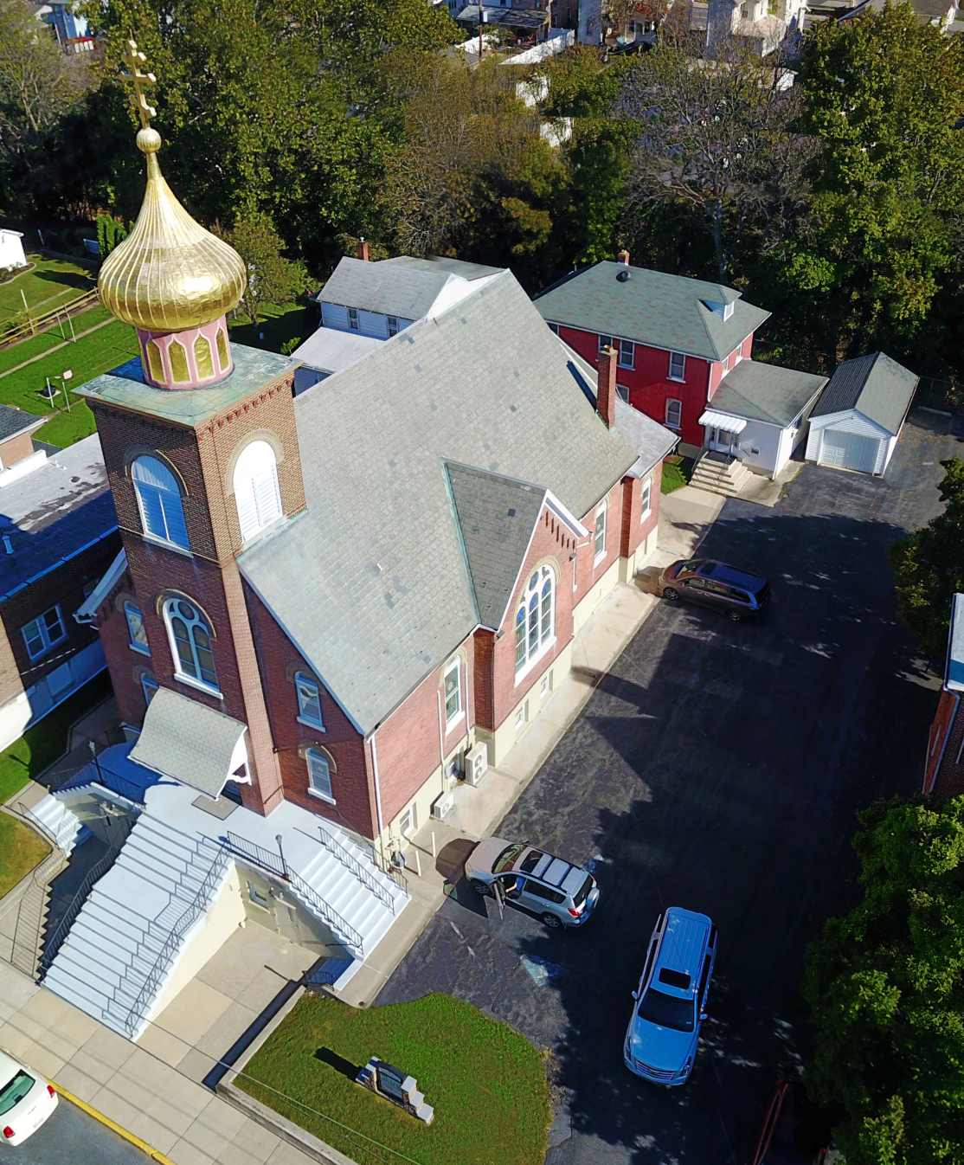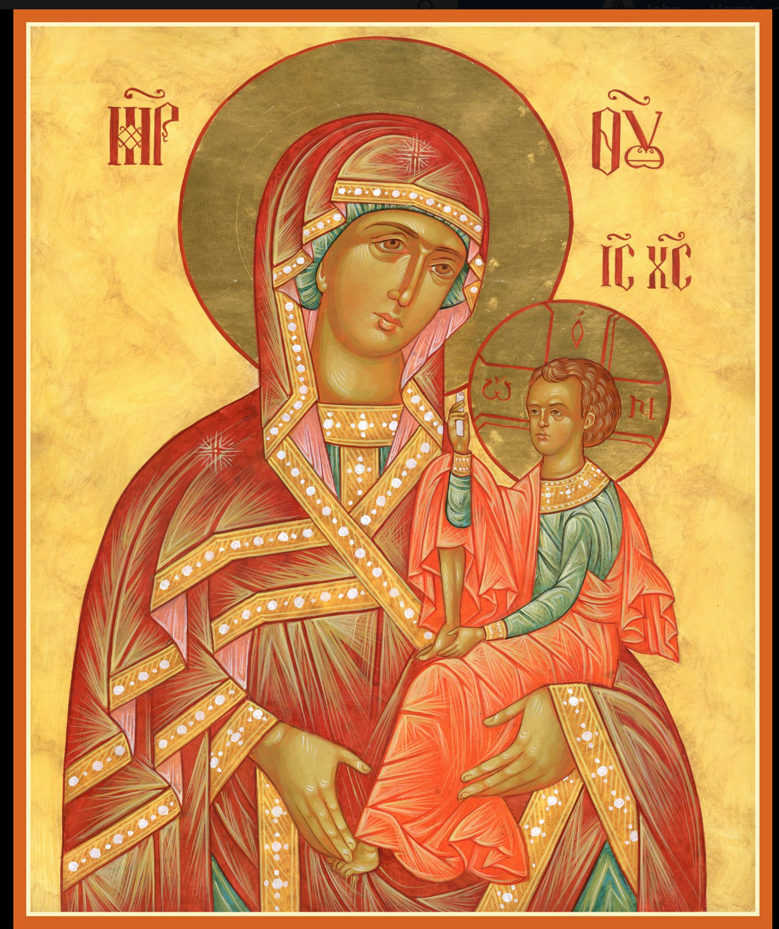

ASSUMPTION OF THE VIRGIN MARY
UKRAINIAN ORTHODOX CHURCH
ECUMENICAL PATRIARCHATE OF CONSTANTINOPLE AND NEW ROME
1301 Newport Avenue
Northampton, Pennsylvania 18067
Mitered Archpriest Myron Oryhon
Rev. Fr. Oleh Kravchenko, Attached
Protodeacon Mychail Sawarynski, Attached

Telephones: Church Office… (610) 262-2882
Church Fax/Kitchen/Hall… (610) 262-0552
Fr. Myron Oryhon – (607) 752-1999
Protodeacon Mychail’s Residence… (610) 262-3876
Websites: holyassumption.org
ukrainianorthodoxchurchusa.org
lvorthodox.wordpress.com
E-mail: Parish… avmuoc@gmail.com
Protodeacon Mychail…pravoslavni@rcn.com
Webmaster, John Hnatow… john.hnatow@gmail.com
==============================================================
04th August (22nd July) 2019

Seventh Sunday after Pentecost. Tone 6. Holy Myrrh-bearer & Equal to the Apostles MARY MAGDALENE (1st C.) Translation of the Relics of Hieromartyr PHOCAS (403) CORNELIUS, monk of Pereyaslav (1693).

Romans 15:1-7 Matthew 9:27-35 Corinthians 9:2-12 Luke 8:1-3

PROPERS FOR LITURGY OF ST. JOHN CHRYSOSTOM

Tropar of the Resurrection, Tone 6
The angelic powers were at Your tomb. The guards became as dead men. Mary stood by Your grave seeking Your Most Pure Body. You captured Hell, not being tempted by it. You came to the Virgin, granting Life. Lord, risen from the dead, glory to You.

Tropar of the Dormition, Tone 1
In giving birth, you preserved your virginity. In falling asleep you did not forsake the world, Birth-Giver of God. You were translated to Life, Mother of Life, and through your prayers you deliver our souls from death.

Tropar to Myrrhbearer Mary Magdalene, Tone 1
By keeping His commandments and laws, Holy Mary Magdalene, you followed Christ, Who for our sake was born of the Virgin. And in celebrating Your most holy memory today, we receive forgiveness of sins by your prayers.

Kondak of the Resurrection, Tone 6
When Christ God, the Giver of Life, with His Life-giving Hand raised all of the dead from the valleys of misery, He bestowed Resur-rection on the human race. He is the Savior, the Resurrection, the Life and the God of all.

Glory to the Father and to the Son and to the Holy Spirit.

Kondak to Mary Magdalene, Tone 4
Standing before the Cross of the Savior, suffering with the Mother of the Lord, the most glorious Mary Magdalene offered praise with tears. She cried out: “What is this strange wonder? He Who holds the whole creation in His hand chooses to suffer. Glory to Your power, O Lord.”

Now and ever and unto ages of ages. Amen.

Kondak of the Dormition, Tone 2
Neither the tomb nor death had power over the Birth-Giver of God; she is ever watchful in her prayers and in her intercession lies un-failing hope. For as the Mother of Life, she has been translated to life by the One Who dwelt within her ever-virginal womb.

Prokimen of the Resurrection, Tone 6
Save Your people, O Lord, and bless Your inheritance.

Verse: O Lord, to You will I call. O my God, be not silent unto me.

Prokimen to Mary Magdalene, Tone 4
God is wondrous in His saints, the God of Israel.

Verse: In the congregations, bless God, the Lord from the well-springs of Israel.

Alleluia Verses in Tone 6
He that dwells in the help of the Most High will abide in the shelter of the God of Heaven.

He will say to the Lord: You are my helper and my refuge. He is my God and I will hope in Him.

With patience I waited for the Lord and He was attentive to me. He listened to my supplication.

He brought me up out of the pit of misery and from the mire of clay.

Communion Hymn:
Praise the Lord from the heavens, praise Him in the Highest.
Rejoice in the Lord, you righteous; praise befits the upright.
Alleluia (3X)

LITURGICAL MENEION & SCRIPTURE READINGS
FOR THE EIGHTH WEEK AFTER PENTECOST

Mon. 05 Aug. POCHAIYEV ICON of the Mother of God (1675)
Hieromartyr APOLLINARIS, Bishop of Ravenna.
1 Corinthians 9:13-18 Matthew 16:1-6

Tue. 06 Aug. Martyr CHRISTINA of Tyre (300). Martyrs and
Passion Bearers BORIS & HLIB (1015).
1 Corinthians 10:5-12 Matthew 16:6-12

Wed. 07 Aug. DORMITION of RIGHTEOUS ANNA. Deaconess
FAST DAY: OLYMPIAS (409) Virgin EUPRAXIA of Tabenna.
Oil 1 Corinthians 10:12-22 Matthew 16:20-24

Thur. 08 Aug. Hieromartyrs HERMOLAUS, HERMIPPUS &
HERMOCRATES at Nicomedia. PARASCEVE of
Rome. Ven. MOSES the Hungarian of the Caves.
1 Corinthians 10:28-11:7 Matthew 16:24-28

Fri. 09 Aug. Great Martyr & Healer PANTELEIMON (305)
FAST DAY: Ven. Abbess ANTHUSA and her 90 sisters.
Oil 1 Corinthians 11:8-22 Matthew 17:10-18

Sat. 10 Aug. Apostle AQUILA of the 70. PRISCILLA. Martyr
JUSTUS of Rome. Ven. ELLIUS of Egypt (4th C.)
Romans 9:1-5 Matthew 9:18-26

5:00 PM GREAT VESPERS

Sun. 11 Aug. 8th Sunday after Pentecost. Martyr CALLINICUS of Gangra in Asia Minor (250). Virgin-martyr SERAPHIMA of Antioch (2nd C.) Tone 7.

8:30 AM THIRD & SIXTH HOURS
9:00 AM DIVINE LITURGY of JOHN CHRYSOSTOM

Bene Note: ON HOLY COMMUNION
Please be advised that according to the Canons of the Orthodox Church, the Sacrament of Holy Communion can only be admin-istered to Orthodox Christians (Baptized & Chrismated, making them living members of the Body of Christ), One must be prepared to approach the Holy Chalice by fasting, prayer and confession.

NECROLOGY:
05 August… Theodore Stashitsky ’46, Cathryn Fedorischen ‘11
07 August… Dennis Saruba ’89, Eva Pypiuk ’00,
Stephania Teply ‘12
09 August… John Mislicky ‘62
10 August… Paul Smallen ‘63

VICHNAYA PAMYAT! MEMORY ETERNAL

BIRTHDAYS:
06 August… Zachary Phillips
09 August… Alexandra Ost

MNOHAYA LITA! MANY YEARS!

WE PRAY FOR THE HEALTH AND WELL-BEING of the ill afflicted: William Savitz, Catherine Kochenash, Fr. Vasyl Dovgan, Vladimir & Emma Krasnopera, Tessie Kuchinos, Brendan Phillips, Jessie Hnatow, Jessica Meashock, Adam Hewko, Betty Hendrickson, Andrew Thaxton, Michelle Pierzga, Susan Ferretti, Carole Zarayko, William Fischer, Ekaterina Seremula, Marianna Goshow, Judy Albright, Jerome Yankowy.

CONGRATULATIONS AND BEST WISHES are extended to FATHER OLEH & PANI MATKA OL’HA on the birth of a daughter on July 19th in N.J. All are doing well.

CONGRATULATIONS AND BEST WISHES to MYHAILO & OLEKSANDRA YARCHAK, who were united in the Sacrament of Holy Matrimony in our church on July 26th. Mnohaya Lita!
CONGRATULATIONS AND BEST WISHES to Father Richard Jendras who was ordained to the Holy Priesthood last Saturday by Archbishop Daniel at our sister parish, St. Mary’s Pokrova of Allentown, where he will serve as rector. God grant him many years!

Our CONDOLENCES to Elaine Hewko and family members on the repose of her husband, + Vasyl (“Wass”) Hewko, 96, who reposed in the Lord on July 27th. A life-long member of this parish and World War II veteran may his memory be eternal! Vechnaya Pamyat!

SAVE THE DATE: ANNUAL CHURCH PICNIC will held at Canal St. Park with a “PIG ROAST” catered by Fr. James Cairns on SATURDAY, SEPTEMBER 28th from 12 noon to 7 PM. Outdoor Vespers will be served beginning at 5 PM at the park.

OCMC “AGAPE CANISTER” DONATIONS were $18.00; thank
you for your generous support of our Missions around the globe.

NORTHAMPTON FOODBANK is still in need of foodstuffs, especially tuna, canned potatoes and baby food.

VOLUNTEERS for SUMMER COFFEE HOUR are needed Sign-up sheet in Hall. Coffee will be prepared. You supply the baked goods.

Please continue to save Redner’s tapes; use your Reward’s Card.”

St. Sophia’s Seminary is experiencing a growth in new admissions. For 2019, 30 students have enrolled and is there is a need of furni-ture totaling $4,500. The seminary needs funds to cover these im-provements from the faithful. Checks may be sent to: St. Sophia’s Seminary, PO Box 240, South Bound Brook, NJ 08880,

Celebrations marking the 1,031st anniversary of the Baptism of Ukraine were held last weekend, on Volodymyr Hill on the banks of the Dnipro River and then a Cross Procession followed with over 300,000 believers to the relics of 20 saints and 5 wonderworking icons. Services concluded on the Square outside Pecherska Lavra.

