August 18, 2019

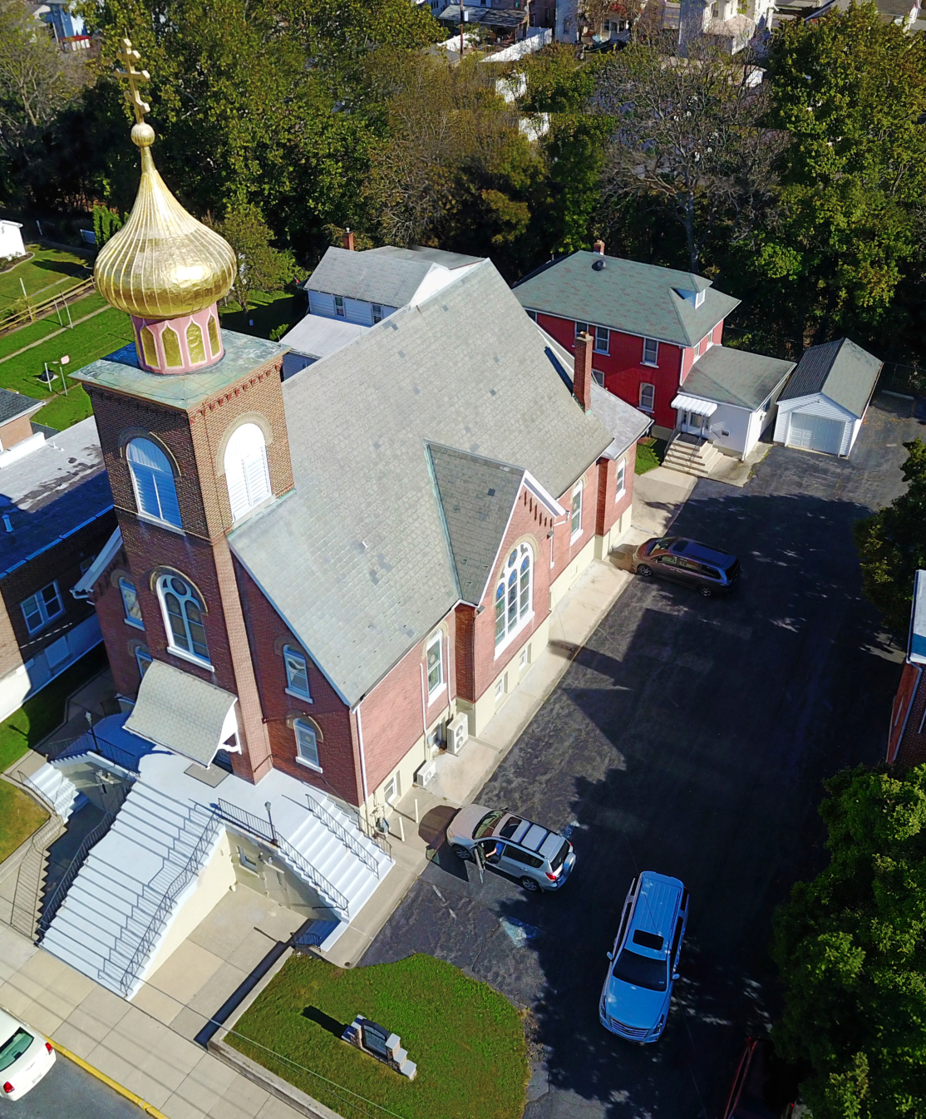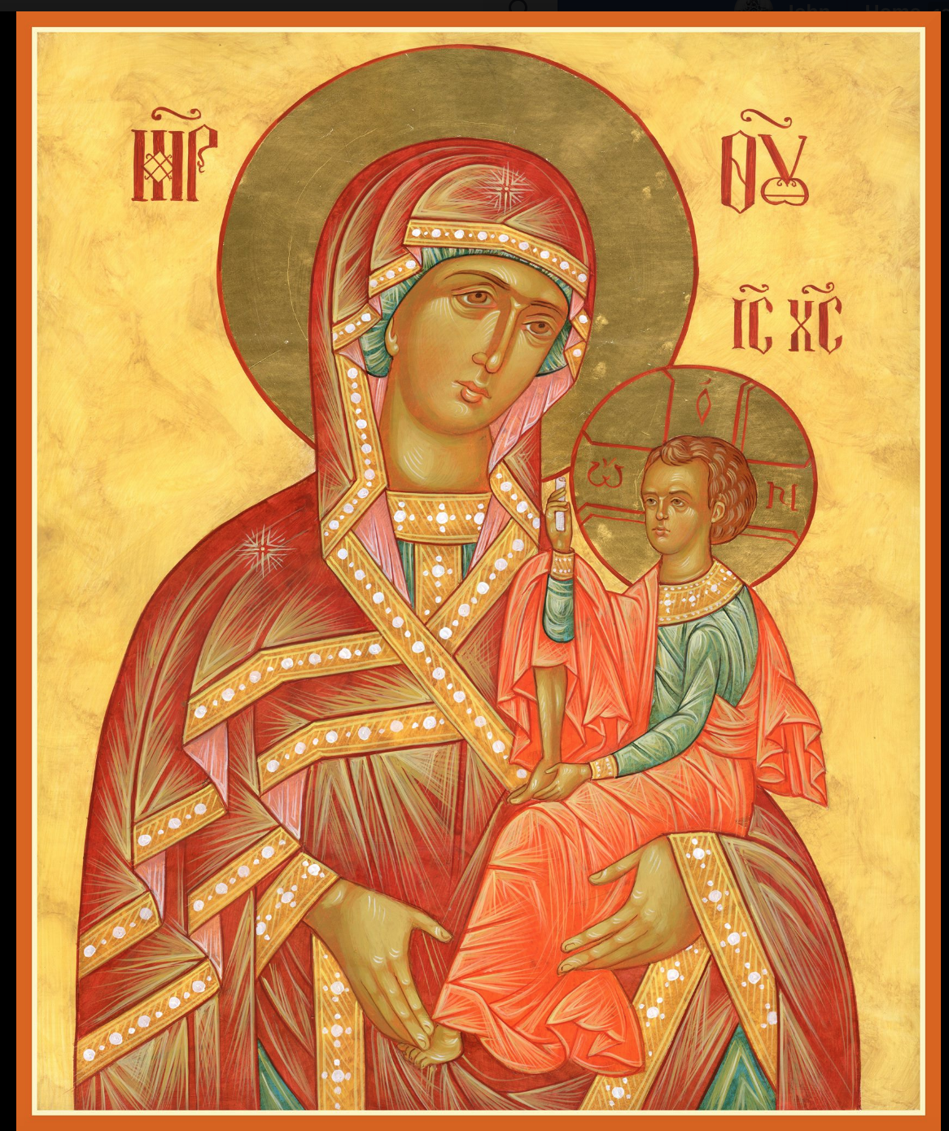

ASSUMPTION OF THE VIRGIN MARY
UKRAINIAN ORTHODOX CHURCH
ECUMENICAL PATRIARCHATE OF CONSTANTINOPLE AND NEW ROME
1301 Newport Avenue
Northampton, Pennsylvania 18067
Mitered Archpriest Myron Oryhon
Rev. Fr. Oleh Kravchenko, Attached
Protodeacon Mychail Sawarynski, Attached
Telephones: Church Office… (610) 262-2882
Church Fax/Kitchen/Hall… (610) 262-0552
Fr. Myron Oryhon – (607) 752-1999
Fr. Oleh Kravchenko – (732) 507-2274
Protodeacon Mychail’s Residence… (610) 262-3876
Websites: holyassumption.org
ukrainianorthodoxchurchusa.org
lvorthodox.wordpress.com
E-mail: Parish… avmuoc@gmail.com
Protodeacon Mychail…pravoslavni@rcn.com
Webmaster, John Hnatow… john.hnatow@gmail.com
==============================================================
18th August (5th Aug.) 2019

Ninth Sunday after Pentecost. Tone 8. FOREFEAST OF THE TRANSFIGURATION. Martyr EUSIGNIUS of Antioch. Hiero-
Martyrs FABIAN (250) & ANTHERUS (257), Popes of Rome.
1 Corinthians 3:9-17 Matthew 14:22-34
Today’s Bulletin, sponsored in loving memory of +ANTOINETTE MEASHOCK is offered by grandson Reader Maximos Meashock.
PROPERS FOR LITURGY OF ST. JOHN CHRYSOSTOM

Tropar of the Resurrection, Tone 8
You descended from on high, Merciful One. You accepted the three-day burial to free us from our passions. Lord, our Life and Resurrection, Glory to You.

Tropar of the Dormition, Tone 1
In giving birth, you preserved your virginity. In falling asleep you did not forsake the world, Birth-Giver of God. You were translated to Life, Mother of Life, and through your prayers you deliver our souls from death.

Tropar of the Forefeast, Tone 4
Come, you faithful, let us welcome the Transfiguration of Christ, and let us joyfully cry as we celebrate the prefeast: “The day of holy gladness has come; the Lord has ascended Mount Tabor to radiate the beauty of His divinity.”

Kondak of the Resurrection, Tone 8
By rising from the tomb, You raised up the dead. Adam is risen and Eve exults in Your Resurrection. The entire world celebrates Your rising from the dead, Greatly Merciful One.

Glory to the Father and to the Son and to the Holy Spirit.

Kondak of the Forefeast, Tone 4
Today all mortal nature shine with the divine Transfiguration and cries with exultation: “Christ the Savior is transfigured to save us all.”

Now and ever and unto ages of ages. Amen.

Kondak of the Dormition, Tone 2
Neither the tomb nor death had power over the Birth-Giver of God; she is ever watchful in her prayers and in her intercession lies un-failing hope. For as the Mother of Life, she has been translated to life by the One Who dwelt within her ever-virginal womb.

Prokimen of the Resurrection, Tone
Pray and give glory to the Lord our God.

Verse: In Judah God is known; His Name is great in Israel.

Alleluia Verses in Tone 8
Come let us rejoice in the Lord. Let us shout with jubilation to God our Savior.

Let us come before His face with thanksgiving; with psalms let us shout in jubilation to Him.

Communion Hymn:
Praise the Lord from the heavens, praise Him in the Highest.
Alleluia (3X)

LITURGICAL MENEION & SCRIPTURE READINGS
FOR THE TENTTH WEEK AFTER PENTECOST

Sun. 18 Aug. Eve of the TRANSFIGURATION
5:00 PM FESTAL VESPERS with LITYA

Mon. 19 Aug. TRANSFIGURATION OF OUR LORD & GOD.
FISH 2 Peter 1:10-19 Matthew 17:1-9
8:30 AM THIRD & SIXTH HOURS
9:00 AM DIVINE LITURGY & BLESSING OF FRUITS

Tue. 20 Aug. Martyr DOMETIUS of Persia (363) and disciples
FAST DAY Martyrs MARINUS the soldier & ASTERIUS (260)
1 Corinthians 15:29-38 Matthew 21:23-27

Wed. 21 Aug. EMILIAN the Confessor, Bishop of Cyzicus (820)
FAST DAY MYRON, Bishop of Crete (350)
1 Corinthians 16:4-12 Matthew 21:28-32

Thur. 22 Aug. Apostle MATTHIAS (63). Martyr ANTHONY of
FAST DAY Alexandria. PSOES of Egypt (4th C.)
2 Corinthians 1:1-7 Matthew 21:43-46

Fri. 23 Aug. Martyrs Archdeacon LAURENCE & Pope SIXTUS
FAST DAY FELICISSIMUS & AGAPITUS, deacons (258)
2 Corinthians 1:12-20 Matthew 22:23-33

Sat. 24 Aug. Martyr Archdeacon EUPLUS (304) Martyrs
FAST DAY: BASIL & THEODORE of the Kyiv Caves (1098)
OIL Romans 15:30-33 Matthew 17:24-18:4

NO VESPERS AT OUR CHURCH

Sun. 25 Aug. 10th Sunday after Pentecost. Afterfeast of the TRANSFIGURATION. Martyrs ANICETUS &
PHOTIUS of Nicomedia. Tone 1
8:30 AM THIRD & SIXTH HOURS
9:00 AM DIVINE LITURGY of JOHN CHRYSOSTOM

NECROLOGY:
19 Aug… Mykyta Zalizko ’36, Parania Bilyk ‘71
20 Aug… Wallace Vasilowsky ‘85
21 Aug… Philip Kowalchuk ’54, Wasyl Sheska ‘54
22 Aug… John Ziatyk ‘79
23 Aug… Palahia Maslanyk ’74, Helen Schur ‘01
25 Aug… Stephen Nazar ‘26

VICHNAYA PAMYAT! MEMORY ETERNAL
BIRTHDAYS:
19 Aug… Jeremy Madea
20 Aug… Stanley Scioscia, Mary Ann Jaeger, Michael Baird
21 Aug… Andriy Semenovych
22 Aug… Helen Crayosky
23 Aug… Jasmine Pavlinsky
25 Aug… Andrew Sawarynski

MNOHAYA LITA! MANY YEARS!

WE PRAY FOR THE HEALTH AND WELL-BEING of the ill afflicted: William Savitz, Catherine Kochenash, Vladimir & Emma Krasnopera, Tessie Kuchinos, Brendan Phillips, Jessie Hnatow, Jessica Meashock, Adam Hewko, Betty Hendrickson, Andrew Thaxton, Michelle Pierzga, Susan Ferretti, Carole Zarayko,
Priest Vasyl Dovgan, William Fischer, Ekaterina Seremula, Marianna Goshow, Judy Albright, Jerome Yankowy.

BENE NOTE: ON HOLY COMMUNION
Please be advised that according to the Canons of the Orthodox Church, the Sacrament of Holy Communion can only be administered to Orthodox Christians ( Baptized & Chrismated, making them living members of the Body of Christ). One must be prepared to approach the Holy Chalice by fasting, prayer and confession.

SAVE THE DATE: ANNUAL CHURCH PICNIC will be held at Canal St. Park with a “PIG ROAST” catered by Fr. James Cairns on SATURDAY, SEPTEMBER 28th from 12 noon to 7 PM. Outdoor Vespers will be served beginning at 5 PM at the park.

OCMC “AGAPE CANISTER” DONATIONS were $19.00; thank
you for your generous support of our Missions around the globe.

NORTHAMPTON FOODBANK is still in need of foodstuffs, especially tuna, canned potatoes and baby food.

The TRANSFIGURATION OF CHRIST is one of the main events
recorded in the Gospels and is one of the 12 Major Feasts of the Church. Please join us in worship this evening at 5 PM for the Vigil on the eve of the feast and tomorrow at 9 AM for the Divine Liturgy.

VOLUNTEERS for SUMMER COFFEE HOUR are needed Sign-up sheet in Hall. Coffee will be prepared. You supply baked goods.

Please continue to save Redner’s tapes; use your Reward’s Card.”

CONGRATULATIONS TO THE NORTHAMPTON UKRAINIAN ORTHODOX LEAGUE CHAPTER AND ITS MEMBERS, WHO RECEIVED THE AWARD: “CHAPTER OF THE YEAR” at the 72nd Annual UOL Convention held at the All Saints Camp in Emlenton, Pa., August 1-4 for its service and activities. Accepting the award on behalf of the parish chapter was Father Myron Oryhon. Also, our best wishes to JUSTIN OST, who won the essay contest at the event.

ORTHODOX CHRISTIAN MISSION CENTER
Father Martin Ritsi, Executive Director, sent our parish a thank you letter for our continued financial support to the OCMC for its missions around the globe. This summer the first mission teams went to Albania, Colombia, Sweden and Indonesia in early June.
In addition, over the past couple of weeks, OCMC partnered with the “PROJECT MEXICO” program which builds homes in Mexico for the poor and needy. Not only were homes built but the young adults were introduced to the vocation of missions. OCMC was able to help with home building and train some of the staff.

