August 25, 2019

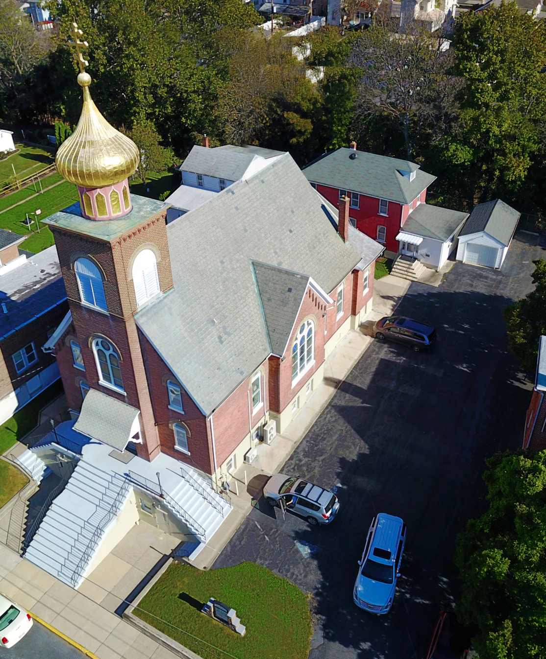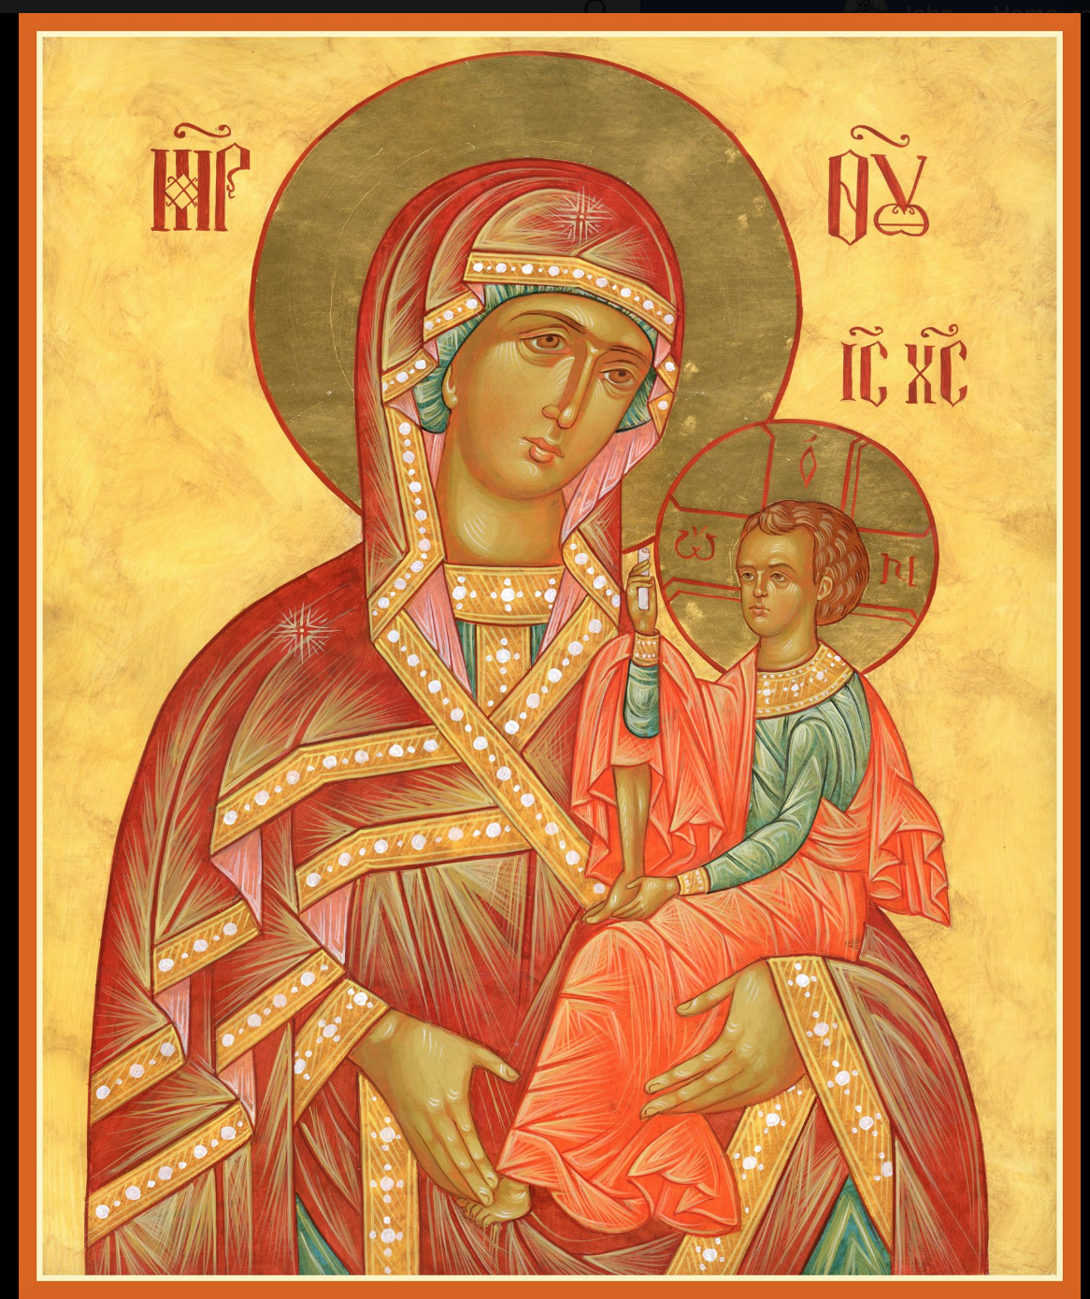

ASSUMPTION OF THE VIRGIN MARY
UKRAINIAN ORTHODOX CHURCH
ECUMENICAL PATRIARCHATE OF CONSTANTINOPLE AND NEW ROME
1301 Newport Avenue
Northampton, Pennsylvania 18067
Mitered Archpriest Myron Oryhon
Rev. Fr. Oleh Kravchenko, Attached
Protodeacon Mychail Sawarynski, Attached

Telephones: Church Office… (610) 262-2882
Church Fax/Kitchen/Hall… (610) 262-0552
Fr. Myron Oryhon – (607) 752-1999
Fr. Oleh Kravchenko – (732) 507-2274
Protodeacon Mychail’s Residence… (610) 262-3876
Websites: holyassumption.org
ukrainianorthodoxchurchusa.org
lvorthodox.wordpress.com
E-mail: Parish… avmuoc@gmail.com
Protodeacon Mychail…pravoslavni@rcn.com
Webmaster, John Hnatow… john.hnatow@gmail.com
==============================================================
25th August (12th Aug.) 2019

Tenth Sunday after Pentecost. Tone 1. Afterfeast of the Transfiguration. Martyrs ANICETUS & PHOTIUS, of Nicomedia (305)
Hieromartyr ALEXANDER, Bishop of Comana (3rd C.)
Martyrs PAMPHILIUS & CAPITO.
1 Corinthians 4:9-16 Matthew 17:14-23

PROPERS FOR LITURGY OF ST. JOHN CHRYSOSTOM

Tropar of the Resurrection, Tone 1
When the stone had been sealed by the Jews, while the soldiers were guarding Your Most Pure Body, You arose on the third day, Savior, granting life to the world. Therefore, the Powers of Heaven cried to You Giver of Life: Glory to Your Resurrection, Christ. Glory to Your Kingdom. Glory to Your Divine Plan, only Lover of Mankind.

Tropar of the Dormition, Tone 1
In giving birth, you preserved your virginity. In falling asleep you did not forsake the world, Birth-Giver of God. You were translated to Life, Mother of Life, and through your prayers you deliver our souls from death.

Tropar of the Transfiguration, Tone 7
You were Transfigured on the Mount, O Christ God, revealing Your glory to Your disciples as far as they could bear it. Let Your ever-lasting Light shine upon us sinners. Through the prayers of the Birth-Giver of God, O Giver of Light, glory to You.

Tropar to the Holy Martyrs, Tone 4
Your holy martyrs Anicetus and Photius, O Lord, through their sufferings have received incorruptible crowns from You, our God. For having Your strength, they laid low their adversaries and shattered the powerless boldness of demons. Through their inter-cessions, save our souls.

Kondak of the Resurrection, Tone 1
As God, You arose from the tomb in glory, raising the world with Yourself. Human nature praises You as God for death has vanished. Adam exults, Master. Eve, free from bondage, rejoices and cries out: “You Christ, are the Giver of Resurrection to all.”

Glory to the Father and to the Son and to the Holy Spirit.

Kondak of the Transfiguration, Tone 7
When You were transfigured on the mountain, Christ God, Your disciples saw as much of Your Glory as they could bear. So that when they looked upon You being crucified, they would understand that You suffered freely and proclaim to the world that You are indeed the radiance of the Father’s glory.

Now and ever and unto ages of ages. Amen.

Kondak of the Dormition, Tone 2
Neither the tomb nor death had power over the Birth-Giver of God; she is ever watchful in her prayers and in her intercession lies un-failing hope. For as the Mother of Life, she has been translated to life by the One Who dwelt within her ever-virginal womb.

Prokimen of the Resurrection, Tone 1
Let Your mercy, Lord, be upon us as we have put our hope in You.

Verse: Rejoice in the Lord, you righteous. Praise befits the upright.

Prokimen of the Feast, Tone 4
Lord, how many are Your works. In wisdom You have made them all.

Alleluia Verses in Tone 1
God gives me retribution and has subdued peoples under me.

He magnifies the salvation of the king and deals mercifully for His anointed, for David and his seed forever.

The Heavens re Yours, the earth also is Yours.

Blessed are the people who know the sound of joy.

In place of “It is right in truth…”
Magnify, my soul, the Lord Who was transfigured on Tabor.
Irmos, Tone 4: Your birth-giving was undefiled. God came forth from your womb and He appeared on earth in the flesh, making His dwelling among mortals. Therefore, Birth-Giver of God, we all magnify you.
Communion Hymn:
Praise the Lord from the heavens, praise Him in the Highest.
Lord, we will walk in the light of Your Countenance and exult in our Name forever. Alleluia (3X)

LITURGICAL MENEION & SCRIPTURE READINGS
FOR THE ELEVENTH WEEK AFTER PENTECOST

Mon. 26 Aug. Leave-taking of the Transfiguration. MAXIMUS the
FAST: Confessor (662). Martyrs HIPPOLYTUS, CON-
OIL CORDIA, IRENAEUS & ABUNDIUS of Rome.
2 Corinthinas 2:3-15 Matthew 23:13-22

Tue. 27 Aug. Prophet MICAH (8th C. BC) Hieromartyr FAST: MARCELLUS, Bishop of Apamea (389).
OIL 2 Corinthians 2:14-3:3 Matthew 23:23-28

Wed. 28 Aug. DORMITION OF THE MOTHER OF GOD.
FISH PARISH PATRONAL FEAST DAY.
Philippians 2:5-11 Luke 10:38-42, 11:27-28
8:30 AM THIRD & SIXTH HOURS
9:00 AM DIVINE LITURGY & BLESSING OF
FLOWERS & HERBS

Thurs. 29 Aug. Translation of the IMAGE NOT MADE BY
HANDS of our LORD (944). Martyr DIOMEDES
the Physician of Tarsus in Cilicia (298). Ven. CHERIMON of Egypt (4th C.)
2 Corinthians 3:4-11 Matthew 23:29-39

Fri. 30 Aug. Martyr MYRON of Cyzicus (250). Martyrs
FAST THYRSUS, LEUCIUS & CORONATUS (250).
2 Corinthians 4:13-18 Matthew 24:27-51

Sat. 31 Aug. Martyrs FLORUS & LAURUS of Illyria (2nd C.)
1 Corinthians 1:3-9 Matthew 19:3-12

5:00 PM GREAT VESPERS

Sun. 01 Sept. 11th Sunday after Pentecost. AFTERFEAST of the
DORMITION. Martyr ANDREW STRATELATES
& 2,593 soldiers with him in Cilicia. Tone 2.
8:30 AM THIRD & SIXTH HOURS
9:00 AM DIVINE LITURGY of JOHN CHRYSOSTOM

Bene Note: ON HOLY COMMUNION
Please be advised that according to the Canons of the Orthodox Church, the Sacrament of Holy Communion may be administered only to Orthodox Christians ( Baptized & Chrismated), making them living members of the Body of Christ). One must be prepared to approach the Holy Chalice by fasting, prayer and confession.

NECROLOGY:
25 Aug… Stephen Nazar ‘26
26 Aug… John Marakovits ‘57
27 Aug… Michael Budnick ’44, Anna Piatok ’87, Evhen Proch ‘14
29 Aug… Pauline Poticha ’68, John Sawarynski ‘62
31 Aug… Danylo Chymiy ’26, Mary Vitushinsky ’82,
George Dorosh ‘00

VICHNAYA PAMYAT! MEMORY ETERNAL

BIRTHDAYS:
25 Aug… Andrew Sawarynski
27 Aug… Joseph Seremula

ANNIVERSARIES:
01 Sept… Paul & Cheryl Sawarynski

MNOHAYA LITA! MANY YEARS!
WE PRAY FOR THE HEALTH AND WELL-BEING of the ill afflicted: William Savitz, Catherine Kochenash, Fr. Vasyl Dovgan, Vladimir & Emma Krasnopera, Tessie Kuchinos, Brendan Phillips, Jessie Hnatow, Jessica Meashock, Adam Hewko, Betty Hendrickson, Andrew Thaxton, Michelle Pierzga, Susan Ferretti, Carole Zarayko, William Fischer, Ekaterina Seremula, Marianna Goshow, Judy Albright, Jerome Yankowy.

FR. OLEH & PANI OL’HA would like to invite all parishioners to the BAPTISM & CHRISMATION of their infant daughter, ELIZABETH, on Monday, September 2nd in our church beginning at 10 AM. ARCHBISHOP DANIEL will officiate.

SAVE THE DATE: ANNUAL CHURCH PICNIC will be held at Canal St. Park with a “PIG ROAST” catered by Fr. James Cairns on SATURDAY, SEPTEMBER 28th from 12 noon to 7 PM. Outdoor Vespers will be served beginning at 5 PM at the park.

OCMC “AGAPE CANISTER” DONATIONS were $16.00; thank
you for your support of our Missions around the globe.

NORTHAMPTON FOODBANK is still in need of foodstuffs, especially tuna, canned potatoes and baby food. Huge thanks to Reader Maximos, Steve, Melanie, Paul, Barbara, Michael, Helen, Linda, Margaret, Linda, Howard, Juanita and Kathy for volunteering and helping at the Food Bank in July. Donations are gratefully appreciated. Food Bank is on Facebook; “Home of the Northampton Area Food Bank”.

VOLUNTEERS needed for COFFEE HOUR, Sept. 01st . Sign-up sheet in Hall. Coffee will be prepared. You supply baked goods.

Please continue to save Redner’s tapes; use your Reward’s Card.”

PARISH COUNCIL MEETING, WEDNESDAY, SEPT. 4th at 7 PM.

SUNDAY SCHOOL SCHEDULE

Mrs. Mary Ost – Pre-K to 3rd grade. All Sundays beginning Sept. 8th.

Mrs. Linda Winters – 4th to 6th grade: Sept. 8th – 9 AM, 15th - 11 AM, 22^{nd -} 9 AM, 29th – 9 AM; Oct. 6th – 11 AM, 13th – 9 AM,
20th – 11 AM, 27th – no class; Nov. 3rd – 11 AM, 10th – 9 AM,
17th – 11 AM, 24th - 9 AM; Dec. 1st – 11 AM, 8th – 9 AM,
15th – St. Nicholas Program, 22nd – 9 AM

Ms. Bettyann Woyewoda – 7th to 12th grade – all classes at 9 AM beginning on August 25th.

MEMORIAL DONATIONS TO THE CHURCH
“IN MEMORY OF + WASYL HEWKO”

$100 $20
Fred Stubits Dorothy Geosits
Pat Lorenz & Eric Jacobs Anna Hammel & Family
Steve & Heidi Skrapits
$50 Rose & Vince Grabarits
Jack & Carol Meyers Andy & Gerry Filipovits
Paul Kochenash Frank & Julie Harhart
Arnold & Irene Urban
$40 Vladimir & Emma Krasnopera
Gerald & Tessie Reenock
$15
$25 Caroline, Phyllis, John Yastrzab
Roger & Karen Seremula Kathryn Novogratz
Michael Hnatow
Christine & Bill Nagle $10
Martha Jandrisevits June Mishko
Nancy Novogratz Sharon Geosits
Frances Rupinski John & Janet Meyers
Mr. & Mrs. Felix Jurasits Catherine Kochenash
Theresa Geosits

