ASSUMPTION OF THE VIRGIN MARY UKRAINIAN ORTHODOX CHURCH
ECUMENICAL PATRIARCHATE OF CONSTANTINOPLE AND NEW ROME
1301 Newport Avenue, Northampton, Pennsylvania 18067
Rev. Fr. Oleg Kravchenko, Rector
Protodeacon Mikhail Sawarynski, Attached
Websites: holyassumption.org and ukrainianorthodoxchurchusa.org
Facebook: Assumption of the Virgin Mary Ukrainian Orthodox Church
YouTube: AVM UOC Church
Contacts:
Fr. Oleg Kravchenko - (484) 834-7261; olegkravchenko2212@gmail.com
Protodeacon Mikhail – (H) (610) 262-3876); pravoslavni@rcn.com
Office – (610) 262-2882; avmuoc@gmail.com
Webmaster, John Hnatow – john.hnatow@gmail.com

Click HERE for Prayer in Time of Corona Virus
Tune in to our news, announcements, and online Facebook Livestream Liturgies HERE!

LET’S PRAY FOR THE PEACE IN UKRAINE!

DAILY LITURGICAL CALENDAR, SCRIPTURE READINGS AND MENAION

Sun. 28 Aug. ELEVENTH SUNDAY AP. TONE 2. DORMITION of our MOST HOLY LADY the THEOTOKOS and EVER VIRGIN MARY.
Epistles: 1 Corinthians 9:2-12 & Philippians 2:5-11
Gospels: Matthew 18:23-35 & Luke 10:38-42, 11:27-28
Blessing of flowers and herbs Festal Brunch

HAPPY PATRONAL FEAST DAY OF OUR PARISH!

Today’s Bulletin is sponsored in loving memory of John Sawarynski and is offered by his grandson, Protodeacon Mikhail.

Liturgical Meneion & Scripture Readings
Mon. 29 Aug. Martyr Diomedes the Physician of Tarsus in Cilicia (298).
2 Cor. 5:10-15 Mk.1:9-15
Tue. 30 Aug. Martyr Myron of Cyzicus (250).
2 Cor. 5:15-21 Mk. 1:16-22
6:30 PM Moleben for Ukraine (our church)
Wed. 31 Aug. Martyrs Florus and Laurus of Illyria (2nd c.).
2 Cor. 6:11-16 Mk. 1:23-28
6:30 PM Parish Board Meeting
Thu. 01 Sep. Martyr Andrew Stratelates.
2 Cor. 7:1-10 Mk. 1:29-35
9:30 AM Divine Liturgy and Door Opening of the Chrysostom Academy
Fri. 02 Sep. Prophet Samuel.
2 Cor. 7:10-16 Mk. 2:18-22
Sat. 03 Sep. Apostle Thaddeus.
1 Cor. 1:26-29 Mt. 20:29-34
5:00 PM Great Vespers with Examination of Conscience.

Sun. 04 Sep. Blessing of the youth for the new Academic Year
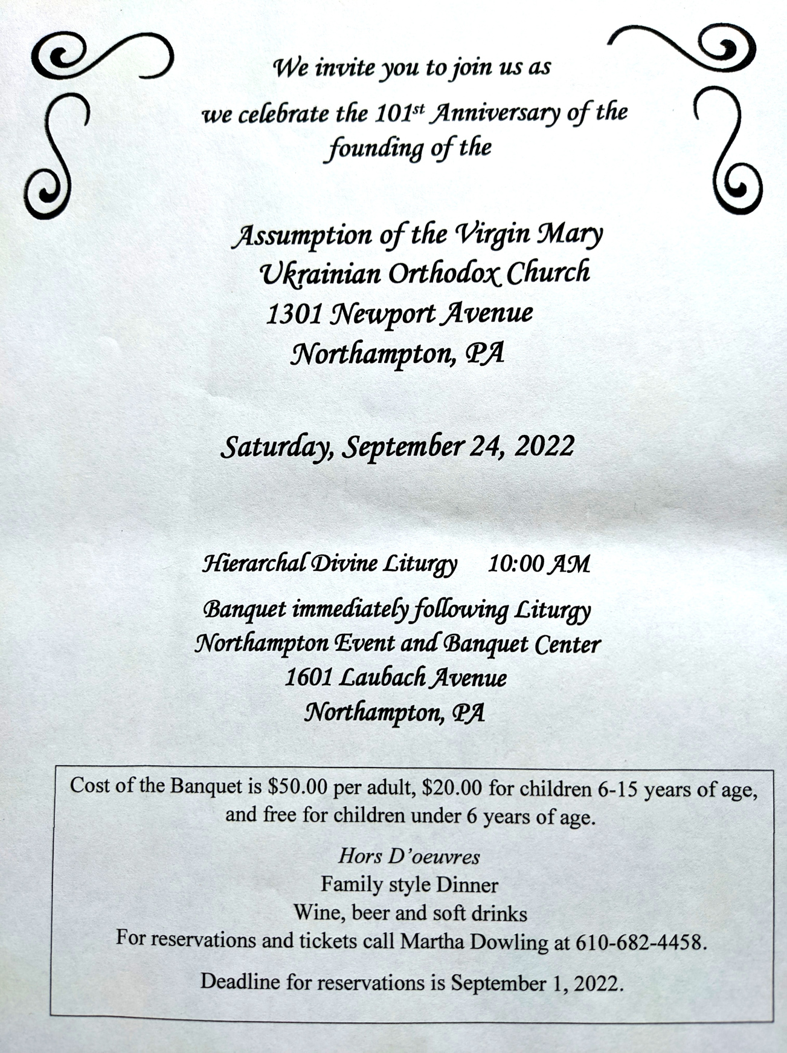

PROPERS FOR THE LITURGY OF ST. JOHN CHYRSOSTOM
Tropar Resurrection, Tone 2. When You descended to death, Life Immortal, You slayed Hell with the splendor of Your Divinity. And when from the depths You raised the dead, all the powers of Heaven cried out: Giver of life, Christ our God, glory to You.
Tropar of the Dormition, Tone 1. In giving birth, you preserved your virginity. In falling asleep you did not forsake the world, Birth-Giver of God. You were translated to life, Mother of Life, and through your prayers you deliver our souls from death.
Glory… Kondak Resurrection, Tone 2. Hell became fearful, Almighty Savior, seeing the miracle of Your Resurrection from the tomb. The dead arose and all creation, with Adam, beheld this and rejoiced with You and the world my Savior, praises You forever.
Now and ever… Kondak of the Dormition, Tone 2. Neither the tomb nor death had power over the Birth-Giver of God; she is ever watchful in her prayers and in her intercession lies unfailing hope. For as the Mother of Life, she has been translated to life by the One Who dwelt within her ever-virginal womb.
Prokimen of the Resurrection, Tone 2. The Lord is my strength and my song. He has become my salvation.
Verse: The Lord has chastened me sorely, but He has not given me over to death.
Prokimen of the Dormition, Tone 3. My soul magnifies the Lord and my spirit rejoices in God my Savior.
Epistles: 1 Corinthians 9:2-12 & Philippians 2:5-11
Alleluia Verses Tone 2. May the Lord answer you in the day of trouble. May the Name of the God of Jacob protect you.
Lord, save the king and hear us on the day we call out to You.
Lord, arise into Your rest, You and the Ark of Your holiness.
Gospels: Matthew 18:23-35 & Luke 10:38-42, 11:27-28
Instead of “It is right in Truth”. Beholding the Dormition of the Most Pure One, the angels were amazed, as the Virgin was taken up from earth to heaven.
Irmos, Tone 1: In you, Pure Virgin, the bounds of nature are overcome; Childbirth remains virginal and death is betrothed to life, Birth-Giver of God, Virgin after bearing a child and alive after death, always save your inheritance.
Communion Hymn: I will take the cup of salvation and call upon the Name of the Lord. Alleluia (3X).
- Data change of Parish outing to the Sight and Sound Theater in Lancaster to October 5 (3 pm). Youth are free.
- Melanie Unger is seeking names of parishioners to be sponsors on our Parish's "booster" page for the 101st Anniversary yearbook. Please submit $10.00 per name for this page to show your love and support for our beloved Church on her 101st birthday. Happy birthday to Assumption of the Virgin Mary Ukrainian Orthodox Church. Mnohaya lita!
- Ukrainian language course starts in September. Please Sign up at the hall.
- Divine Liturgy and Door Opening of our Chrysostom Academy with His Eminence Met. Savas of Pittsburgh GOA. September 1st, 9:30 AM. 395 Bridle Path Rd, Bethlehem, PA 18017.
- Welcome to opening of new Academic Year at St. Sophia Seminary. 10 September, 10am.
- CHOIR REHEARSAL for the 101st parish anniversary Divine Liturgy will be in the church hall, Thursday, September 22nd at 7PM. All choir members are asked to attend. Also, if they is anyone that currently doesn’t sing in the choir but wants to do so for the anniversary, please come join us for rehearsal.
-Day at the Ballpark - Sunday; September 25, 1:35 PM - join our sister Parish St. Mary’s UOC in Allentown for an afternoon and root for the Iron Pigs as they take on the Scranton\Wilkes-Barre RailRiders. Tickets are $28. Youth are free. Picnic Patio area. For tickets ask Fr. Oleg.
- There is a possibility to have a professional icon workshop in our church with an experienced iconographer. Interested?-ask Fr. Oleg.
- Welcome to contribute articles or pictures to the bulletin. Let's make bulletins together!
- Pan-Orthodox Virtual Bible Study via Zoom. Wednesdays at 12 PM. Meeting ID: 576 301 6482. Passcode: 238492. To make it on a big screen at hall ask Fr. Oleg.
- Donations for Ukraine: medical supplies, diapers, baby food, new shoes and clothing.
- For food bank: baby foods, canned potatoes and meats, tuna, pasta, sauces, mac. & cheese.
ANNIVERSARIES:
01 Sept…Paul & Cheryl Sawarynski
02 Sept…William & Nadine Savitz
MANY YEARS!

BIRTHDAYS:
02 Sept…Juanita Vitushinsky \МНОГАЯ ЛІТА!

NECROLOGY:
All Ukrainian civilians and soldiers killed in the Russian invasion.
29 Aug…John Sawarynski ’62, Pauline Poticha ‘68
31 Aug…Danylo Chymij ’26, Mary Vitushinsky ’82, George Dorosh ’00
01 Sept…Stephen Nazar ’64, Wasyl Andrus’69, Stephen Trimpey ’75, Lyudmila Poshtar ‘93
02 Sept…James Onuschak ‘27
MEMORY ETERNAL! ВІЧНАЯ ПАМ’ЯТЬ!

PRAYER FOR THE HEALTH & SALVATION OF THE AFFLICTED: Ukrainian soldiers and civilians wounded during the Russian aggression, Metropolitan Antony, Helen Crayosky, Raisa Melnychuk, Vira Muzychka, Ivan, William Leszczuk, child Charlie, Angela Knoblach, James Osmun, priest Vasyl Dovgan, Rosemarie Pypiuk, Kirk Swauger, Stephanie Donnelly, Nicholas Alexander, Danny Berro, child Alexandria, Elizabeth Pastushenko, Philippe Chasseuil, Joan Molnar, Brandon and Stacy Snyder, Aaliyah Osmun, Ihor Broda, William Savitz, Vladimir Krasnopera, Brendan Phillips, Jessie Hnatow, Jessica Meashock, Adam Hewko, Andrew Thaxton, Susan Ferretti, Judy Albright, Rob Hewko, Daniel Kochenash, Christopher Mack, Norman Betrous, Tom Petro Jr., Robert Zarayko Jr.
The Blessing of Flowers. On the Feast of Falling-asleep (Dormition) of the Mother of God, tradition teachers us that when Mary "Fell-asleep in the Lord" the apostles put her in Tomb. The tradition claims that flowers were discovered in her tomb after her body was taken to heaven has influenced this office and made it the blessing of flowers. As the remainder of this event, flowers were and are brought to the Churches and blessed. They now seen not merely as a thing of beauty, but a living sign of God's presence in nature. The historical origin of this custom seems to have been the blessing of the first fruits of olives by the Patriarch of Constantinople. The Slav texts title it as "Blessing of Herbs," and the intention of prayer seems to be the blessing of herbs that were used for medical purposes in the summer heat which was conductive to many infectious diseases.
By Sr. Vassa. “…for he has regarded the humility of his handmaiden. For behold, henceforth all generations will call me blessed.” (Lk 1: 48, The “Song” of the Theotokos)
Is this a “humble” statement, I mean, the part about “henceforth all generations will call me blessed”? Of course it is, because the Mother of God said it. But I think, mainly because of our misconceptions of “humility,” were anyone else to make mention of their fame, let alone anticipate their future fame, “henceforth,” in “all generations,” we would probably find such words “not humble,” at the very least. “Humility,” however, does not mean being blind to our gifts or blessings, but rather seeing them in the proper light, and that is, as given by God, and with heartfelt gratitude to Him. In fact, taking an honest look at our “strengths” and positive sides, as given by God, is a healthy exercise in gratitude, which is so central, so essential, for our connection or communion with God. While we also need regularly to have an honest look at our weaknesses and shortcomings, we also need to remain grateful, and bless God, for our own, unique gifts, like, having a good sense of humor, or a knack for organization, or for playing a musical instrument, or for being a good listener, or being blessed with a loving marriage, or with a good job, or with a good education, or simply with good looks. A recognition and gratitude for these gifts, as “related” to God, because He has given them, inspires us to serve Him and others through them, to His greater glory. Most Holy Theotokos, today, when we celebrate Your Dormition, help us to be “humbled,” also through our gifts and blessings, as You were. Because Your "gifts," like being the Mother of One crucified, were also Your "cross," as are ours. Most Holy Theotokos, save us!
Urban legend has it that in 1990 a woman entered a Haagen-Dazs in the Kansas City Plaza for an ice-cream cone. While she was ordering another customer entered the store. She placed her order, turned and found herself staring face to face with Paul Newman. He was in town filming Mr. and Mrs. Bridge. His blue eyes made her knees buckle. She finished paying and quickly walked out of the store with her heart still pounding. Gaining her composure she suddenly realized she didn't have her cone; she turned to go back in. At the door she met Paul Newman who was coming out. He said to her, "Are you looking for your ice-cream cone?" Unable to utter a word she nodded yes. "You put it in your purse with your change." When was the last time the presence of God made us forget what was going on around us? Made us forget the dishes? Made us forget the ball games? Made us forget bank accounts? Made you forget where...you put your ice cream cone?

