ASSUMPTION OF THE VIRGIN MARY UKRAINIAN ORTHODOX CHURCH
ECUMENICAL PATRIARCHATE OF CONSTANTINOPLE AND NEW ROME
1301 Newport Avenue, Northampton, Pennsylvania 18067
Rev. Fr. Oleg Kravchenko, Rector
Protodeacon Mikhail Sawarynski, Attached
Websites: holyassumption.org and ukrainianorthodoxchurchusa.org
Facebook: Assumption of the Virgin Mary Ukrainian Orthodox Church
YouTube: AVM UOC Church
Contacts:
Fr. Oleg Kravchenko - (484) 834-7261; olegkravchenko2212@gmail.com
Protodeacon Mikhail – (H) (610) 262-3876); pravoslavni@rcn.com
Office – (610) 262-2882; avmuoc@gmail.com
Webmaster, John Hnatow – john.hnatow@gmail.com

Click HERE for Prayer in Time of Corona Virus
Tune in to our news, announcements, and online Facebook Livestream Liturgies HERE!
LET’S PRAY FOR THE PEACE IN UKRAINE!

Sun. 11 Sep. THIRTEENTH SUNDAY AFTER PENTECOST. TONE 4. BEHEADING OF THE GLORIOUS PROPHET, FOREUNNER & BAPTIST, JOHN. (Strict Fast Day)
1 Corinthians 16: 13-24 & Acts 13: 25-32
Matthew 21: 33-42 & Mark 6: 14-30
HAPPY GRANDPARENT’S DAY!

Make a list of the living and deceased and bring to the Altar. We’ll pray for them during Liturgy.
For pastoral visits at home or in a hospital, please let Fr. Oleg know.

Bulletin is sponsored by Janet and Bettyann Woyewoda in loving memory of + Pauline Woyewoda.

And also

by Melanie Unger in loving memory of my brother, + Michael Smallen on the fourth anniversary and my cousin, + Roger Evhen, on the third anniversary of repose in the Lord.

DAILY LITURGICAL CALENDAR, SCRIPTURE READINGS AND MENAION

Mon. 12 Sep. Sts. Alexander (340), John (595), and Paul the New (784), patriarchs.
2 Cor. 12:10-1 Mk. 4:10-23
Tue. 13 Sep. The Placing of the Cincture (Sash) of the Most Holy Theotokos (395-408).
2 Cor. 12:20–13:2 Mk. 4:24-34
6:30 PM Moleben for Ukraine (Holy Protection, Allentown)
Wed. 14 Sep. Church New Year. St. Symeon Stylites (459)
1 Tim. 2:1-7 Lk. 4:16-22
Thu. 15 Sep. 3,628 Martyrs who suffered at Nicomedia (3 rd-4th c.).
Gal. 1:1-10, 20 – 2:5 Mk. 5:1-20
Fri. 16 Sep. St. Phoebe, deaconess at Cenchreae near Corinth (1st c.).
Gal. 2:6-10 Mk. 5:22-24, 35 – 6:1
Sat. 17 Sep. Holy Prophet and God-seer Moses (1531 B.C.).
1 Cor. 4:1-5 Mt. 23:1-12
5:00 PM Great Vespers
Sun. 18 Sep. 9:00 AM Divine Liturgy

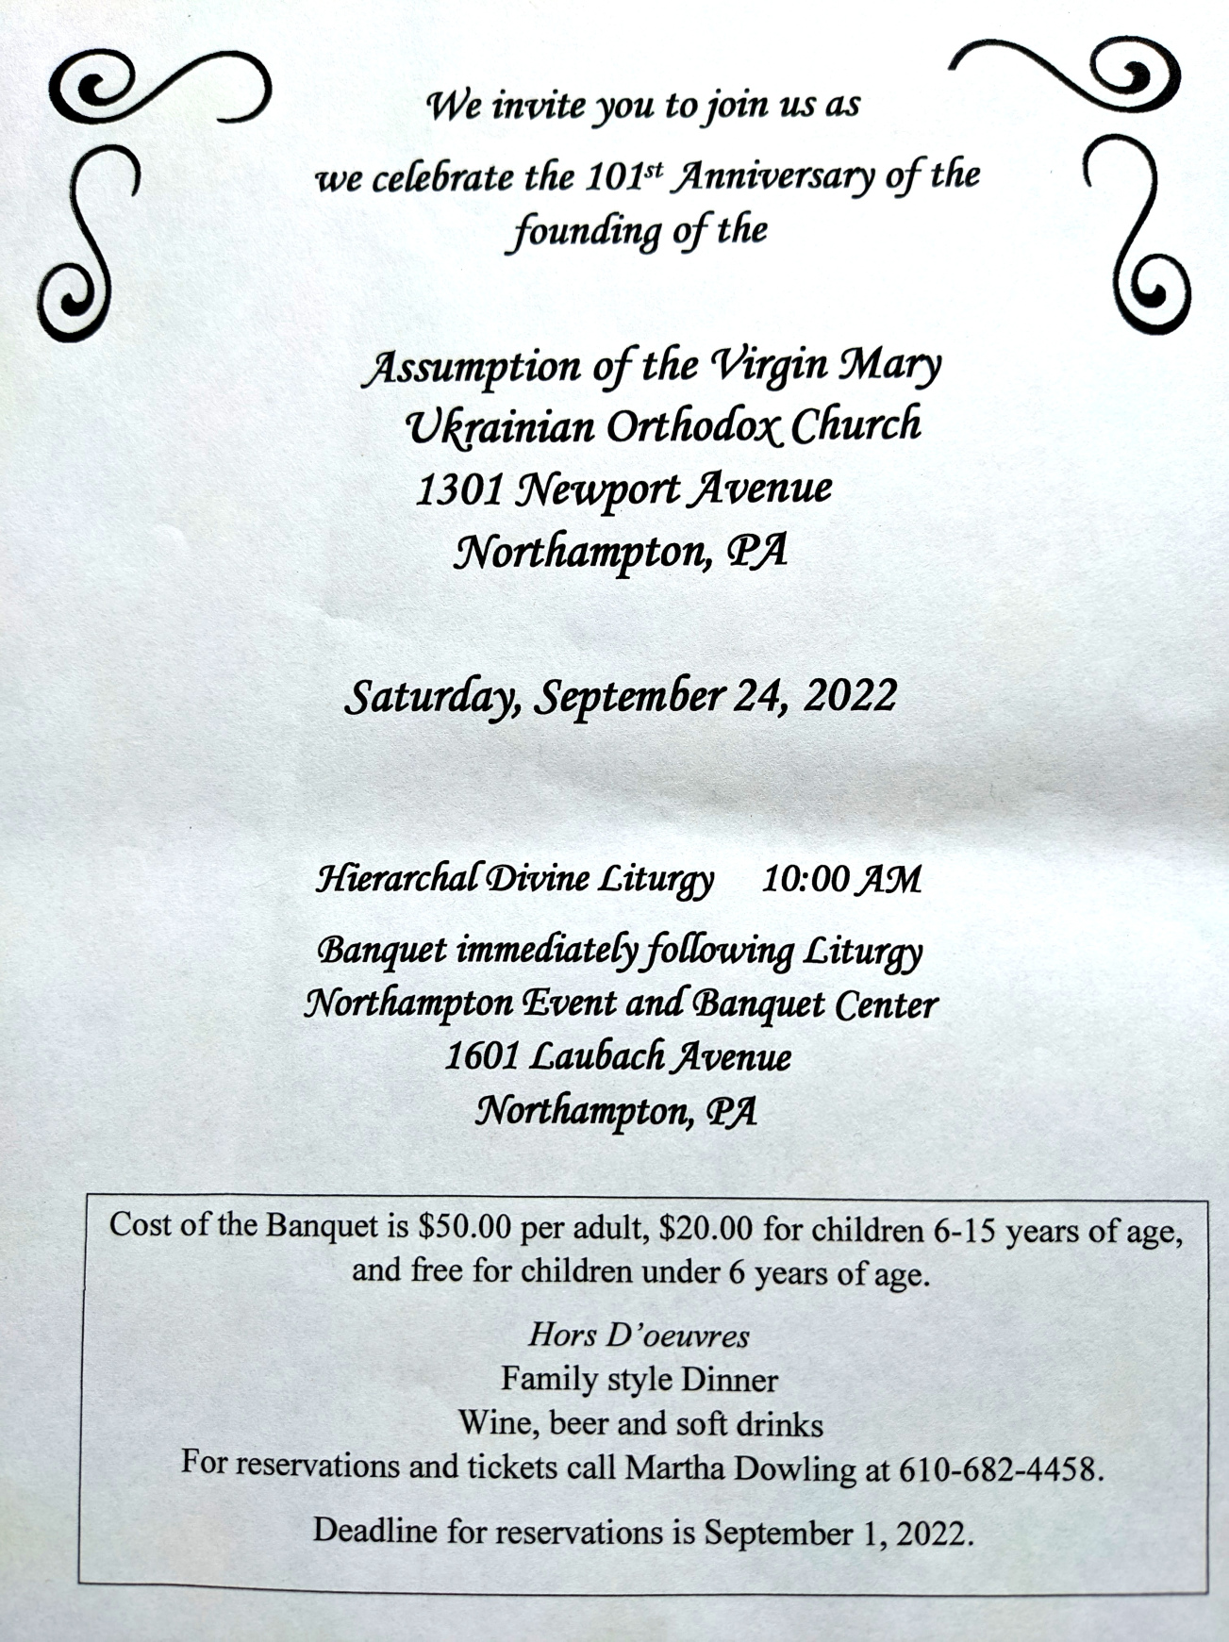

PROPERS FOR THE LITURGY OF ST. JOHN CHYRSOSTOM
Tropar of the Resurrection, Tone 4. When the women disciples of the Lord learned from the angel the joyous message of Your Resurrection, they cast away the ancestral curse and with gladness told the Apostles: Death is overthrown. Christ God is risen, granting the world great mercy.
Tropar of the Dormition, Tone 1. In giving birth, you preserved your virginity. In falling asleep you did not forsake the world, Birth-Giver of God. You were translated to life, Mother of Life, and through your prayers you deliver our souls from death.
Tropar of the Beheading, Tone 2. The memory of the Righteous is praised, but you are well pleased, Forerunner, with the testimony of the Lord. For you truly have been revealed as more honorable than the prophets since you were deemed worthy to baptize in the stream the One they foretold. Therefore, having fought and suffered for the Truth, you have also joyfully preached the good tidings of God revealed in the flesh to those in Hell. He takes away the sins of the world and grants us great mercy.
Kondak of the Resurrection, Tone 4. My Savior and Redeemer, as God, arose from the tomb and delivered the earthborn from bondage. He has shattered the gates of Hell and, as Master, He has risen on the third day.
Glory… Kondak of the Beheading, Tone 5. The glorious beheading of the Forerunner was part of God’s saving plan that the coming of the Savior might be announced even to those in Hell. Weep then, Herodias, that you asked for a wicked murder, because you loved neither God’s law nor eternal life, but only the passing pleasure of life.
Now and ever… Kondak of the Dormition, Tone 2. Neither the tomb nor death had power over the Birth-Giver of God; she is ever watchful in her prayers and in her intercession lies unfailing hope. For as the Mother of Life, she has been translated to life by the One Who dwelt within her ever-virginal womb.
Prokimen of the Resurrection, Tone 4. How marvelous are Your works, O Lord. In wisdom You have made them all.
Verse: Bless the Lord, my soul. O Lord my God, You are very great.
Prokimen, Tone 7. The Righteous shall rejoice in the Lord and hope in Him.
Epistles: 1 Corinthians 16: 13-24 & Acts: 13: 25-32
Alleluia Verses Tone 4. Bend Your bow and proceed prosperously, and reign because of truth, meekness and righteousness.
You have loved righteousness and hated iniquity.
The Righteous shall flourish like a palm tree and shall increase like the cedars of Lebanon.
Gospels: Matthew 21:33-42 & Mark 6:14-30
Communion Hymn: Praise the Lord from the Heavens. Praise Him in the Highest. The Righteous shall be in everlasting remembrance. They shall not be afraid of any evil report. Alleluia (3X).

- Senior UOL Chapter sponsors a YARD/GARAGE SALE Saturday October 22nd from 8 AM to 2 PM! Please search for items that you are willing to donate. All proceeds will benefit our UOL Chapter. Any unsold items will be returned to the donor. Our UOL Chapter assists our Parish by sponsoring activities and events as well as contributing financial assistance.
- Date change of Parish outing to the Sight and Sound Theater in Lancaster to October 5 (3 pm). Youth are free.
- Ukrainian language course. Please Sign up at the hall.
-CHOIR REHEARSAL for the 101st parish anniversary Divine Liturgy will be in the church hall, Thursday, September 22nd at 7PM. All choir members are asked to attend. Also, if thethere is anyone that currently doesn’t sing in the choir but wants to do so for the anniversary, please come join us for rehearsal.
-Day at the Ballpark - Sunday; September 25, 1:35 PM - join our sister Parish St. Mary’s UOC in Allentown for an afternoon and root for the Iron Pigs as they take on the Scranton\Wilkes-Barre RailRiders. Tickets are $28. Youth are free. Picnic Patio area. For tickets – sign up at hall.
- 101st Anniversary of the founding of our Holy Temple. Saturday, September 24, 2022. Hierarchal Divine Liturgy (10:00 AM) and Banquet in Northampton Event and Banquet Center (by preordered tickets only).
- Sign up list for the professional icon workshop in our church is downstairs.
- Welcome to contribute articles or pictures to the bulletin. Let's make bulletins together!
- Pan-Orthodox Virtual Bible Study via Zoom. Wednesdays at 12 PM. Meeting ID: 576 301 6482. Passcode: 238492. To make it on a big screen at hall ask Fr. Oleg.
- Donations for Ukraine: medical supplies, diapers, baby food, new shoes and clothing.
- For food bank: baby foods, canned potatoes and meats, tuna, pasta, sauces, mac. & cheese.

BIRTHDAYS:
14 Sept…Linda Winters
16 Sept…Gabriel Sawarynski
МНОГАЯ ЛІТА! MANY YEARS!

NECROLOGY: All Ukrainian civilians and soldiers killed in the Russian invasion.
11 Sept…All victims of the terrorist attacks upon this nation whose names You alone Lord know, Pauline Woyewoda ’07, Michael Smallen Jr. ’18, Paul Kuchinos ’04, John Magerka.
12 Sept…Peter Vitushinsky ’72, Maria Kap ‘01
13 Sept…Elizabeth Faryna (infant) ’23, Peter Bochniak ’60
14 Sept…Andrew Martnick ’84
15 Sept…Mary Lubianecki ’57
16 Sept…Volodymyr Nazar (infant) ’25, Anna Lelo ’00, Zenovia Martincek ’05,
Nicholas Parchomenko ‘16
17 Sept…Roger Seremula ’19, Mykola Oleksa ’44, Frances Warner ’75, Joseph Nazar’79. Pavlo Papaylo ’52
MEMORY ETERNAL! ВІЧНАЯ ПАМ’ЯТЬ!

PRAYER FOR THE HEALTH & SALVATION OF THE AFFLICTED: Ukrainian soldiers and civilians wounded during the Russian aggression, Metropolitan Antony, John Hnatow, Michael Hnatow, Helen Crayosky, Raisa Melnychuk, Olha Beizyn, Vitaliy Beizyn, Ludmyla Melnychuk, William Leszczuk, child Charlie, Angela Knoblach, James Osmun, priest Vasyl Dovgan, Rosemarie Pypiuk, Kirk Swauger, Stephanie Donnelly, Nicholas Alexander, Danny Berro, child Alexandria, Elizabeth Pastushenko, Philippe Chasseuil, Joan Molnar, Brandon and Stacy Snyder, Aaliyah Osmun, Ihor Broda, William Savitz, Vladimir Krasnopera, Brendan Phillips, Jessie Hnatow, Jessica Meashock, Adam Hewko, Andrew Thaxton, Susan Ferretti, Judy Albright, Rob Hewko, Daniel Kochenash, Christopher Mack, Norman Betrous, Tom Petro Jr., Robert Zarayko Jr
The Challenge of St Simeon Stylites The Byzantine calendar assigns to September 1st, as `saint of the day', the earliest and best known of the `stylites' - those ascetics who, on top of a pillar, lived a life separated from the world'. Such was the extraordinary life of Simeon in the 5th century. The Church seems to throw down a challenge to the world deliberately in inviting us, on the first day of the Church year, to contemplate a case so extreme that it constitutes a paradox. For the life of a stylite appears to be a negation of all the values honored by `reasonable', `civilized', `modern' man. The history of Christian sainthood is full of such cases, which are in some way a scandal. Of course, sainthood adapts itself to the conditions of each age and usually takes on some of the features of contemporary life. But it is good that, from time to time, a voice cries in the desert and sends out a strong call to renunciation and penitence. This call has never ceased being heard, and even in our day, hermit life still has a number of followers'. In honouring Simeon the Stylite on the first day of the year, eastern Christianity takes a clear stand; it shows that it neither disowns nor abandons heroic forms of sainthood. The world does not understand; it either jeers or is indignant. For these belong to the kind of things Jesus spoke of when he said: `I thank thee, O Father, Lord of heaven and earth, because thou hast hid these things from the wise and prudent, and hast revealed them unto babes'.
The parable of the tenants is the second in three parables Jesus tells in the presence of the chief priests and Pharisees. Each parable shares the same basic theme. In the parable of the tenants, a landowner sends servants to collect his fruit only to have two sets of servants killed by the tenants. Finally, he sends his son who is also killed. Jesus asks the priests and Pharisees what would then happen to the tenants. Their response is that the tenants will meet a horrible fate, and new tenants will be chosen. Through our Christian lens, this parable is clear. Although it may not have been as clear to the priests and Pharisees, they obviously understood well enough to be angered and want to get Jesus for it. In our own lives, this parable is applicable as a reminder of our own tenant status in the world. As stewards of God’s creation, how good is our fruit and are we returning to God what belongs to God? (By Tracey Allred)
By Sr. Vassa. So, the girl’s mother has her revenge on the Greatest Among the Prophets. And yet, he is not the victim in this story. Because revenge is neither cathartic nor “sweet,” as both ancient wisdom and modern psychological studies show. It prolongs in the avenger the “unpleasantness” of the original, perceived offense, keeping him or her from “moving on,” and often triggers a new cycle of aggression. In the words of Francis Bacon, it keeps the wounds of the avenger “green, which otherwise would heal, and do well.” In the case of Herod, Salome, and her mother, they are left with a bloody head on a platter, along with the days and weeks that followed, to ponder the mutual manipulation that occurred between them on this night. But the disciples of St. John the Baptist simply “came and took the body and buried it.” They do not continue the usual cycle of revenge. They moved on, as they “went and told Jesus.” And that’s what I’m going to do today, if confronted with any large or small injustice done to me, whether real or just perceived. I hand it over to Him, so the buck stops here, with Him and in Him. “Vengeance is mine, and recompense,” says the Lord (Deut 32: 35). Glory be to Him.

