Sun. 24 Sep. SATURDAY before the EXALTATION of the CROSS. AFTERFEAST OF THE NATIVITY of the VIRGIN MARY. Ven. THEODORA of Alexandria (490). Marytrs DEMETRIUS, his wife, EUANTHIA, & son, DEMETRIANT (1st C.). Martyrs DIODORUS, DIDMYS & DIOMEDES of Laodicea (4th C.) Martyr IA of Persia (363). Ven. EUPHRONSYNUS.
Epistles: 1 Corinthians 2:6-9 & 1 Corinthians 4:17-5:5
Gospels: Matthew 10: 37-11:1 & Matthew 24:1-13

(by preordered tickets only)

Sat. 25 Sep 05:00 PM Great Vespers
Sun. 25 Sep. 09:00 AM Divine Liturgy.

PROPERS FOR THE LITURGY OF ST. JOHN CHYRSOSTOM
Entrance Hymn: Come let us worship and bow down before Christ, Son of God, through the prayers of the Birth-Giver of God, save us who sing to You: Alleluia.
Tropar of the Nativity of Birth-Giver of God, Tone 4. Your Nativity, Virgin Birth-Giver of God, has proclaimed joy in the universe. The Sun of Righteousness, Christ our God, has shone forth from you. By annulling the curse, He gave a blessing. By destroying Death, He has granted us Life Eternal.
Tropar of the Dormition, Tone 1. In giving birth, you preserved your virginity. In falling asleep you did not forsake the world, Birth-Giver of God. You were translated to Life, Mother of Life, and through your prayers you deliver our souls from death.
Tropar to the Venerable Mother Theodora, Tone 8. The image of God was truly preserved in you, O Mother, for you took up the Cross and followed Christ. By so doing you taught us to disregard the flesh for it passes away, but to care instead for the soul, since it is immortal. Therefore, Venerable Theodora, your spirit rejoices with the angels.

Glory…. Kondak of the Nativity of the Birth-Giver of God, Tone 4. By your birth Most Pure Virgin, Joachim and Anna were free from childlessness. And Adam and Eve from the corruption of death. We, you people celebrate this, delivered from the guilt of sin, as we chant to you: “A barren woman gives birth to the Birth-Giver of God, the Mother of our Life.”
Now and ever… Kondak of the Dormition, Tone 2. Neither the tomb nor death had power over the Birth-Giver of God, she is ever watchful in her prayers, and in her intercession lies unfailing hope, for as the Mother of Life, she has been translated to Life, by the One Who dwelt within her ever-virginal womb.
Happy 101st Anniversary of the founding
of our Holy Temple.

Banquet in Northampton Event and Banquet Center
Prokimen of the day, Tone 4. God is wondrous in His Saints, the God of Israel.
Verse: Bless God in the assembly, the Lord from the wellsprings of Israel.
Prokimen of the Virgin Mary, Tone 3. My soul magnifies the Lord and my spirit rejoices in God my Savior.
Alleluia Verses, Tone 3. I waited patiently for the Lord and He was attentive to me. He heard my supplication.
Verse: He brought me up out of the pit of misery and from the mire of the day.
Instead of “it is right in truth”…Tone 8. Magnify, my soul, the Virgin Mary, the glorious Nativity of the Mother of God.
Virginity is alien to motherhood and childbearing is foreign to virgins. Yet, in you Birth-Giver of God, both are found. Therefore, all the nations of the earth, unceasingly magnify you.
Communion Hymns: Praise the Lord from the heavens. Praise Him in the Highest. I will take the cup of salvation and call upon the Name of the Lord. The righteous shall be in everlasting remembrance; they shall not fear any evil report. Alleluia (3X)
We are grateful for: - UOL donated $1500 to the church on behalf of the Anniversary.
- The table mums for the Banquet are donated by John and Linda Vitushinsky in memory of John’s parents and his brother Michael. Also thanks to Danielle Vitushinsky for the church ornaments and the table decorations.
- The flowers in memory of Catherine Kochenash are donated by Marjorie Martin, Sandra Parks and Karen Seremula.
- The flowers in memory of Roger Seremula are donated by Beth Seremula, Karen Seremula, and Mark Seremula.
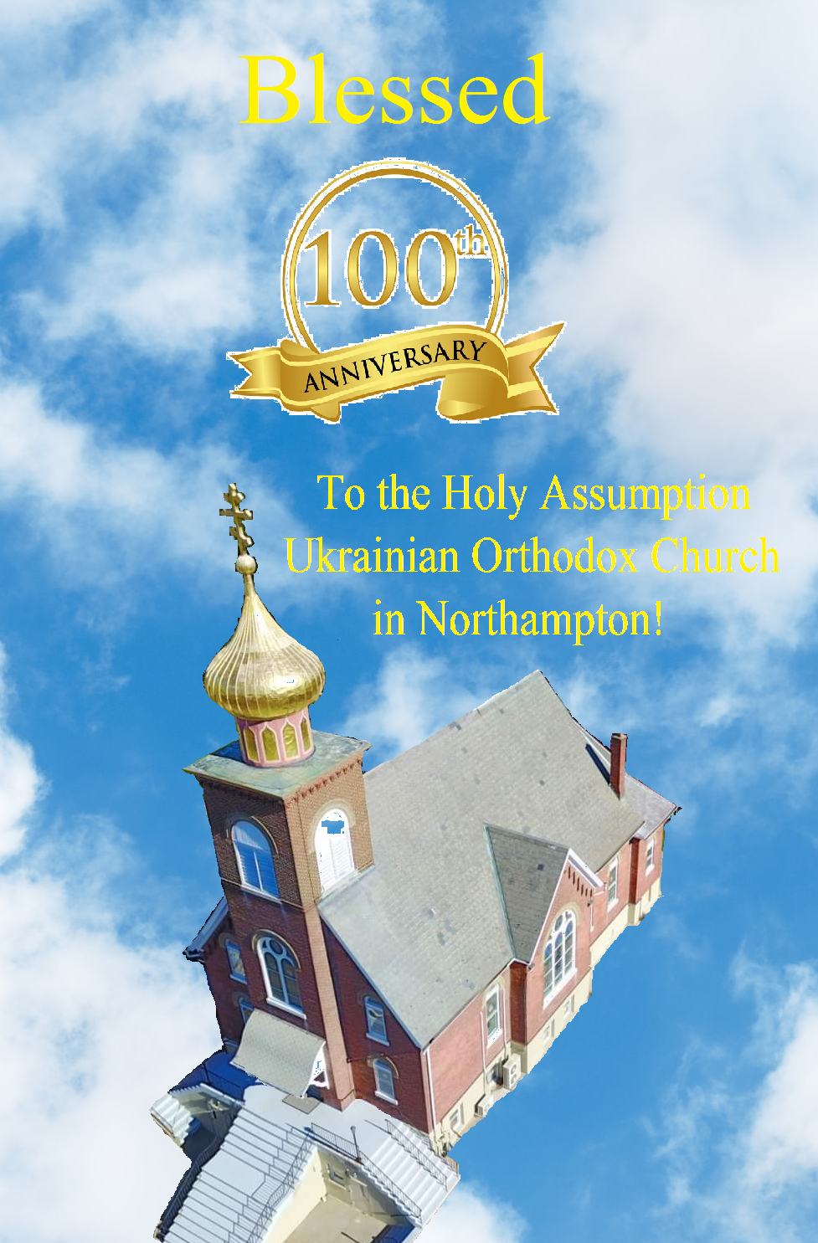
- Please send photos you take at the 101st anniversary celebration to John Hnatow. He will post them on the church website.
-Day at the Ballpark - Sunday; September 25, 1:35 PM - join our sister Parish St. Mary’s UOC in Allentown for an afternoon and root for the Iron Pigs as they take on the Scranton\Wilkes-Barre RailRiders. Tickets are $28. Youth are free. Picnic Patio area. For tickets – sign up at hall.
- Our Church will not be making pierogies until late November due to construction issues. Will keep you posted on the date we will resume production. Thank you for understanding. Please do not call for orders until the new date is posted.
- Senior UOL Chapter sponsors a YARD/GARAGE SALE Saturday October 29th from 8 AM to 2 PM! Please bring over items for Church garage! You can drop them off in the church hall, rectory or church garage. All proceeds will benefit our UOL Chapter. Any unsold items will be returned to the donor. Our UOL Chapter assists our Parish by sponsoring activities and events as well as contributing financial assistance.
- Date change of Parish outing to the Sight and Sound Theater in Lancaster to October 5 (3 pm). Youth are free.
- Ukrainian language courses, Sundays after Liturgies. Please Sign up at the hall.
- Sign up list for the professional icon workshop in our church is downstairs.
- You’re all welcome to contribute articles or pictures to the bulletin. Let's make bulletins together!
- Pan-Orthodox Virtual Bible Study via Zoom. Wednesdays at 12 PM. Meeting ID: 576 301 6482. Passcode: 238492. To make it on a big screen at hall ask Fr. Oleg.
- Donations for Ukraine Winter stuff: winter 0•F sleeping bags (black, grey, olive, dark brown colors only), male winter clothing only, thermal long sleeves underwear and pants, thermal socks, balaclavas, winter tactical mittens, winter non-bright colors coasts, fleece jackets, winter/ski hats, toe warmers, emergency blankets, winter/ski boots, traumatic wounds first aid packets, Amazon gift cards are welcome for buying all needed stuff.
- For food bank: baby foods, canned potatoes and meats, tuna, pasta, sauces, mac. & cheese.

ECUMENICAL PATRIARCHATE OF CONSTANTINOPLE AND NEW ROME
1301 Newport Avenue, Northampton, Pennsylvania 18067
Rev. Fr. Oleg Kravchenko, Rector
Protodeacon Mikhail Sawarynski, Attached
Websites: holyassumption.org and ukrainianorthodoxchurchusa.org
Facebook: Assumption of the Virgin Mary Ukrainian Orthodox Church
YouTube: AVM UOC Church
Contacts: Fr. Oleg Kravchenko – (484) 834-7261; olegkravchenko2212@gmail.com
Protodeacon Mikhail – (H) (610) 262-3876; pravoslavni@rcn.com
Office – (610) 262-2882; avmuoc@gmail.com
Webmaster, John Hnatow – john.hnatow@gmail.com

