ASSUMPTION OF THE VIRGIN MARY UKRAINIAN ORTHODOX CHURCH
ECUMENICAL PATRIARCHATE OF CONSTANTINOPLE AND NEW ROME
1301 Newport Avenue, Northampton, Pennsylvania 18067
Rev. Fr. Oleg Kravchenko, Rector
Protodeacon Mikhail Sawarynski, Attached
Websites: holyassumption.org and ukrainianorthodoxchurchusa.org
Facebook: Assumption of the Virgin Mary Ukrainian Orthodox Church
YouTube: AVM UOC Church
Contacts:
Fr. Oleg Kravchenko - (484) 834-7261; olegkravchenko2212@gmail.com
Protodeacon Mikhail – (H) (610) 262-3876); pravoslavni@rcn.com
Office – (610) 262-2882; avmuoc@gmail.com
Webmaster, John Hnatow – john.hnatow@gmail.com

Click HERE for Prayer in Time of Corona Virus
Tune in to our news, announcements, and online Facebook Livestream Liturgies HERE!
LET’S PRAY FOR THE PEACE IN UKRAINE!

Sun. 13 Nov. 22nd SUNDAY after Pentecost. Tone 5. Apostles STACHY, AMPLIAS, URBAN, NARCISSUS, APELLES, & ARISTOBULUS of the 70. Martyr EPIMACHUS of Pelusium (250). Ven. MAURA of Constantinople (436). Venn. SPYRIDON & Nicodemus, Prosphora bakers of the Kyiv Caves. Galatians 6: 11-18 Luke 8: 26-39

The bulletin is sponsored by Stanley Scioscia in loving memory of his wife,
Thea Marie, on the sixth anniversary of her repose in the Lord. Memory Eternal.

Liturgical Meneion & Scripture Readings

Mon. 14 Nov. Ven. Martyrius the Deacon (13th c.) and St. Martyrius of the Kyiv Caves.
Col. 2:13-20 Lk. 10:22-24
Tue. 15 Nov. Holy and Glorious Great-martyr Demetrius the Myrrhgusher of Thessalonica.
Col. 2:20-3:3 Lk. 11:1-10
06:30 PM Moleben for the peace in Ukraine (St. John the Baptist, Northampton).
Wed. 16 Nov. St. Nestor the Chronicler of the Kyiv Caves (1114).
Col. 3:17-4:1 Lk. 11:9-13
Thu. 17 Nov. Ven. Job of Pochaiv (1651). St. Demetrius, metropolitan of Rostov (1709).
Col. 4:2-9 Lk. 11:14-23
Fri. 18 Nov. Virgin-martyr Anastasia the Roman (256).
Col. 4:10-18 Lk. 11:23-26
Sat. 19 Nov. Hieromartyr Zenobius and his sister Zenobia (285).
2 Cor. 5:1-10 Lk. 8:16-21

05:00 PM Great Vespers.
Sun. 20 Nov. 09:00 AM Divine Liturgy. UOL Meeting. Adult Education.

PROPERS FOR THE LITURGY OF ST. JOHN CHYRSOSTOM
Tropar of the Resurrection, Tone 5. Let us, the faithful, praise and worship the Word, co-eternal with the Father and the Spirit, born for our salvation of the Virgin. In His Good Will, He was lifted up on the Cross in the flesh to suffer death and to raise the dead, by His glorious Resurrection.
Tropar of the Dormition, Tone 1. In giving birth, you preserved your virginity. In falling asleep you did not forsake the world, Birth-Giver of God. You were translated to Life, Mother of Life, and through your prayers you deliver our souls from death.
Tropar to the Apostles, Tone 5. Let us acclaim Stachy, Apelles, Amplias, Urban, Narcissus and Aristoboulos, as a six-stringed harp of the Spirit, singing of God’s marvelous gifts to mankind. Together, as divine Apostles, they ask that grace may be granted to our souls.
Kondak of the Resurrection, Tone 5. You descended into Hell, my Savior, destroying its gates as Almighty, resurrecting the dead as Creator and destroying the sting of death. You have delivered Adam from the curse, Lover of all Mankind. Therefore, we all cry out to You: “Lord, save us.”
Glory… Kondak to the Apostles, Tone 8. Fittingly, let us praise those sacred treasures of the All Holy Spirit and rays of the Sun of Glory, the wise Apostles Apelles, Urban, Aristoboulos, Amplias, Narcissus and Stachy, who received grace from our God.
Now and ever… Kondak of the Dormition, Tone 2. Neither the tomb nor death had power over the Birth-Giver of God, she is ever watchful in her prayers, and in her intercession lies unfailing hope, for as the Mother of Life, she has been translated to Life, by the One Who dwelt within her ever-virginal womb.
Prokimen of the Resurrection, Tone 5. You, O Lord, shall protect us and preserve us from this generation forever.
Verse: O Lord, save me for there is no longer any righteous man.
Epistle: Galatians 6: 11-18
Alleluia Verses, Tone 5. Of Your mercies, O Lord, I will sing forever; unto generation and generation, I will proclaim Your truth with my mouth.
You have said: Mercy will be established forever and My truth will be prepared in the heavens.
Gospel: Luke 8: 26-39
Communion Hymns: Praise the Lord from the heavens. Praise Him in the Highest. Alleluia (3X)

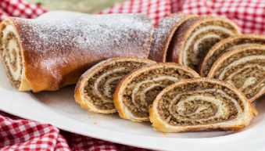
- HOLIDAY NUT ROLL SALE. Fillings: Apricot, Lekvar(Prune), Nut, Poppyseed, Red Raspberry, Pumpkin/Cheese. $17.00 each. Last date for orders: November 22, 2022. Call for orders: Marty 610-682-4458.
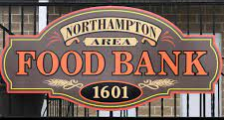
- For the Food Bank: TURKEYS AND 5 POUND HAM! baby foods, canned potatoes and meats, tuna, pasta, sauces, mac. & cheese.

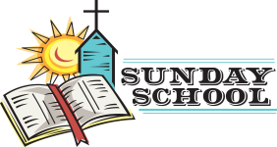
- Sunday School schedule: Mrs. Mary Ost (Preschool/Elementary) Sundays 8:55-9:20 AM. Mrs. Karen Osmun (Secondary) Sundays at 8:45-9:15 AM.

- Our Church will not be making pierogies due to construction issues. Will keep you posted on the date we will resume production. Thank you for understanding. Please do not call for orders until the new date is posted.
- Welcome to contribute articles or pictures to the bulletin. Let's make bulletins together!
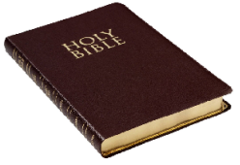
- Pan-Orthodox Virtual Bible Study via Zoom. Wednesdays at 12 PM. Meeting ID: 576 301 6482. Passcode: 238492. To make it on a big screen at hall ask Fr. Oleg.

- NEW List of needed Winter support for Ukraine: winter 0•F sleeping bags (non-bright colors only), new thermal underwear, new thermal socks, balaclavas, winter tactical mittens, toe warmers, men winter/ski warm light boots (9-11sizes), emergency survival kits, emergency burncare dressings, chest seals (Halo), Israeli compression bandages, Celox rapid hemostatic gauzes, any pain relief and antibiotics (pills and IV), NAR CAT tourniquets, Nasopharyngeal airway tubes, high protein bars, military MREs (meals-ready-to-eat), personal water filters (like LifeStraw), Amazon gift cards for buying all needed stuff are welcome.
ANNIVERSARY:
17 Nov…Walter & Mary Ann Dworakivsky
МНОГАЯ ЛІТА! MANY YEARS!

NECROLOGY: Ukrainian civilians and soldiers killed in the Russian invasion.
13 Nov…Amelia Borysenko ’77, Dorothy Pokotello ‘03
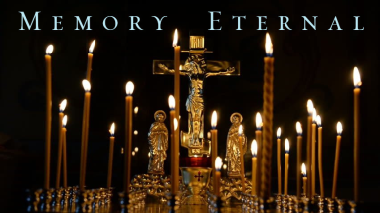
14 Nov…Katherine Kochenash ’89, Joseph Paukovits ‘00
15 Nov…George Porochniak ’83, Gloria Zadubera ’01
16 Nov…Margaret Kuchinos ’06
17 Nov…John Mitchell ’36
18 Nov…Nehme Azar ’95, Andriy Semenovych’41
19 Nov…Anna Huzela ‘09
MEMORY ETERNAL! ВІЧНАЯ ПАМ’ЯТЬ!

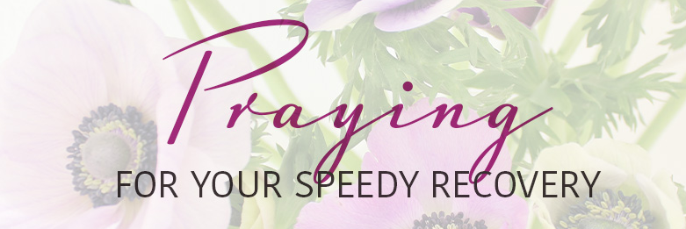
PRAYER FOR THE HEALTH & SALVATION OF THE AFFLICTED: Ukrainian soldiers and civilians wounded during the Russian aggression, Helen Crayosky, Nadine Savitz, Barbara Grason, John Hnatow, Michael Hnatow, Annette DeFiore, Shirl Merolli, Raisa Melnychuk, Olha Beizyn, Vasyl Beizyn, Ludmyla Melnychuk, William Leszczuk, child Charlie, James Osmun, priest Vasyl Dovgan, Rosemarie Pypiuk, Kirk Swauger, Stephanie Donnelly, Nicholas Alexander, Danny Berro, child Alexandria, Elizabeth Pastushenko, Philippe Chasseuil, Joan Molnar, Aaliyah Osmun, William Savitz, Vladimir Krasnopera, Brendan Phillips, Jessie Hnatow, Jessica Meashock, Adam Hewko, Andrew Thaxton, Susan Ferretti, Judy Albright, Daniel Kochenash, Christopher Mack, Norman Betrous, Tom Petro Jr., Robert Zarayko Jr.

ORTHODOXY AROUND THE WORLD
Paralympian Charalambos Tagianides swam 25 miles from Rhodes to Panormitis in Symi on November 4th. The athlete presented his gold medal he won in Mexico to Archangel Michael of Symi fulfilling his promise.
On Nov. 1st His Beatitude Metropolitan Epiphaniy of Kyiv and All Ukraine presented certificates to clergy to carry out service to soldiers as chaplains of the Ukrainian military.
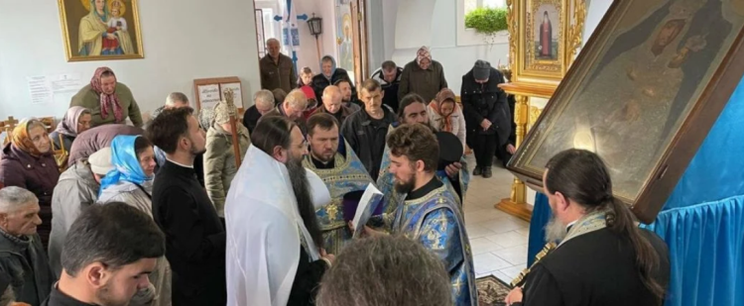
Metropolitan Benjamin of Minsk and Slutsk celebrated the Hierarchal Divine Liturgy on Nov. 6th at the Church of the “Icon of Joy of All Who Sorrow,” now under construction in Minsk since 1991 commemorating the victims of the Chernobyl nuclear disaster of 1986.

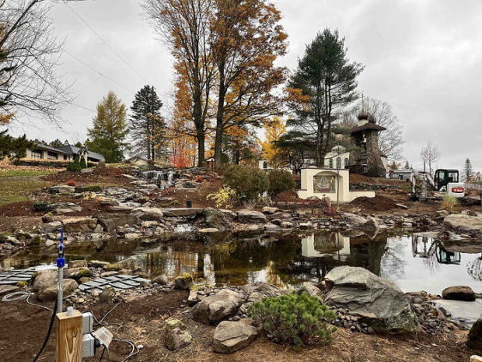
America’s oldest Orthodox Monastery, St. Tikhon’s in Waymart, PA
founded in 1905, has begun construction on a new welcome center for guests and pilgrims. A new icon studio is also under construction. The monastery currently has 18 monks.

Food for Thought. * The sacrament of confession and reconciliation is a great way to drive out our hidden demons that we carry around with us. Have you participated in confession recently? You may find that confessing all of your sins to a priest will make you feel better and clear your conscience.
* Very often events in our life appear to be larger than life and overwhelming. Where does evil manifest itself in your family, with your friends, at your work, or in your parish?' How can you fight this evil and change it into good?
By St. John of Kronstadt: “Remember that the enemy incessantly seeks to destroy you, and attacks you at the time when you least expect it. His malice is infinite. Do not bind yourself by self-love and sensuality, lest they take you an easy prisoner”.
Is It A Devil or a Disease? In polite society we have not wanted to talk much of demons and the demonic. In our liberal, educated culture, we have believed that sin was due mostly to ignorance and that evil could be eradicated by education. In our psychologically enlightened times we have avoided the more ancient religious and mythological language of devils and evil. We have instead preferred words like repression, impulses, sublimation, drives, complexes, phobias, regression, neuroses, psychoses, manic-depressive, schizophrenic and schizoid -- to name a few. If we have been suspicious of religious healers and exorcists and spiritual counselors, we have been implicitly trustful of psychiatrists, psychologists, psychoanalysts, counselors and therapy groups. If we have been doubtful of prayer, meditation and conversion, we have been trustful of amphetamines, barbiturates and tranquilizers, not to mention alcohol, cocaine, and marijuana. If in our time witch doctors have disappeared, strangely enough witches have reappeared by the thousands. Even exorcists are making a small comeback after considerable media exposure and hype. Whether demons and the demonic are widely acknowledged in our time may be debated, but that they were common in Jesus' time we can have no doubt. In his time, when most illness was attributable to sin, it was but a short step to attribute all mental illness or epilepsy to demonic powers actually residing in the person and controlling him or her. Thus to cure a person of seizures or dementia or schizophrenia or melancholia, the healer had to have power not only to name the demon, but power to cast him out, to throw him out of the person's life. (by Maurice A. Fetty)

How to Prepare for the Holy Eucharist …
To all those who partake of the Body & Blood of Christ when they participate in the Divine Liturgy:
As Orthodox Christians, we are called to the Chalice each and every time that we celebrate the Divine Liturgy; however, it is most essential that we prepare ourselves to receive the Lord, so that we will not approach unworthily and risk experiencing the “consuming,” rather than the “purifying” fire of the Eucharist.
With this in mind, the following guidelines will help us in our preparation:
+++ No excessive partying or socializing on Saturday evening…we should keep ourselves in a quiet & prayerful atmosphere, reading the gospels and epistles of the New Testament and praying the “Prayers of Preparation” before Communion (these latter prayers can also be done on Sunday Morning if there is time);
+++ Maintain a prayerful atmosphere on Sunday morning … (difficult with children, yes, but not impossible … try it!);
+++ No consumption of food or drink past a reasonable bedtime the night before (Midnight is preferred)…this includes no smoking and no chewing gum on Sunday morning as well;
+++ If you need your medicine in the morning, please take it … if you are supposed to eat or drink something with it, then do so as moderately as possible;
+++ As always, we should partake of the Sacrament of Confession every month or at least 2 - 4 times a year if we are taking Communion frequently (hint: use the 4 fasting periods of the liturgical year…Advent, Great Lent, Apostles’ Fast & Dormition Fast) … if we are not frequent communicants (3-4 times per month), then Confession is necessary each time we come for Communion;
+++ At the very least, attend the Sunday cycle of prayer…Saturday Evening Vespers, Sunday Morning Matins (morning prayers) and Sunday Divine Liturgy … if we attend Sunday Liturgy irregularly (e.g. – missing more than once a month), then we should not be taking Communion each time we attend, unless we have had Confession in the recent days prior;
+++ Be on time to the Divine Services and be at peace with all people … if we arrive at Church after the Little Entrance with the Gospel, we should not receive Communion on that day … it is truly a sign of disrespect when we enter the services late and / or when we leave the Liturgy early (before the Dismissal) … and … our Lord tells us that we cannot love God and hate our brother … for whoever is “angry with his brother shall be liable to judgment;” (Matthew 5:22)
+++ Fellowship Hour is not to be started until after the Liturgy is completed!
Please strive to practice these Spiritual Disciplines.

