ASSUMPTION OF THE VIRGIN MARY UKRAINIAN ORTHODOX CHURCH
ECUMENICAL PATRIARCHATE OF CONSTANTINOPLE AND NEW ROME
1301 Newport Avenue, Northampton, Pennsylvania 18067
Rev. Fr. Oleg Kravchenko, Rector
Protodeacon Mikhail Sawarynski, Attached
Websites: holyassumption.org and ukrainianorthodoxchurchusa.org
Facebook: Assumption of the Virgin Mary Ukrainian Orthodox Church
YouTube: AVM UOC Church
Contacts:
Fr. Oleg Kravchenko - (484) 834-7261; olegkravchenko2212@gmail.com
Protodeacon Mikhail – (H) (610) 262-3876); pravoslavni@rcn.com
Office – (610) 262-2882; avmuoc@gmail.com
Webmaster, John Hnatow – john.hnatow@gmail.com

Click HERE for Prayer in Time of Corona Virus
Tune in to our news, announcements, and online Facebook Livestream Liturgies HERE!
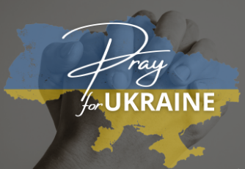

Sun. 27 Nov. 24th SUNDAY after Pentecost. Tone 7. HOLY APOSTLE PHILIP (1st C.) JUSTINIAN, Emperor of Byzantium (565) and his wife THEODORA (548). GREGORY PALAMAS, Archbishop of Thessalonica (1360)
Ephesians 2:14-22 1 Corinthians 4:9-16
Luke 10:25-37 John 1:43-51
Thanksgiving lunch and the last day before the Christmas Fast.
Adult education
BEGINNING OF THE NATIVITY FAST TOMORROW

Liturgical Meneion & Scripture Readings
Mon. 28 Nov. Holy Martyrs and Confessors Gurias (299), Samonas (306), and Abibus.
2 Thess. 1:1-10 Lk. 14:12-15
Tue. 29 Nov. Holy Apostle and Evangelist Matthew (60).
2 Thess. 1:10–2:2 Lk. 14:25-35
06:30 PM Prayer for Ukraine with Archbishop Daniel. Gratitude to Lehigh Valley Community for support (At St. Mary Protection, Allentown).
Wed. 30 Nov. St. Gregory the Wonderworker of Neo-Caesarea (266).
2 Thess. 2:1-12 Lk. 15:1-10
Thu. 01 Dec. Martyr Romanus the Deacon of Caesarea and child-martyr Barulas of Antioh
2 Thess. 2:13 – 3:5 Lk. 16:1-9
Fri. 02 Dec. Prophet Obadiah (9th c. B.C.). Martyr Barlaam (304). Martyr Heliodorus.
2 Thess. 3:6-18 Lk. 16:15-18; 17:1-4;
Sat. 03 Dec. Martyrs Eustace, Thespesius, and Anatolius of Nicaea (312).
Gal.1:3-10 Lk. 9:57-62
05:00 PM Great Vespers with Litiya. Examination of Conscience and Confessions.
Sun. 04 Dec. ENTRY OF THEOTOKOS INTO TEMPLE. 09:00 AM Divine Liturgy.

PROPERS FOR THE LITURGY OF ST. JOHN CHYRSOSTOM
Tropar of the Resurrection, Tone 7. By Your Cross, You destroyed Death. To the Thief, You opened Paradise. For the Myrrh-bearers, You changed weeping into joy. Christ God, You commanded Your disciples to proclaim that You are risen, granting the world great mercy.
Tropar of the Dormition of the Mother of God, Tone 1. In giving birth, you preserved your virginity. In falling asleep you did not forsake the world, Birth-Giver of God. You were translated to Life, Mother of Life, and through your prayers you deliver our souls from death.
Tropar to the Apostle Philip, Tone 3. O Holy Apostle Philip, intercede with our Merciful God to grant our souls forgiveness of sins.
Kondak of the Resurrection, Tone7. The dominion of death can no longer hold humanity captive, for Christ, descended, shattering and destroying its power. Hell is bound while the prophets rejoice with one voice. The Savior has come to those in faith, saying, “Enter, you faithful, into the Resurrection.”
Glory… Kondak to the Apostle Philip, Tone 8. Philip, Your disciple and friend, the emulator of Your sufferings, who spoke with God, proclaimed You as God to all the world. By his supplications and through the intercession of the Mother of God, preserve Your Church, and every city, O most merciful One.
Now and ever… Kondak of the Dormition, Tone 2. Neither the tomb nor death had power over the Birth-Giver of God, she is ever watchful in her prayers, and in her intercession lies un-failing hope, for as the Mother of Life, she has been translated to Life, by the One Who dwelt within her ever-virginal womb.
Prokimen of the Resurrection, Tone 7. The Lord shall give strength to His people. The Lord shall bless His people with peace.
Verse: Bring to the Lord, you sons of God, bring young rams to the Lord.
Prokimen to the Apostle, Tone 4. Their voice has gone out into all the earth and their words to the very ends of the world.
Epistles: Ephesians 2:14-22 & 1st Corinthians 4:9-16
Alleluia Verses, Tone 7. It is good to give thanks to the Lord, to sing praises to Your Name, O Most High.
To declare Your mercy in the morning and Your truth by night.
The heavens shall confess Your wonders, O Lord, and Your truth in the congregation of the saints.
Gospels: Luke 10:25-37 & John 1:43-51
Communion Hymns: Praise the Lord from the heavens. Praise Him in the Highest. Their voice has gone out into all the earth and their words to the very ends of the world. Alleluia (3X)

- Redner's Tapes: Thank you to all who participated in the "Redner's Save a Tape" program. We received a check for $539.00. Reminder: You must use your Redner's Rewards Card so we can receive the 1% Save-a-Tape return.

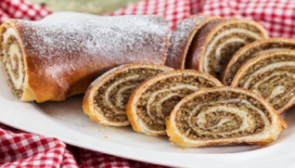
- HOLIDAY NUT ROLL SALE. Fillings: Apricot, Lekvar(Prune), Nut, Poppyseed, Red Raspberry, Pumpkin/Cheese. $17.00 each. Last date for orders: November 22, 2022. PICK-UP: Sat. Dec 10th from 10:00–12:00. Call for orders: Marty 610-682-4458.

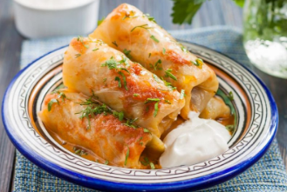
- Pani Olha is making HOLUBKI for sale. Pick up day: Sat. Dec. 10th from 10-12. Advance orders only! Call Pani if interested 862-707-9763. Other homemade food and baking goods will be selling at that day as well.

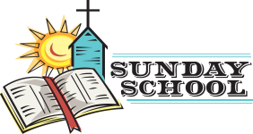
- Sunday School schedule: Mrs. Mary Ost (Preschool/Elementary) Sundays 8:55-9:20 AM. Mrs. Karen Osmun (Secondary) Sundays at 8:45-9:15 AM.

- Ukrainian classes for kids (3-6 y.o.) every Friday from 4 to 5 PM.
- Our Church will not be making pierogies due to construction issues. Will keep you posted on the date we will resume production. Thank you for understanding.
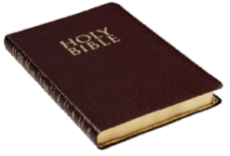
- Wednesday Evening Bible Study via Zoom with a professor of Saint Sophia Seminary Fr. Demetrios(7 PM). Ask Fr. Oleg for the link.
- Wednesday 12 PM Pan-Orthodox Virtual Bible Study via Zoom. Meeting ID: 576 301 6482. Passcode: 238492.
- For Food Bank: baby foods, canned potatoes and meats, tuna, pasta, sauces, mac. & cheese.
- NEW List of needed Winter support for Ukraine: winter 0•F sleeping bags (non-bright colors only), new thermal underwear, new thermal socks, balaclavas, winter tactical mittens, toe warmers, men winter/ski warm light boots (9-11sizes), emergency survival kits, emergency burncare dressings, chest seals (Halo), Israeli compression bandages, Celox rapid hemostatic gauzes, any pain relief and antibiotics (pills and IV), NAR CAT tourniquets, Nasopharyngeal airway tubes, high protein bars, military MREs (meals-ready-to-eat), personal water filters (like LifeStraw), Amazon gift cards for buying all needed stuff are welcome.
- Welcome to contribute articles or pictures to the bulletin. Let's make bulletins together!

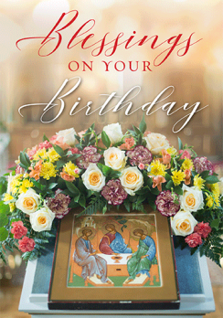
BIRTHDAYS:
28 Nov…Janet Woyewoda, Anne Marie Kroboth
29 Nov…Robert Pavlinsky, Ella Misko
01 Dec…Tatiana Seremula

ANNIVERSARIES:
30 Nov…Robert & Nadda Pavlinsky
МНОГАЯ ЛІТА! MANY YEARS!

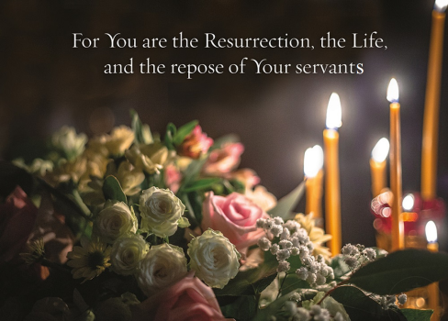
NECROLOGY:
Ukrainian civilians and soldiers killed in the Russian invasion. Newly departed Annette DeFiore
27 Nov…Gregory Winters ’12
30 Nov…Nathan Keiper ‘6801 Dec…Paul Bilyk ‘48
03 Dec…John Faryna ’25

MEMORY ETERNAL! ВІЧНАЯ ПАМ’ЯТЬ

PRAYER FOR THE HEALTH & SALVATION OF THE AFFLICTED:
Ukrainian soldiers and civilians wounded during the Russian aggression, Helen Crayosky, Nadine Savitz, Barbara Grason, John Hnatow, Michael Hnatow, Omelchyk Tatiana, Soldier Serhiy, Shirl Merolli, Raisa Melnychuk, Olha Beizyn, Vasyl Beizyn, Ludmyla Melnychuk, William Leszczuk, child Charlie, James Osmun, priest Vasyl Dovgan, Rosemarie Pypiuk, Kirk Swauger, Stephanie Donnelly, Nicholas Alexander, Danny Berro, child Alexandria, Elizabeth Pastushenko, Philippe Chasseuil, Joan Molnar, Aaliyah Osmun, William Savitz, Vladimir Krasnopera, Brendan Phillips, Jessie Hnatow, Jessica Meashock, Adam Hewko, Andrew Thaxton, Susan Ferretti, Judy Albright, Daniel Kochenash, Christopher Mack, Norman Betrous, Tom Petro Jr., Robert Zarayko Jr.

A Sermon for Thanksgiving.
Protopresbyter Alexander Schmemann, the late Dean of Saint Vladimir’s Seminary, celebrated the Divine Liturgy for the last time on Thanksgiving Day 1983. Two weeks later, on December 13, he fell asleep in the Lord. At the conclusion of the Liturgy, Father Alexander took from his pocket a short written sermon, in the form of a prayer, which he proceeded to read. This was uncharacteristic of Father Alexander, since he never wrote his liturgical homilies, but delivered them extemporaneously. These were his words, which proved to be the last ever spoken by him from the ambo in Church:
Thank you, O Lord! Everyone capable of thanksgiving is capable of salvation and eternal joy. Thank You, O Lord, for having accepted this Eucharist, which we offered to the Holy Trinity, Father, Son and Holy Spirit, and which filled our hearts with the joy, peace and righteousness of the Holy Spirit. Thank You, O Lord, for having revealed Yourself unto us and given us the foretaste of Your Kingdom. Thank You, O Lord, for having united us to one another in serving You and Your Holy Church. Thank You, O Lord, for having helped us to overcome all difficulties, tensions, passions, temptations and restored peace, mutual love and joy in sharing the communion of the Holy Spirit. Thank You, O Lord, for the sufferings You bestowed upon us, for they are purifying us from selfishness and reminding us of the “one thing needed;” Your eternal Kingdom. Thank You, O Lord, for having given us this country where we are free to Worship You. Thank You, O Lord, for this school, where the name of God is proclaimed. Thank You, O Lord, for our families: husbands, wives and, especially, children who teach us how to celebrate Your holy Name in joy, movement and holy noise. Thank You, O Lord, for everyone and everything. Great are You, O Lord, and marvelous are Your deeds, and no word is sufficient to celebrate Your miracles. Lord, it is good to be here! Amen.
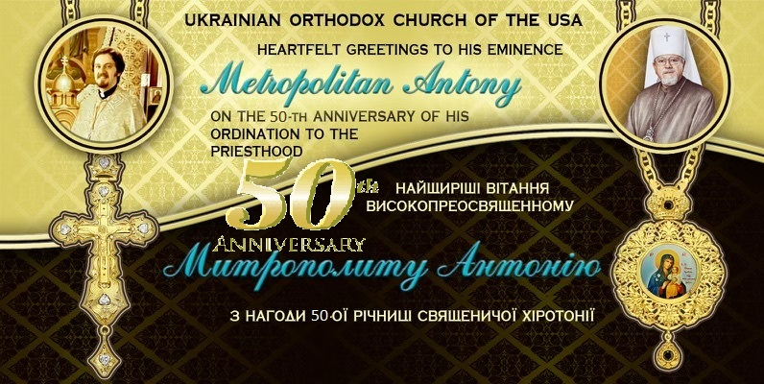
Prayer of Thanksgiving. O Lord Jesus Christ our God, the God of all mercies and bounties, whose mercy cannot be measured, and whose love for man is deep; with fear and trembling we fall down in adoration before Your majesty, unprofitable servants that we are. We humbly thank You for the blessings You have given Your servants all of us and our families. We glorify You, we praise You, we sing to You our Lord and Master and Defender; we fall down before You and beg Your boundless mercy. As You have graciously received Your servants’ prayers and granted them, so also deliver Your Church and preserve us from every hostile assault. Grant us peace and tranquility, that Your faithful people may grow in virtue and love for You, and may partake of all Your benefits, and so we will always offer thanksgiving to You, together with Your Father, and Your most holy, good and life-giving Spirit, one in Trinity, and will joyfully sing to You: Glory to You, O God our Saviour, unto ages of ages.
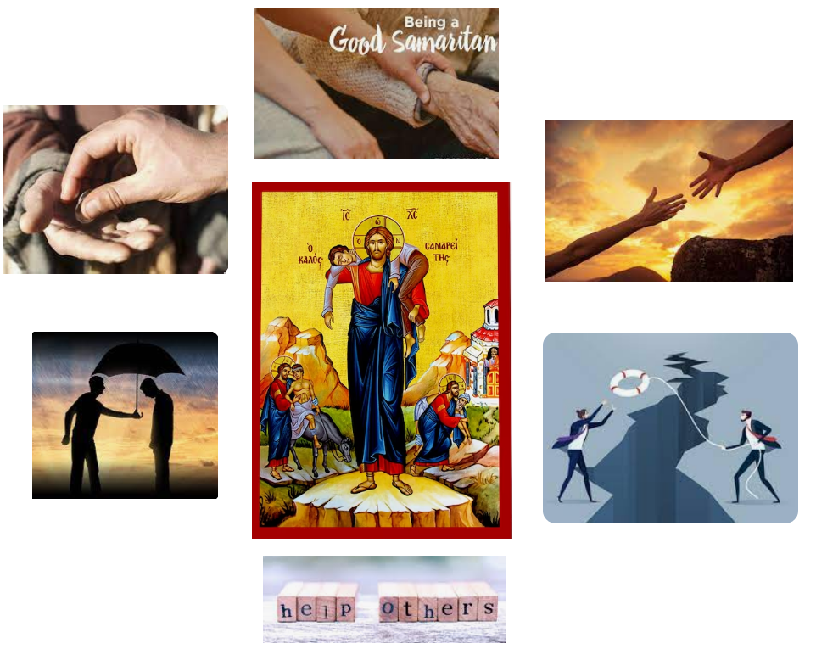
“The bee is more honored than other animals, not because she labors, but because she labors for others”
- St. John Chrysostom

ORTHODOXY AROUND THE WORLD
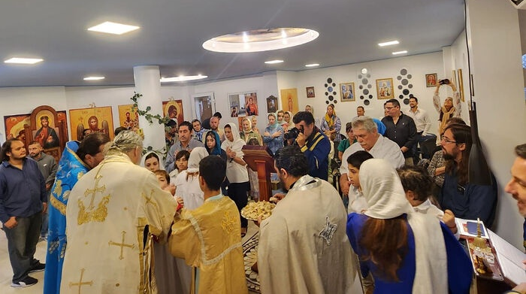
The Orthodox Church of the Annunciation in Guayaquil, Ecuador, founded in 1981, was consecrated by Bishop Kiril of Buenos Aires. On Nov. 18th Metropolitan Epifaniy of Kyiv visited the modular town built for residents of Borodyanka who lost their homes in the war. The charitable project was implemented by the IOCC of the USA.

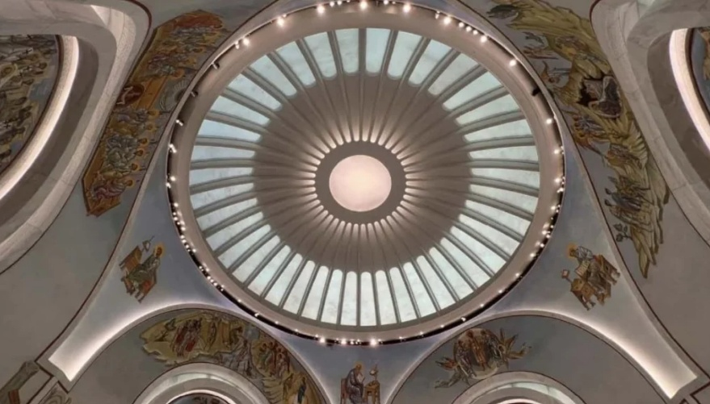
The St. Nicholas Shrine at Ground Zero in NYC with resume full liturgical services after 22 years on the Feast of St. Nicholas in December.

